The 4 Way Forum

**Rotary’s Four Way Test**

* **Is it the TRUTH?**
* **Is it FAIR to all concerned?**
* **Will it build GOODWILL and BETTER FRIENDSHIPS?**
* **Will it be BENEFICIAL to all concerned?"**

[](http://www.lancasterhempfieldrotary.com/)

April 9, 2013

Volume 7 Number 38

<http://www.lancasterhempfieldrotary.com/>

Lancaster, Pennsylvania

**Presider:** Ed McGeehan

**Invocation:** Darrell Gerke

|  |  |  |  |
| --- | --- | --- | --- |
| *Attendance* | Men | Women | Visitors |
| Present | 17 | 6 | 3 |
| % of Gender | 61% | 75% |  |

**Guests: Stefanie Valar,** Lancaster

**Ed Hauck,** Lancaster

**Joe Patterson**

**Happy Bucks:**

**Jim Eshleman:** Pleased his 32 year old daughter had successful disk replacement surgery in her neck, where the surgeon went in from the front *(The editor hopes this detail isn’t a violation of personal privacy. Ed was just really happy about it)*

**Kathryn Pearce**: Survived a week in Disney with a five year old! Her son is 44 inches, which makes the minimum for rides. He was measured many times, and the lines were shortest early in the morning for rides.

**Bill Hager**: Always admires anyone who meets the Disney height requirement.

**Michele Weiss**: Enjoyed respite and time out with the Rotary girls. Second dollar for the memory of Margaret Thatcher.

**Announcements**



**Scott Russell and Ed Bednar reported that Shop for a Cause is in full swing. We could use more help counting ballots.** Ed is at [lebednar@comcast.net](mailto:lebednar@comcast.net)



PASBO is sponsoring the Joseph Kurjiaka Memorial Golf Outing at Crossgates Golf Club on Friday May 17. Joe was a member and past president of the Rotary Club of Lancaster Hempfield. He passed away at age 47.

[The brochure to sign up is here.](https://dl.dropbox.com/u/11730856/01%202013/Kurjiaka%20Memorial%20Golf%20Tournament%20Final%20%281%29.pdf)



**EREY** – **E**very **R**otarian is asked **E**very **Y**ear to make a $100 contribution to the Rotary Foundation. Our Rotary year runs thru 6/2013. If you have NOT made your contribution, make it now. Kathryn Pearce can take your contribution, or make it [online](http://www.rotary.org/en/Contribute/Pages/ridefault.aspx).

our club # is 5348 district # 7390

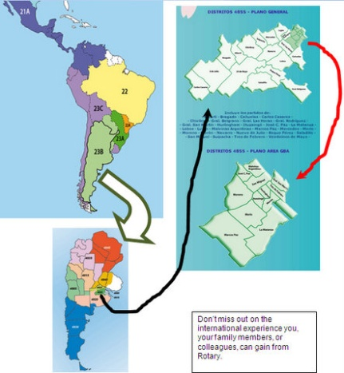**Are you a young professional looking for an opportunity to travel to Greater Buenos Aires, Argentina on an expense paid 4-week tour to study the local culture and to enhance your vocational skills?**  Consider Rotary Group Study Exchange (“GSE”). [Here is the Brochure.](https://dl.dropbox.com/u/11730856/01%202013/GSE%20recruitment%20Team%20Member%202013-14.pdf)

Rotary District 7390 is looking for potential team members for our upcoming Group Study Exchange with Rotary

The team will depart the US on Friday May 2, 2014 and return home on Sunday, June 1st.

**Deadline for submitting Team Member applications – October 15, 2013.**

**Memorial Day Ceremony in Salunga**. Sunday May 26 at noon. Kerry Johnson is setting it up, including a rehearsal. However, he will not be able to attend, and needs an MC from the club. Please volunteer or you will be volunteered by voice vote. If you are interested, contact Kerry at [kerryajohn@aol.com](mailto:kerryajohn@aol.com), or call 538-2454. This is an important annual event organized by this club.



**Community Homeless Outreach Center** is sponsoring a 5k race Saturday June 22. The entry form and [information is HERE](http://www.lancasterchoc.org/5k-run-walk/).

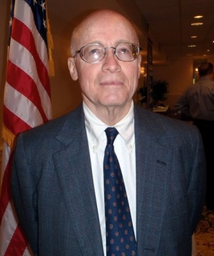**Program:**

**Joe Patterson**

Historic Preservation Trust of Lancaster County

Joe educated the membership about the Lancaster County Preservation Trust.



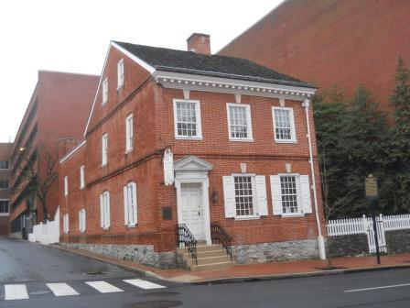Founded in 1966 to “stem the rapid destruction of historic properties in Lancaster County,” the Historic Preservation Trust of Lancaster County’s mission is to preserve and protect Lancaster County’s rich historic and architectural character through education, advocacy and direct action. The trust has been directly involved in preserving more than three dozen important Lancaster County landmarks and has provided advice, assistance and guidance in the protection of others. The trust is a member-supported, 501(c)3 non-profit organization located in the historic Sehner-Ellicott-von Hess House (1787) at 123 North Prince Street in downtown Lancaster.

Joe had an nice photo review of preserved properties, and some that were not able to be preserved.

Check the [Trust’s website](http://hptrust.org/) for more details.

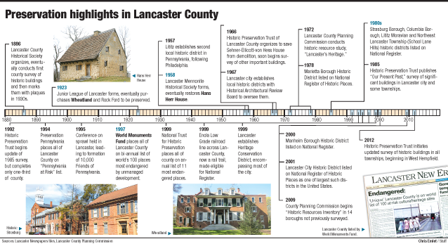

Joe reminded members of the upcoming [Gourmet Gala at Lime Spring Farms, Sunday May 19.](http://hptrust.org/2013-gourmet-gala-sponsors-announced/)

**[](http://www.google.com/imgres?hl=en&sa=X&rls=com.microsoft:en-US&biw=1600&bih=754&tbm=isch&tbnid=RzIdsxoWYDIhpM:&imgrefurl=http://msre.org/meetings/2011-5-8-meeting/&docid=Onu1R7K9OmsG6M&imgurl=http://mtnstaterotaryeclub.org/wp-content/uploads/2010/11/rotary-bell.jpg&w=125&h=192&ei=VKJcUay3Eeuq0AHdo4CoDA&zoom=1&ved=1t:3588,r:7,s:0,i:106&iact=rc&dur=600&page=1&tbnh=153&tbnw=100&start=0&ndsp=24&tx=71&ty=90)**

**“DING” The end**

**

*Please note, all members are reminded to silence all cell phones during meetings.*

*Besides, cell phones cook your brain, Tom McDermott.*

**OUR CLUB GOALS FOR THIS YEAR**

Increase membership by 6+

100% participation in Rotary Foundation giving

Become a Vibrant Club

There will be a brief **board meeting at 8:15 on 4/23** immediately following our regular club meeting.

The primary topic is to review and approve grants but we will also get an update on club finances and discuss any other topics that are brought up at that time.

At this point we have a grant request from the Lititz Club for up to $2,000 to help purchase a vehicle for the Haitian Connection and a request from Brian Beddow for $1,600 to purchase "CPR manikin sets" for the Boy Scout camps at Camp Mack and the Bashore Scout Reservation.

We also might have a couple of applications from HHS students to attend the RYLA event in June.

**Member Advertisement:**

(Your free ad can go here – email it to me at [ajacobs@isaacsdeli.com](mailto:ajacobs@isaacsdeli.com). If I don’t have a compromising photo of a club member for this section, I’ll put in a club member’s advertisement.)

*No advertisement this week, so instead we’ll play our new game, “Whose toes are those?” from our meeting. All members with correct answers get to spend a happy buck next week.*

