Support an International Rotary Vocational Service Project & Raise Funds For Your Rotary, Interact or Rotaract Club
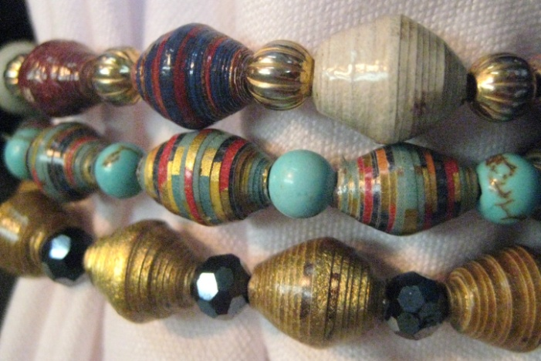
"BEADS FOR HOPE FUNDRAISER IN A BOX"...Here's proof that you can do two things at one time! First, you can support a remarkable international Rotary service project, The School of the Dump in Chinandega, Nicaragua. Second, you can raise money for your own Rotary club or sponsor a box for your Interact or Rotaract club as a fundraiser for their club. Beads for Hope are shown in photo on left.

SCHOOL OF THE DUMP IN CHINANDEGA, NICARAGUA: Many of you have heard Jim Kite (Brenham Rotary), and Frank Huezo (Kingwood Rotary) discuss how this remarkable project has successfully removed children from living in the Chinandega City Dump, and now provides the children with an education, nutritional meals, and medical care. A vital component is the school's Betania Trade School which empowers the students by teaching them a trade with the goal of them reaching financial independence thereby breaking the cycle of poverty.

THE "BEADS FOR HOPE" PROJECT teaches students at the Betania Trade School to make beautiful, hand-crafted beads that are made by hand-rolling recycled wallpaper, then crafted into a beautiful, artisan bracelet. Each bead receives 10 coats of varnish which makes them durable and water resistant. Each student is paid for each bracelet that they make, which empowers them since they can earn double the salary of a school teacher in Nicaragua!

WHAT IS IN EACH "BEADS FOR HOPE FUNDRAISER IN A BOX", WHAT IS THE COST, AND HOW DOES MY CLUB BENEFIT?
Each box contains 100 hand-crafted bead bracelets and the total cost per box is: $375.00
The retail value is: $7 to $10 per bracelet (That's a total retail value of....$700.00 to $1,000.00 per box)
Your club pays $375 per box, sells the bracelets, and your club keeps the profit of between $325.00 to $625.00!
In addition to 100 bracelets, each box will also contain a poster, order forms, and a video which was produced by 17 year old Girl Scout, Maureen Fenninger. Maureen traveled to Chinandega this summer to meet these remarkable young artists with her mom, Kathy Fenninger, a member of the Rotary Club of Houston. It was a life-changing experience!

Here is a link to Maureen's touching YouTube Beads For Hope Video http://www.youtube.com/watch?v=P2vddEVgy7o or you can search "Children of the Dump Beads For Hope 2011." You'll watch the bead making process, see the bracelets, and meet some of the Betania Trade School students that make the jewelry. See video at www.kwrotary.org.

FUNDRAISER FOR INTERACT AND ROTARACT CLUBS: Since most Interact or Rotaract clubs may not have the funds to purchase a box, we are encouraging their sponsoring Rotary club to purchase the box(or boxes) for them, they sell the bracelets, they reimburse the Rotary club their $375, and they keep the profit to possibly purchase another box.

ORDER YOUR BOX OR BOXES of "Beads for Hope" bracelets today, and help the students at the School of the Dump earn money. Your club keeps the profit of $325 to $625 per box which can either be used for your local projects, donated to The Rotary Foundation as your club's PolioPlus or Annual Programs Fund contribution, or donate it to the School of the Dump through: Hope & Relief International Foundational, Inc., 10700 Gerke Road, Brenham, Texas 77833.

These bracelets make excellent gifts for speakers at your Rotary meetings, friends, family, and customers, plus each bracelet contains information card about the project.

For more information about ordering Beads For Hope Fundraiser in a Box, contact:
Frank Huezo @ 281-380-6995, e-mail frankhuezo@aol.com
Jim Kite @ 979-251-0840, e-mail jimkite@sbcglobal.net

