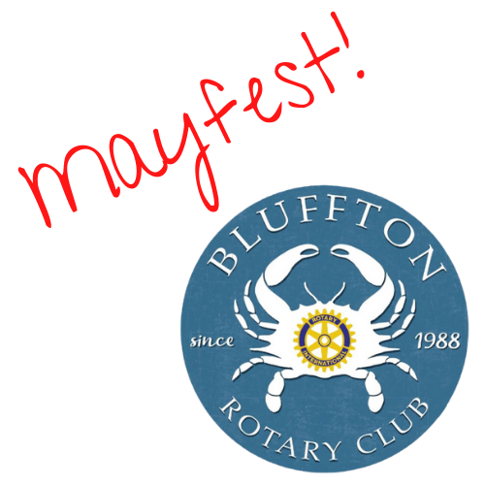 |  | mayfest  Coordinated by The Rotary Club of Bluffton  www.blufftonrotary.org  May 10, 2025

SPONSORSHIP SPONSORSHIP
OPPORTUNITIES BENEFITS

Diamond Premier Sponsor - $5,000
♦Recognition as the major sponsor in all paid ads and posters and on the festival sponsor banners;
♦Corporate logo displayed in all paid ads, posters, sponsor banners and on the web site and Facebook;
♦Verbal recognition by the emcee at the main stage;
♦Complimentary sponsor booth on May River Road festival entrance;
♦10 drink tickets for any of the 3 Rotary bars;
♦Opportunity to associate your company name with this premier Bluffton event!

Platinum Sponsor - $3,000
Sponsor one of these event segments:
Main Stage in Martin Park Food Court
Craft Beer Garden on Bridge Street
Festival Shuttles
♦A prominent listing on the festival sponsor banners;
♦Corporate logo displayed on the festival sponsor banners and the web site and Facebook;
♦Verbal recognition by the emcee at the main stage;
♦Complimentary sponsor booth on May River Road festival entrance;
♦6 drink tickets for any of the 3 Rotary bars;
♦Opportunity to associate your company name with this premier Bluffton event!

Gold Sponsor - $1,500 ♦A listing on the festival sponsor banners;
♦Corporate logo displayed on the festival web site and Facebook;
♦Opportunity to place your company literature in the festival welcome tent;
♦4 drink tickets for any of the 3 Rotary bars;
♦Opportunity to associate your company name with this premier Bluffton event!

Silver Sponsor - $500 ♦A listing on the festival sponsor banners;
♦Corporate logo displayed on the festival web site and Facebook;
♦2 drink tickets for any of the 3 Rotary bars;
♦Opportunity to associate your company name with this premier Bluffton event!

