TEAR DOWN INFORMATION
The festival ends at 5:00pm on Saturday. The Police will not let artist vehicles on Calhoun St until 5:30pm. The street opens to the public at 6:30pm.
We need your cooperation by tearing down first and moving as much as possible to the sidewalk so we can get vehicles down the street to load up.
Vendors may enter the street as follows: You will have a pass in your packet that corresponds with the color of the street that you can enter per the map. You will need to place the appropriate pass on your dash to be given access to Calhoun St between 5:30pm and 6:30pm. The police will not let you enter if you do not use the colored pass. This is also your parking pass for MC Riley parking lot for the weekend.
- Booths 1-22 & 143-168 will have a RED pass which will allow access to Calhoun St via Church St – exit via May River Rd
- Booths 23-34 & 131-142 will have a RED pass which will allow access to Calhoun St via Church St – exit via Lawton St
- Booths 35-47 & 121-130 will have a BLUE pass which will allow access to Calhoun St via Lawrence St – exit via Lawton St
- Booths 44-59 & 99-120 will have a BLUE pass which will allow access to Calhoun St via Lawrence St – exit via Bridge St
- Booths 60-70 & 89-98 will have a BLUE pass which will allow access to Calhoun St via Lawrence St -Exit via Allen St
- Booths 71-88 & 180-221 will have a BLUE pass which will allow access to Calhoun St via Lawrence St- Exit via Water St
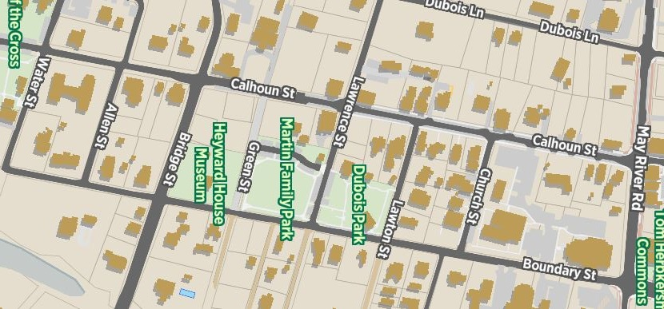
Blue pass entry
Booths 35-130,
180 – 221

Red pass entry
Booths 1 – 34,
130-168
The street will be opened to local traffic at 6:30pm.
Your cooperation will greatly facilitate the tear down operation and get you on your way ASAP. Thank you!

