Individual Program Packet
Includes One Active Membership

Prospective Member:
Complete the New Member Proposal Form and return to your sponsor. If no sponsor, email form to the Executive Administrator, Maureen Adams: maureen@wordconnector.com

Your Personal Information:

Name: __________________________________________ Date of Birth: _______________________

Place of birth: _________________________________ US Citizen? Yes No

Spouse/Partner Name: _________________________________________________________________

Children’s Name and Ages

How long have you lived in the Phoenix Metro area:

Phone: ____________________________ Email address:

Alternate Phone: ________________________________

Home Address: ____________________________ City: _______________State ___ Zip: ______

Name of your Rotary sponsor (if any): _______________________________________________________

College/University & Degree(s): ___________________________________________________________

Military Service? Branch: __________________ Dates: ______Rank: ________

Do you have your own personal website? If yes, address?: www. _______

Scottsdale Rotarian References:

Other Rotarian References (include their club):

Are you a former Rotarian? Club Name, Dates & Activities:

Hobbies & Interests: ________________________________________________________________________________

Organizations in which you are/were a member:

Community Activities: __________________________________________________________________

What interested you in Rotary? __________________________________________________________

I attest that the information herein contained is complete and accurate and acknowledge that submission of this information should not be construed as an application for or guarantee of membership in the Rotary Club of Scottsdale.

Signature Date

Thank you for your interest in the Rotary Club of Scottsdale! We will get back to you soon with the status of your application.

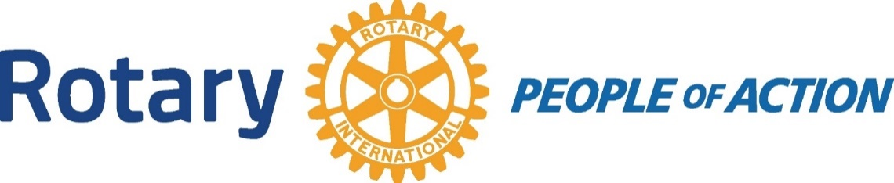

Applicant Certification

I understand that it will be my duty, if elected, to exemplify the Object of Rotary in all my daily contacts and activities, and abide by the constitution, bylaws and policies of the Rotary Club of Scottsdale, as they may be amended from time to time.

I understand that my initial membership fee will be applied as follows:
Initiation Fee: $200.00
Current Membership Quarterly Dues: $325.00 (includes lunches and all dues)
Donation to the Scottsdale Rotary Club Foundation Rolly Fellowship: $100.00 Donation to the Rotary International Foundation Paul Harris Fellowship: $100 annually.

TOTAL: $ 725.00

I further agree to pay when due, all dues and other funds in accordance with the Bylaws and policies of the Rotary Club of Scottsdale.

I hereby give permission to the Rotary Club of Scottsdale to publish my name and proposed classification via whatever method designated by the Board of Directors.

Applicant’s Name (print):

Applicant’s Signature: Date:

