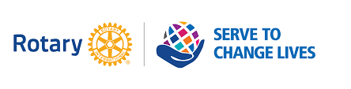
Madison Rotary
Laws of Life Essay Award
Approved by Board of Directors, January 13, 2022

The Rotary Club of Madison invites junior students who are members of Madison High School to participate in a Laws of Life Essay Award. The purpose of the essay award project is to encourage students to explore their core values, such as honesty, perseverance, and compassion.

Essay Theme
Students are asked to select a maxim or 'Law of Life' such as 'honesty is the best policy' or 'No one knows what he can do until he tries,' and to write an essay explaining how the character and ethical implications in the maxim apply to their lives. They will identify life values about which they are particularly passionate - standards they can use as a basis for guiding them through important decisions in their lives. By encouraging students to reflect on key life principles and values, the contest promotes and rewards the development of good character.

Essay Requirements
- Essay should be 750-1000 words in length, typed and double spaced.
- Essay should be based on the student's personal experience or observations. The essay is an opportunity to write and reflect on the individual's life and values.
- The essay should state the 'Law of Life' maxim.

Guidelines for Submission
- The limit is one essay per student.
- The applicant must be a member of the Junior Class of Madison High School.
- The essay must be an original work of the student.
- By submitting original work, the student is consenting to the release of submission to Rotary District 7475 for reproduction in the District and Club Newsletters and/or Websites and for publication in local media.

Program Timeline
- Program announced to students March
- Essays Due May 1, 2022
- Winners announced Late May

Prizes
- Top three essays will be awarded $800 each

