2026 Flag Day 5K Race & Walk
Celebrating America's 250th Anniversary

Dear Community Partners,

On June 14, 2026 — Flag Day, the Pequannock Valley Rotary Club will host our annual 5K Race & Walk in celebration of our community and our country. This year’s event carries special meaning as our nation approaches the 250th anniversary of the birth of the United States of America.

From the moment Paul Revere rode through the night in April of 1775, warning that the British were coming, a movement began that would ultimately lead to the creation of a new nation built upon freedom, opportunity, and community responsibility.

In many ways, the spirit that fueled those early patriots is the same spirit that fuels community service today. For over 70 years, the Pequannock Valley Rotary Club has proudly served the communities of Pequannock Township, Lincoln Park, and Riverdale. .

Since our founding in 1953, our club has contributed well over $1 million to support the needs of our community. Proceeds from the 2026 Rotary 5K Race & Walk will continue to support:

Local scholarships for graduating students

Food pantry assistance for families in need

Youth leadership programs

Community service initiatives

Emergency assistance programs
- Rotary International Polio eradication initiative

As we celebrate America’s 250th anniversary, we invite you to join us as a sponsor of this special Flag Day event. Your support helps us continue Rotary’s mission of “Service Above Self.”

Thank you for considering joining us in making a difference.

With appreciation,
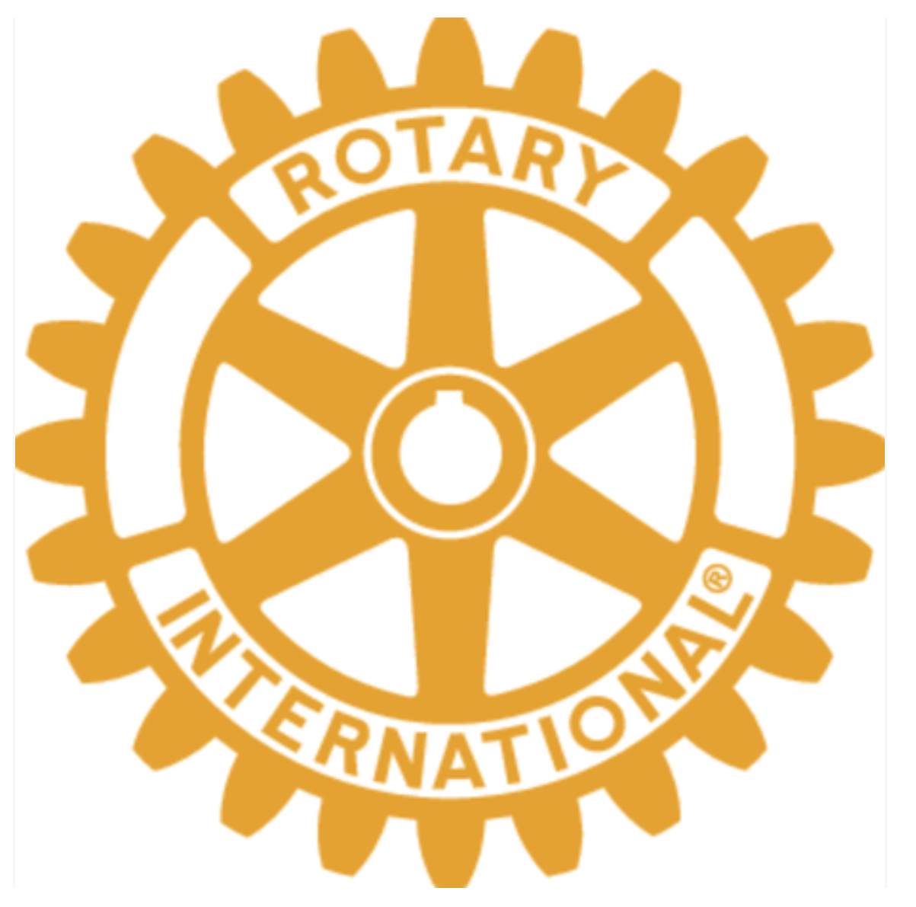

Pequannock Valley Rotary Club

The Road to Independence – Sponsorship Opportunities

1775 | Paul Revere | Lexington & Concord | Continental Congress | Continental Army | Common Sense | Declaration of Independence | 1776

Paul Revere Sponsor – $2,500
April 18, 1775 – Paul Revere’s midnight ride warned colonial militias that British troops were advancing.
Benefits: Premier logo placement, website recognition, social media recognition, two complimentary race entries.
Lexington & Concord Sponsor – $1,500
April 19, 1775 – The first battles of the American Revolution.
Benefits: Large logo placement on race materials, website recognition, social media recognition, . one complimentary race entries
Continental Congress Sponsor – $1,000
May 10, 1775 – Delegates gathered in Philadelphia to unite the colonies.
Benefits: Logo on website and event materials.
Continental Army Sponsor – $750
June 14, 1775 – The Continental Army was formed and George Washington became Commander‑in‑Chief.
Benefits: Recognition on signage and website.
Bunker Hill Sponsor – $500
June 17, 1775 – Colonial forces proved they could stand up to the British Army.
Benefits: Name listed on sponsor board and website.
Common Sense Sponsor – $250
January 1776 – Thomas Paine’s pamphlet inspired support for independence.
Benefits: Name listed on sponsor board.
Declaration Sponsor – $200 July 4, 1776 – The Declaration of Independence formally created the United States.
Benefits: Recognition at the race.

Sponsorship Opportunities:

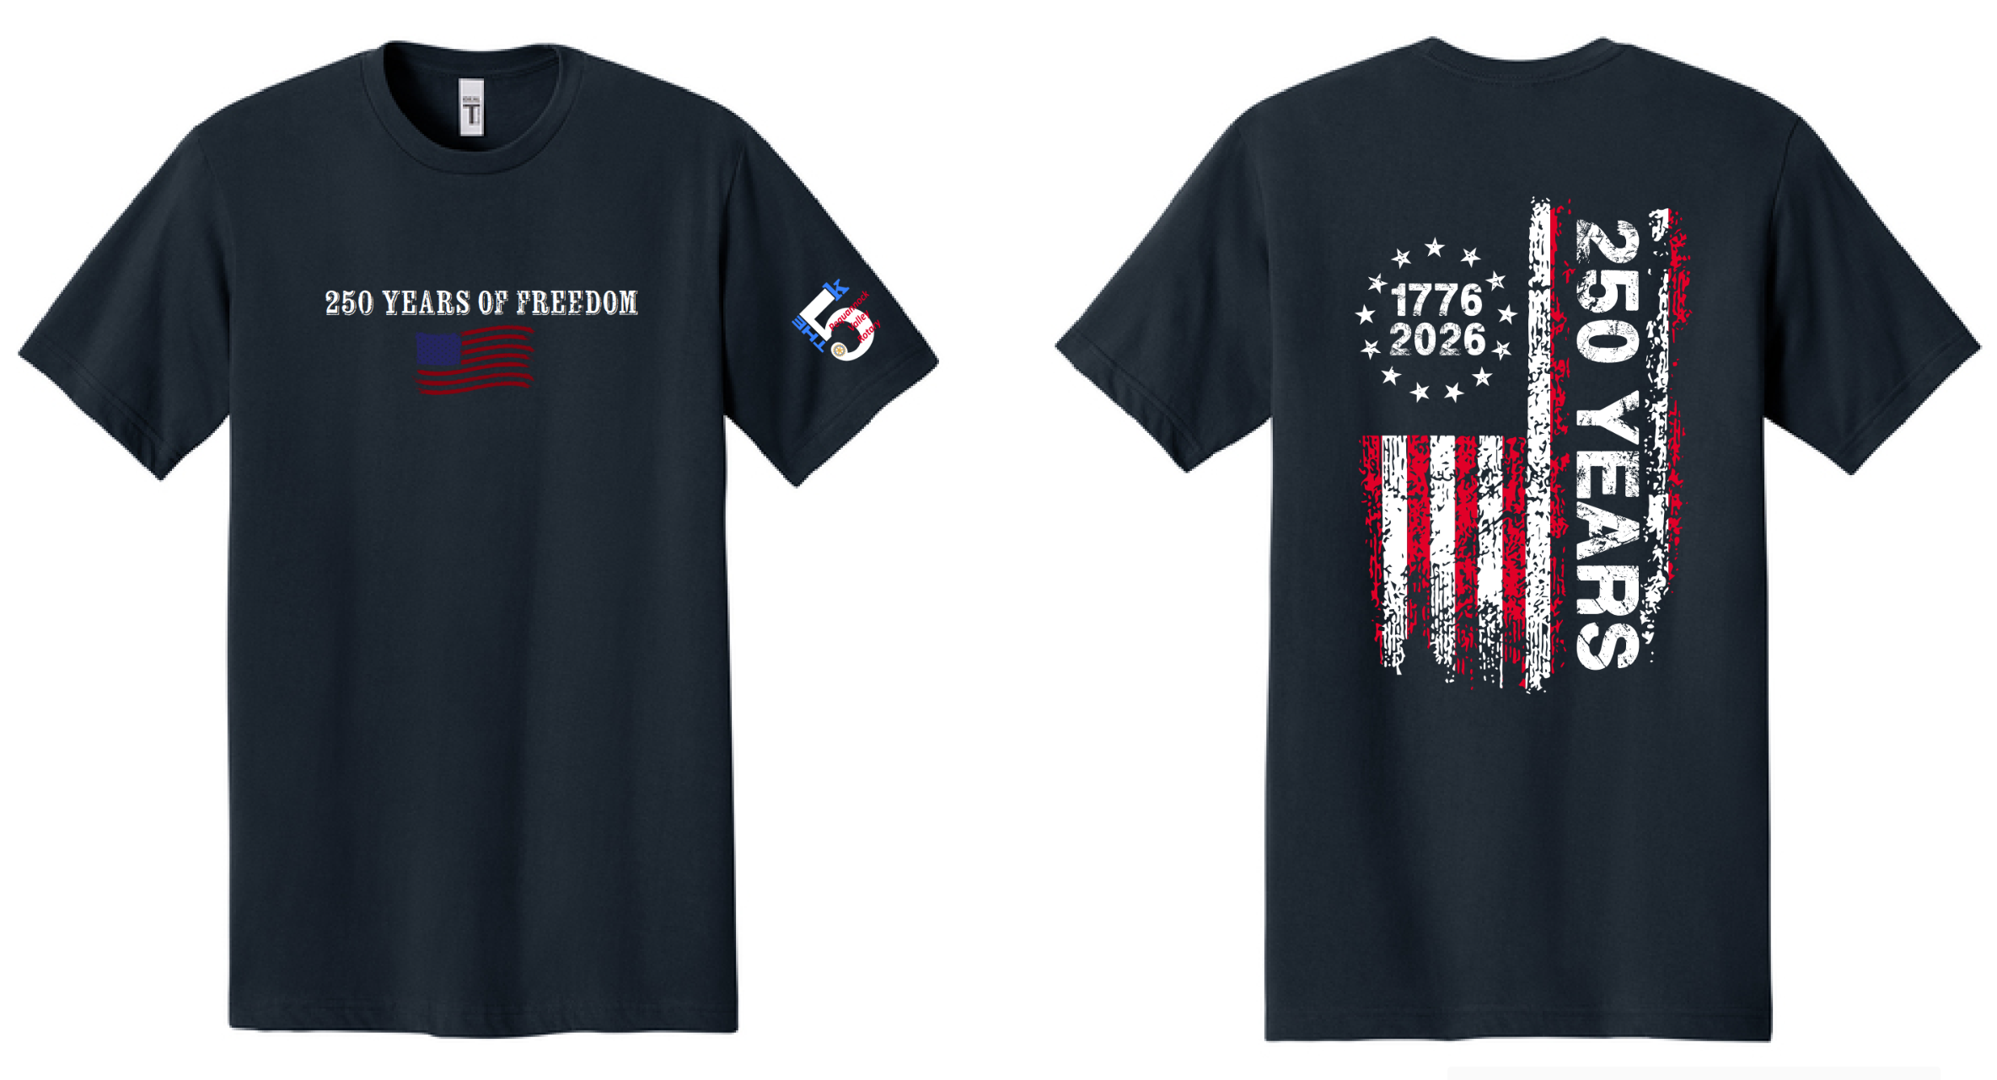
 | $2,500 | Paul Revere Sponsor
 | $1,500 | Lexington & Concord Sponsor
 | $1,000 | Continental Congress Sponsor
 | $750 | Continental Army Sponsor
 | $500 | Bunker Hill Sponsor
 | $250 | Common Sense Sponsor
 | $200 | Declaration Sponsor
All sponsors who contribute $200 or more will be given a high-quality 2026 race shirt Please fill out the enclosed form when submitting your contribution
.Sponsorship deadline is June 1st
Thank you for your help by being a sponsor of the Pequannock Valley Rotary Foundation 5k Race / Walk. As a thank you we would like to give you an official 2026 Rotary Day 5k Race / Walk shirt. To ensure the correct size and delivery location please file out the information below:
Sponsor Name: ___________________________________________________

Sponsor Contact Person: ____________________________________________________

Address: _________________________________

City______________________________________ State______________ Zip Code_____________

Phone #: ___________________________

E-Mail: _____________________________________________________________
Adult Shirt Size (circle one) S M L XL

Please make check payable to: Pequannock Valley Rotary Foundation

Thank You
The Pequannock Valley Rotary Foundation

