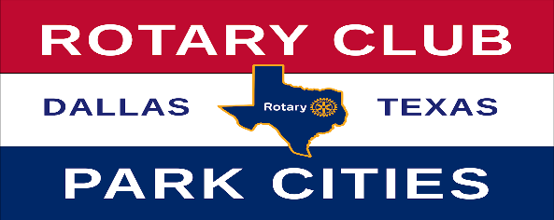
2021-2022 Nominations
Rotary Club of Park Cities Awards
AWARD | NOMINEE | COMMENT
Wilbur Hawkins
Spirt of Rotary Award

Hugh B. McAfee, Jr
Service Above Self Award

Col. Robert Q. Smith, Jr
Club Service Award

C.C. Collie
Distinguished Leadership Award

Linda Tunnell
New Member Award

Lifetime Achievement Award

Cleveland G. Clinton
Collaborative Award

Return To:
- Karen Farris – kfarris7238@gmail.com
- Fred Brown – fred.brown.tx@gmail.com

