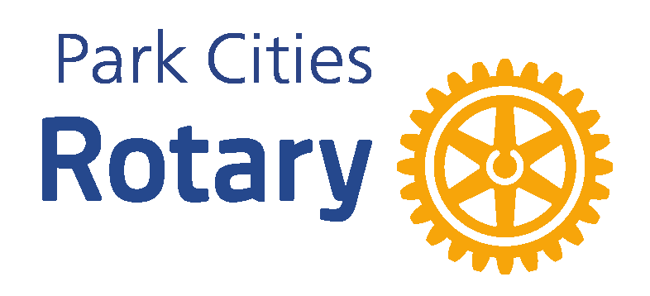 | 2026  PARK CITIES 4TH of JULY PARADE  INVOICE for Patronage &/or Sponsorship
Patrons of the Parade - your payment for the 2026 Park Cities 4th of July Celebration must be made payable to the NORTH TEXAS FOOD BANK. Please call Susan Glen, the RCPC Relationship Manager for the NTFB, at 214-908-9981 for instructions about how and when to submit your check in order to maximize matching opportunities.

Sponsors of the Festival and Parade - your payment for the 2026 Parade and Festival must be made payable to the ROTARY CLUB OF PARK CITIES. Please call Tom Rhodes, the Centennial Park Team Lead, at 214-202-7008 for instructions about submitting your check.

Please complete this form and send it along with a corporate logo in a JPEG or similar type file for use in the publicity documents to Karen Farris at kfarris7238@gmail.com as soon as possible so that we can know about your patronage or sponsorship of the parade. The deadline for ensuring full PR advantages of your donation is April 30, 2026.

Please complete the following information about your company:

Name of Contact: _________________________________________________

Company: __________________________________________________________

Address: __________________________________________________________

Telephone: ______________________________________________________

Email: __________________________________________________________

NTFB Patronage Level $_______________
RCPC Parade Sponsorship Level $ ___________________

Please direct your questions to Karen Farris at 214-537-4999. For Patrons, your tax receipt for a charitable donation will come from the NTFB. For Sponsors, the Rotary Club is a 501(c)(4) making your contribution a marketing expense.

We appreciate your working with us to celebrate this great holiday! THANK YOU!

