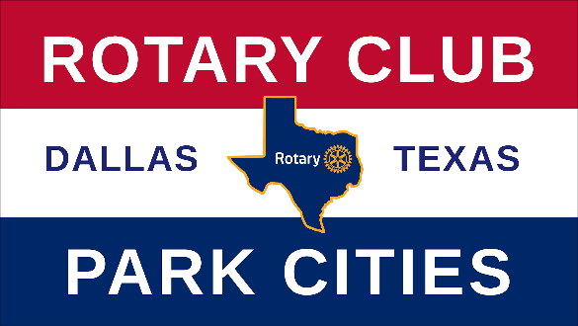
Membership Categories
Effective May 1, 2024

- Individual Membership:
- Single member application
- Annual Dues of $420 (prorated based on join date)
- One time initiation fee of $265.
- Young Professional Membership: (Under the age of 30)
- Annual Dues of $210 (prorated based on join date)
- One time initiation fee of $55.
- Dual Membership:
- Allows an adult spouse / partner of the same household, or the adult child or grandchild under the age of 35 of an existing or new member of RCPC to become a 2nd member of the Club
- Annual dues are $210 (50% of the full membership price prorated based on join date)
- No initiation fee for the second member
- Corporate Membership:
- Companies with under 10 employees: One time initiation fee of $525
- Annual dues for up to two joining members is $900; (Third, fourth, and fifth joining member pays an additional $290/person.)

- Companies with over 10 employees: One time initiation fee of $525
- Annual dues of $1,800 includes membership dues for up to five joining members.

Corporate membership includes:

Company business card advertisement in The HUB and RCPC Club website and recognition at a RCPC Club meeting twice a year

Right of first sponsorship in RCPC, community, and partner events (e.g. July 4th Parade, Tree Lighting, NTFB Packing Days); Additional fee is required.

