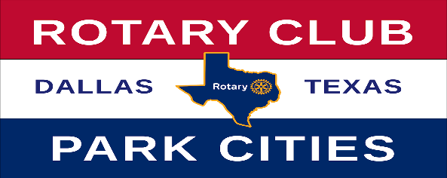
2025-2026 Nominations Rotary Club of Park Cities Awards
AWARD | NOMINEE | COMMENT
Wilbur Hawkins
Spirit of Rotary Award
Hugh B. McAfee, Jr Service Above Self Award
Col. Robert Q. Smith, Jr Club Service Award
C.C. Collie
Distinguished Leadership Award
Linda Tunnell
New Member Award
Lifetime Achievement Award
Cleveland G. Clinton Collaborative Award
Stan Wright
Community Service Award
Return To:
- Karen Farris – kfarris7238@gmail.com
- Fred Brown – fred.brown.tx@gmail.com

