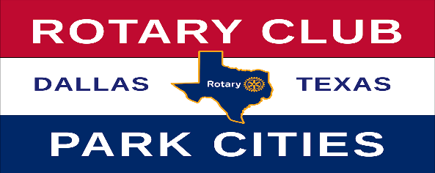
2022-2023 Nominations
Rotary Club of Park Cities Awards
AWARD | NOMINEE | COMMENT
Wilbur Hawkins
Spirt of Rotary Award
Hugh B. McAfee, Jr
Service Above Self Award
Col. Robert Q. Smith, Jr
Club Service Award
C.C. Collie
Distinguished Leadership Award
Linda Tunnell
New Member Award
Lifetime Achievement Award

Cleveland G. Clinton
Collaborative Award

Stan Wright
Community Service Award

Return To:
- Karen Farris – kfarris7238@gmail.com
- Fred Brown – fred.brown.tx@gmail.com

