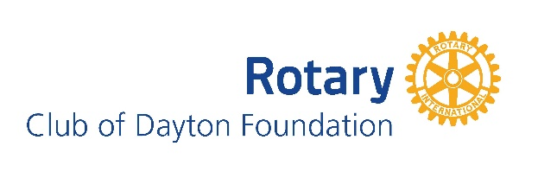
The Dayton Rotary Foundation funding priority is to support proactive and meaningful programs and activities that meet the community needs in the Greater Dayton Region.

Basic Grant information:
- Dayton Rotary Foundation Funding Focus (in the Greater Dayton Region)
- At Risk Populations
- Education Initiatives
- Arts and Culture
- Proposing organizations must be an IRS qualified 501 (c) 3 non-profit organization
- Grant awards are for $3,000 for a single-year funding cycle
- Organizations will only be awarded funding every two years
- Grant deadlines are: March 31, June 30, September 30, and December 31
- Grant applications are reviewed the month after the grant deadline
- Applicants are notified via email by Rotary Executive Director following foundation meeting

Please use this form as a template using Times New Roman, 12 pt. font

Organization Information
Organization Name:
Organization full address:
Contact Name:
Contact email:
Contact phone number:
Organization website address:
County/counties served:
Federal Tax ID:
Date of Incorporation:
Are there any Dayton Rotary Club members involved with your organization? If yes, who?

Organization Background:
Mission statement:
Brief history: (Not to exceed 250 words)

Project Information – Not to exceed two (2) pages
Project Name:
Project goal(s): (Not to exceed 250 words)
Project Description: (Not to exceed 500 words)
Need in the community being addressed: (Not to exceed 250 words)
Target audience:
Number of individuals impacted:
Timeline:
How will success be measured: (Not to exceed 250 words)
How will the project be sustained: (Not to exceed 250 words)
List top five funders for this project:

Financial Information (must include detailed income and expense)
- Project budget

Attachments:
- IRS 501 (c) 3 determination letter
- Most recent audited financial statement and/or 990
- Organization budget

