THE NOVEL - 23 Mile Ride
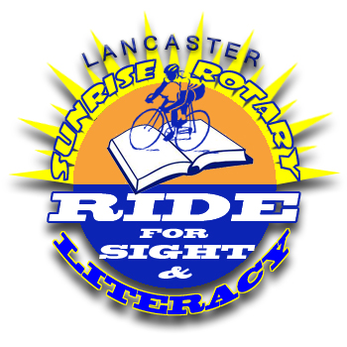
White Road Marks to water stop
Yellow Road Marks water stop to finish

On course assistance: 484-256-7992

Key: R = Right Turn L = Left Turn

Start and Finish: Manheim Township Community Park, Neffsville

Follow Yellow Arrows

Exit Front of Park from pavilion 0.0
L E. Petersburg Road
L W. Oregon Road .5
Cross Lititz Pike (Rt. 501) .7
Thru on E. Oregon Road
Cross Kissel Hill Road
Thru on E. Oregon Road
L John Landis Road 2.9
R Millport Road 3.7
R East Millport Road 4.5
R Becker Road 5.0
L Log Cabin Road 5.1
Thru on Zooks Mill Covered Bridge
L Rose Hill Road 6.5
L Cocalico Creek Road 7.0
Cross Newport Road (Rt. 772) 7.5
Thru on Cocalico Creek Road
Cross Oregon Pike (Rt. 272)
Busy Intersection! 8.3
T Lauber Road
R Old Akron Road 8.4
L Tobacco Road 8.5
R Pool Road 8.9
R W. Metzler Road 9.5
L Snyder Road 9.7
T Becomes Turtle Hill Road at
Stop sign 10.0
L W. Farmersville Road 10.5
R Locust Street 10.8
L Maple Avenue 11.0
R Center Square Road 12.3
Water Stop 122 Center Square Rd.
On the left 12.4

Follow White Arrows

Continue on Center Square Road
Cross Glen Brook Road (Rt. 772) 13.2
Busy Intersection!
Thru on Center Square Road
Cross Forest Hill Road 13.9
Thru on Center Square Road
R Quarry Road 14.8
L Stormstown Road 14.9
R Snakehill Road 15.7
L Mondale Road 15.7
R Bridge Road 15.9
Thru covered + across concrete bridge
R Creek Rd. (No road sign) 16.5
Cross Oregon Pike (Rte. 272) 16.7
T Creek Road 16.7
R E. Oregon Rd. (50 yards) 17.0
L Creek Road (not marked) 17.0
L E. Millport Road 18.5
L E. Millport Road 18.6
L John Landis 19.4
R Keen’s Road 20.1
L Kissel Hill Road 20.3
R E. Oregon Road 20.5
R Airport Road 21.3
L Fairview Drive 22.1
R Fieldcrest Drive 22.5
Cross Lititz Pike (Rt. 501) 22.7
T Bloomfield Drive
L Enter rear Manheim Township Comm. Park after shopping center on right/before Squire Rd
(Take walk/bike path on right through woods into rear of park) 23.3

