The rotary club of fort wayne


Family Membership Application
The Rotary Club of Fort Wayne’s Family Membership category offers flexibility to enable your family to serve your community - and beyond - as you reap the benefits and opportunities available through Rotary.

How Your FAmily Membership Works
- Family members: You may have one additional family member be an active member of the Rotary Club of Fort Wayne.
- Membership requirements: Rotary requires members attend 60% of weekly meetings and to be active on one “internal” and one “external” committee. These can be divided between the family members
- Initiation fees and dues: New family member pays a one-time initiation fee of $25.
  - The lead family member pays the annual dues of $360 plus the $100 donation to the Fort Wayne Rotary Foundation, for a total of $460 in annual dues.
  - The other family member pays Rotary International and District 6540 annual dues of $110 plus the $100 donation to the Fort Wayne Rotary Foundation, for a total of $210 in annual dues.
- Weekly meetings: Monday luncheon meetings, held at Parkview Field, begin at noon and end promptly at 1:15 p.m. Lunch cost is $10 and there is a $3 “sergeant fee” to support local charities and Rotary projects.
- For more information: Please contact Fort Wayne Rotary Secretary Jane Wilks at 260.341.1600 or fwrotarysecretary@gmail.com

About Rotary
The Rotary Club of Fort Wayne…
- Maintains the Avenue of Trees at Headwaters Park.
- Conducts yearly clean-up of river shores.
- Supports Washington School – Helped to start the Parent Teacher Association, established Early Act Leadership Development Program, work directly with students and teachers through the Study Connection and Lunch Buddy programs, and active in other events and projects.
- Created the Circle of Hope in Headwaters Park.
- Promotes world peace through Student Exchange and Youth Exchange programs.
- Serves internationally by supporting schools, literacy, and polio eradication in Togo, Africa, and elsewhere.
- Supports youth leadership through RYLA (Rotary Youth Leadership Awards) leadership weekend training camp for high school students, the annual high school speech contest, the Cleo Fox Scholarship for high school student music experiences, Rotary Youth Exchange and a scholarship award for outstanding college bound students who exemplify Rotary’s motto of “Service Above Self.”
- Is part of a national and international network of 1.2 million members who:
- Support eradication of polio globally
- Promote literacy programs globally
- Help supply clean, accessible water to third-world countries
- Promote peace efforts through greater understanding of one another at a grassroots level
- Form an international network of ethical business and community leaders who follow Rotary 4-Way Test

The rotary club of fort wayne

family Membership Application

You may have two family members as active members of the Rotary Club of Fort Wayne, with one person designated as “lead” representative. If already a member of the Rotary Club of Fort Wayne, you may skip the next two pages and go to page 4 for the family member to complete.

lead family membership representative Information
Name (first, middle, last):

Spouse (first, middle, last, if applicable):
Date of birth: | Home phone: | Mobile phone:
Home address:

City: | State: | ZIP code:
Have you been a Rotarian  before? | Club name(s): | Dates:

Employment Information
Current employer:

Title:

Employer address:

City: State: ZIP code:
Phone: E-mail:
Preferred address: Home Work

Membership information
Sponsor name:

Relationship to sponsor:

Sponsor statement: Why should this person be a part of Rotary?

Why did you decide to become a Rotarian?

areas of service interest
Please check all areas in which you are interested:
___ Audit & Finance ___ Environment
___ Cashiers & Greeters ___ Local Service
___ Celebration Dinner ___ International Service
___ Club Bulletin & Internet ___ World Affairs Conference
___ Fundraising ___ Youth Programs
___ Golf ___ The Rotary Foundation
___ House ___ History & Public Relations
___ Invocations & Music ___ Programs
___ Sergeant-At-Arms ___ Membership
X *New member done-in-a-day project [each new member class creates this!]
___ *What are your other service interests?

Signatures
By signing below you verify that you have read the application materials and agree to the terms described therein.
Signature of applicant: |  | Date:
Signature of sponsor: |  | Date:

The rotary club of fort wayne

family Membership Application

second family membership representative Information
Name (first, middle, last):

Spouse (first, middle, last, if applicable):
Date of birth: | Home phone: | Mobile phone:
Home address:

City: | State: | ZIP code:
Have you been a Rotarian  before? | Club name(s): | Dates:

Employment Information
Current employer:

Title:

Employer address:

City: State: ZIP ode:
Phone: E-mail:
Preferred address: Home Work

Membership information
Sponsor name:

Relationship to sponsor:

Sponsor statement: Why should this person be a part of Rotary?

Why did you decide to become a Rotarian?

areas of service interest
Please check all areas in which you are interested:
___ Audit & Finance ___ Environment
___ Cashiers & Greeters ___ Local Service
___ Celebration Dinner ___ International Service
___ Club Bulletin & Internet ___ World Affairs Conference
___ Fundraising ___ Youth Programs
___ Golf ___ The Rotary Foundation
___ House ___ History & Public Relations
___ Invocations & Music ___ Programs
___ Sergeant-At-Arms ___ Membership
X *New member done-in-a-day project [each new member class creates this!]
___ *What are your other service interests?

Signatures
By signing below you verify that you have read the application materials and agree to the terms described therein.
Signature of applicant: |  | Date:
Signature of sponsor: |  | Date:

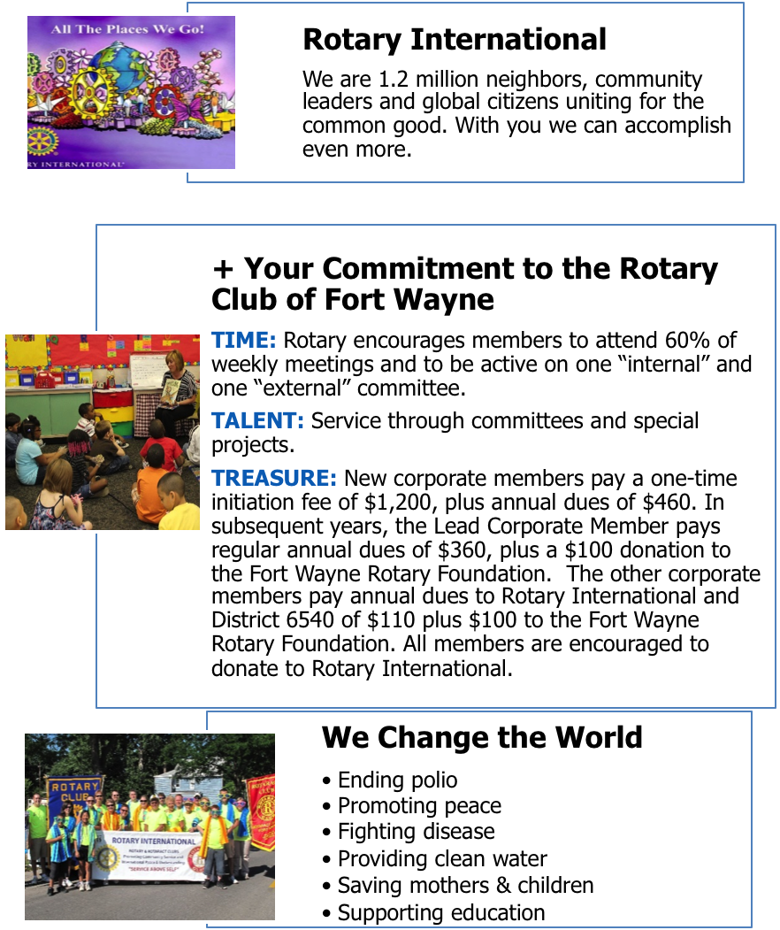

___________________________________________________________________________________________________________
CHANGING THE WORLD, CLOSE TO HOME.
Ending Polio. Providing clean water.
Promoting peace. Saving mothers and children.
Fighting disease. Supporting education.

