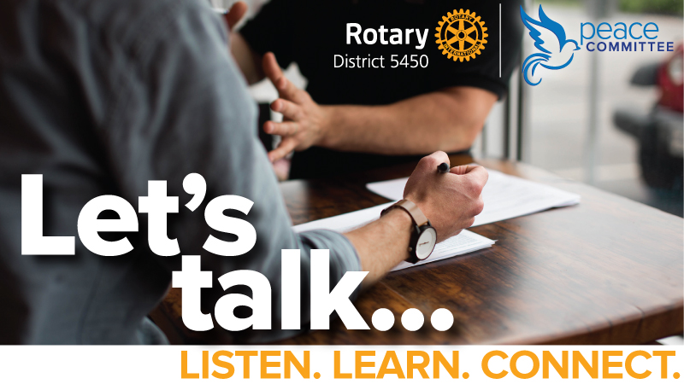

Let’s find peace and commonality in our ever-changing divided time. Please join us at the Learning to Talk Again Workshop.

Presented by Randall Butler (J.D. and CEO of the Institute for Sustainable Peach, and International Mediation Trainer), this experiential learning workshop will focus on the difficulties we face in simple conversations. We’ll have teach-ins and group exercises that cover simple principles and practices that make constructive conversations possible again.

- WHEN? Saturday, September 26, 9 am – 5 pm by ZOOM
- COST? Free. You must register (space is limited to 100)
- HOW TO REGISTER? Click HERE
- QUESTIONS? Jim Halderman, Chair, D. 5450 Peace Committee, D5450PeaceCommittee@gmail.com or (303) 564-3315

