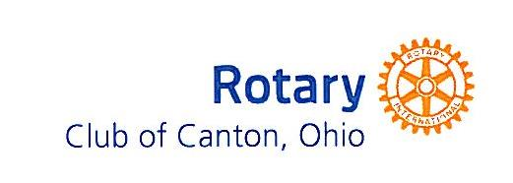
A Year in Review -What You Did Through Your Club
For the eleven months ending May 31, 2016

Fund Raiser Results: $37,566.99
-Annual Charitable Fund Contributions
-Community Contributions
-Pancake Day
-Health Screen
-Oktoberfest
-Holiday Cards
-Coffee Fundraiser
-Rotary Shirts
-Massillon Scholarship
-New Member Project-Marathon Fundraiser

Avenue of Service Projects: _$13,538.38
Rotary Foundation/International: $3,409.15
-Youth Exchange Student
-District Global Grant-Agri-eco farming-Philippines

Club Public Relations: $1,831.96
-Interact Club
-Four Way Test
-Done In A Day

Club/Community Service Projects: $8,297.27
-RYLA
-Rotary Scouts
-Crime Prevention Program
-Cystic Fibrosis Foundation Walk in honor of Tom Vignos
-Sponsored Martin Luther King Breakfast
-Pro Football Hall of Fame
-Philomatheon Annual Picnic
-Stark County District Library-Family Place Spaces-District Grant
-Salvation Army
-Light Up Downtown
-Akron-Canton Food Bank
-American Red Cross
-Operation Warm

Endowment Fund Donations: $100,000.00
-Market Square Project

Club Administration: $24,000.00

*RI Foundation Actual: $8,170.00 - *PolioPlus raised $1,658.00 this year – *includes member donations

Membership: Began the year with 165 members, Current Membership: 156 (143 active/13 honorary)
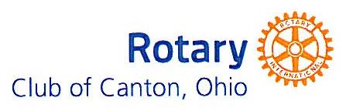
A Year in Review - What You Did Through Your Club
For The Eleven Months Ending May 31, 2016

Fund Raiser Results: $37,566.99
-Annual Charitable Fund Contributions (members) $13,980.67
-Community Contributions $ 46.00
-Pancake Day $ 6,096.75
-Health Screen $ 2,529.01
-Oktoberfest $12,944.56
-Holiday Cards $ 15.00
-Coffee Fundraiser $ 205.00
-Rotary Shirts $ 50.00
-Massillon Scholarship $ 500.00
-New Membership Project-Marathon Fundraiser $ 1,200.00

Avenue of Service Projects: $13,538.38
Rotary Foundation/International: $3,409.15
-Youth Exchange Student $3,009.15
-District Global Grant-Agri-eco farming-Philippines $ 400.00

Club Public Relations: $1,831.96
-Interact Club $ 31.96
-Four Way Test $ 300.00
-Done In A Day $1,500.00

Club/Community Service Projects: $8,297.27
-RYLA $ 650.00
-Rotary Scouts $3,245.32
-Crime Prevention Program $ 100.00
-Cystic Fibrosis Foundation Walk in honor of Tom Vignos $ 250.00
-Sponsored Martin Luther King Breakfast $ 140.00
-Pro Football Hall of Fame Tickets $ 320.00
-Philomatheon Annual Picnic $ 519.25
-Stark County District Library -Family Place Spaces--District Grant $2,500.00
-Salvation Army -bellringing $ 5.00
-Light Up Downtown $ 59.70
-Akron-Canton Food Bank $ 100.00
-American Red Cross $ 100.00
-Operation Warm $ 308.00

Endowment Fund Donations: $100,000.00
- Market Square Project $100,000.00

Club Administration: $24,000.00 ($2,000/mth)

*RI Foundation Actual: $8,170.00 *PolioPlus - $1,658.00 this year - *includes member donations

Membership: Began the year with 165 members, Current Membership: 156 (143 active/13 honorary)

