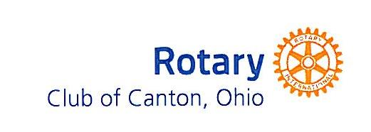
A Year in Review -What You Did Through Your Club
For the eleven months ending June 26, 2017

Fund Raiser Results: $31,427.65
-Annual Charitable Fund Contributions
-Community Contributions
-Health Screen
-Oktoberfest
-New Member Project-Marathon Fundraiser

Avenue of Service Projects: _$35,318.49
Rotary Foundation/International: $4,131.78
-Youth Exchange Student

Club Public Relations: $3,825.00
-Interact Club
-Four Way Test
-Done In A Day
-Leadership Stark County

Club/Community Service Projects: $27,361.71
-RYLA
-Rotary Scouts
-Pro Football Hall of Fame Tickets
-Philomatheon Annual Picnic
-District Grant
-Operation Warm
-Historic McKinley Rivalry
-First Tee
-Camp Tuscazoar Foundation
-Community Hospice of Stark County
-Stark County Hunger Task Force
-Military Family Project – District 6650
-Habitat for Humanity

Endowment Fund Donations: $17,000.00
-Rotary Scouts
-Leadership Stark County
-Big Brothers Big Sisters of Summit, Medina and Stark County
-Hammer and Nails, Inc.
-Child & Adolescent Behavioral Health

Club Administration: $18,000.00

*RI Foundation Actual: $6,468.00 - *PolioPlus raised $2,155.00 this year – *includes member donations

Membership: Began the year with 156 members, Current Membership: 155 (143 active/12 honorary)
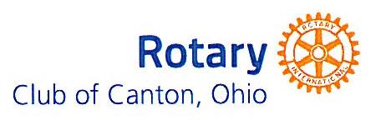
A Year in Review - What You Did Through Your Club
For The Eleven Months Ending June 26, 2017

Fund Raiser Results: $31,427.65
-Annual Charitable Fund Contributions (members) $11,396.51
-Community Contributions $ 1,425.00
-Health Screen $ 6,863.14
-Oktoberfest $ 7,953.00
-New Membership Project-Marathon Fundraiser $ 450.00
-Other $ 3,340.00

Avenue of Service Projects: $35,318.49
Rotary Foundation/International: $4,131.78
-Youth Exchange Student $4,131.78

Club Public Relations: $3,825.00
-Interact Club $ 500.00
-Four Way Test $ 325.00
-Done In A Day $1,500.00
-Leadership Stark County $1,500.00

Club/Community Service Projects: $27,361.71
-RYLA $ 700.00
-Rotary Scouts $ 617.00
-Pro Football Hall of Fame Tickets $ 160.34
-Philomatheon Annual Picnic $ 1,485.75
-District Grant $ 2,421.00
-Operation Warm $ 527.62
-Historic McKinley Rivalry $ 500.00
-First Tee $ 500.00
-Camp Tuscazoar Foundaton $ 100.00
-Community Hospice of Stark County $ 100.00
-Stark County Hunger Task Force $ 250.00
-Military Family Project – District 6650 $ 5,000.00
-Habitat for Humanity $15,000.00

Endowment Fund Donations: $17,000.00
- Rotary Scouts $2,500.00
-Leadership Stark County $2,500.00
-Big Brothers Big Sisters of Summit, Medina and Stark Counties $4,000.00
-Hammer and Nails, Inc. $4,000.00
-Child & Adolescent Behavioral Health $4,000.00

Club Administration: $18,000.00

*RI Foundation Actual: $6,468.00 *PolioPlus - $2,155.00 this year - *includes member donations
Membership: Began the year with 156 members, Current Membership: 155 (142 active/12 honorary)

