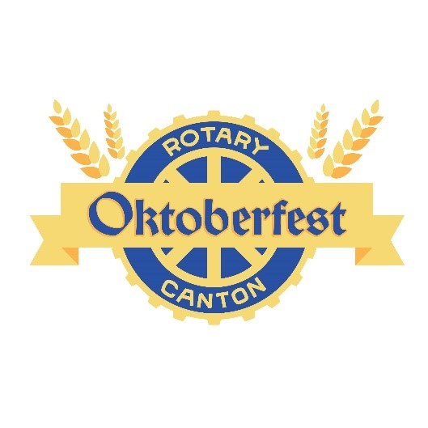
The Canton Rotary Oktoberfest is the one and only classic Oktoberfest in the City of Canton, Ohio. This unique event takes place on September 21, 2017 in the heart of Downtown Canton. The last two Canton Rotary Oktoberfest celebrations were a great success with nearly 500 people in attendance, and we look forward to an even larger Oktoberfest this year. This year we are expanding the event to the streets of Canton. Tables will line the streets to accommodate family and friends who gather for socializing while they enjoy special and unique beers.
The Oktoberfest will include beer from up to 20 local, regional, and national breweries, German style brats (prepared by our own Rotary Master Grillers!), entertainment featuring Visinata (Johnnie Maier) and Donauschwabische Blaskapelle a genuine German Oktoberfest band from Cleveland complete with dancing and singing. A surprise dignitary will appear for the traditional tapping of the Oktoberfest keg to kick off the festivities!
It’s no secret that craft beers have taken our Country by storm, and Canton is at the forefront of that movement. The Canton Rotary Oktoberfest attracts the finest and most in-demand brewers who in turn attract families and people of all ages to enjoy this fun and wholesome event.
Another important benefit of the Canton Rotary Oktoberfest is that all of the net proceeds go to support the amazing things that Rotary does for our community and throughout the world. The Rotary Club of Canton supports the following with funds raised with our Oktoberfest celebration: Summer Food Backpack Program for Canton City School students, RYLA (Rotary Youth Leadership Awards), Interact Club, Rotary Scouts, Junior Achievement, The Philomatheon Society, Habitat for Humanity ECO, American Red Cross (Canton), Cystic Fibrosis Foundation, Scholarships for Canton City School students, Stark County Public Library, Canton Symphony Orchestra, Canton Calvary Mission, First Tee of Canton, and more.
Sponsorships are available at various levels ranging from $5000 to $100 and are all listed on the attached form. Sponsors will receive recognition in various ways, including on all social media websites, event T-shirts, promotional materials, and more.

