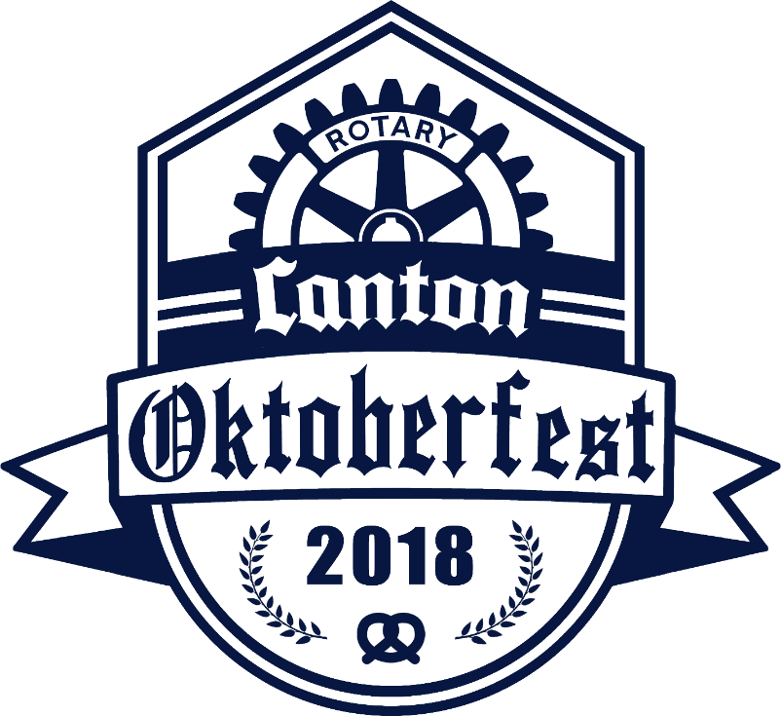
The Canton Rotary Oktoberfest is the one and only classic Oktoberfest in the City of Canton, Ohio. This unique event takes place on September 20, 2018 in the heart of Downtown Canton, and the theme this year is “Battle of the Breweries”! The last three Canton Rotary Oktoberfest celebrations were a great success with nearly 500 people in attendance, and we look forward to an even larger Oktoberfest this year. This year we are expanding the event to the streets of Canton. Tables will line the streets to accommodate family and friends who gather for socializing while they enjoy special and unique beers.
The Oktoberfest will include beer from up to 20 local, regional, and national breweries, German style brats (prepared by our own Rotary Master Grillers!), entertainment featuring Visinata (Johnnie Maier) and Oktoberfest dances by the Canton Ballet, brewery competition for the coveted Canton Rotary Oktoberfest SUPERMUG! A surprise dignitary will appear for the traditional tapping of the Oktoberfest keg!
It’s no secret that craft beers have taken our Country by storm, and Canton is at the forefront of that movement. The Canton Rotary Oktoberfest attracts the finest and most in-demand brewers who in turn attract a wide spectrum of attendees.
Another important benefit of the Canton Rotary Oktoberfest is that all of the net proceeds go to support the amazing things that Rotary does for our community and throughout the world. The Rotary Club of Canton supports the following with funds raised with our Oktoberfest celebration: Summer Food Backpack Program for Canton City School students that provided over 1800 meals over their winter and summer breaks, twice yearly community health screening and fair at Mercy, Habitat for Humanity ECO and the neighborhood revitalization project, First Tee, Military Family and First Responders Center, Rotary Scouts, Junior Achievement, The Philomatheon Society, American Red Cross (Canton), Scholarships for Canton City School students, Stark County Public Library, humanitarian projects worldwide including Polio Plus – eradication of the scourge of polio from the world, First Tee of Canton, and more.
Sponsorships are available at various levels ranging from $10,000 to $500 and are all listed on the attached form. Sponsors will receive recognition in various ways, including on all social media websites, event T-shirts, promotional materials, and more.

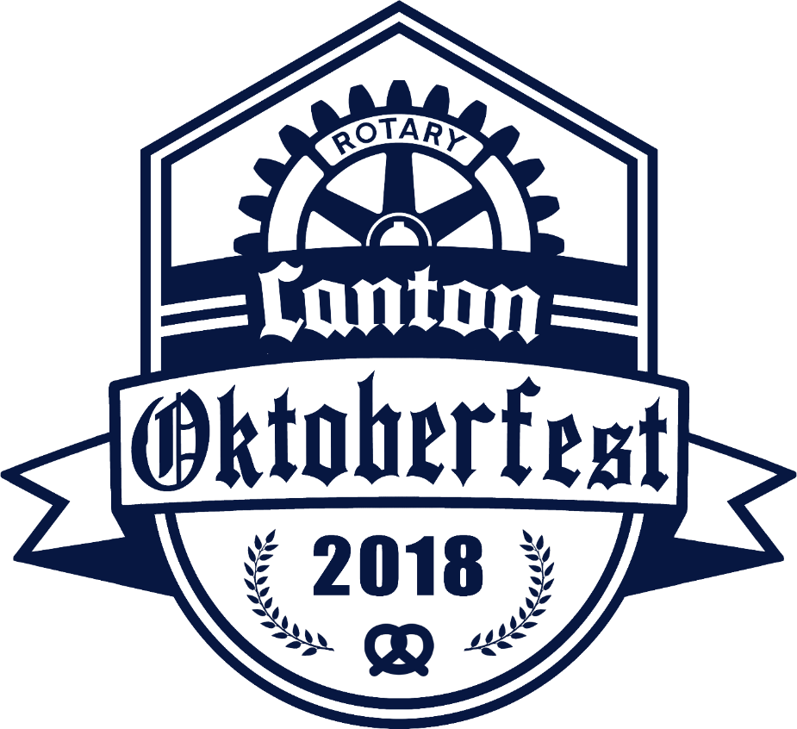
Event Sponsor: $10,000
- The Event Sponsor will receive the most exposure and recognition of all the sponsors associated with this event.
- Your organization will receive up to 20 complimentary event tickets.
- Your organization will be listed as the main sponsor of the Canton Rotary Golf outing and will have a free foursome
- Your organization will receive premium logo placement as the Event Sponsor on all promotional materials and event pieces including advertising, logo on event T-shirt and all event signage.
- Your organization will receive significant visibility on the Canton Rotary website and in all social media activities promoting this event.
- Your organization will receive a full two-year membership to the Rotary Club of Canton which includes all dues and lunch meals for two years (subject to membership rules)
- Your organization will receive logo exposure in all Oktoberfest promotions and Repository ads and radio on Q92
- Your organization will receive a complimentary interview or other exposure with Q92 radio as arranged with Don Peterson of Q92
.

$5,000 Sponsor level
- Your organization will receive 10 complimentary event tickets.
- Your organization will receive name recognition on all event signage.
- Your organization will be listed as a sponsor at the Canton Rotary golf outing and you will receive a free foursome for the outing.
- Your organization will receive visibility on the Canton Rotary website and in social media activities promoting this event including listing with logo on event T-shirt.
- Your organization will be listed on all event promotional material including radio and newspaper features on the Oktoberfest
- Your organization will receive a full one-year membership to the Rotary Club of Canton which includes all dues and lunch meals for one year (subject to membership rules)

$2,500 Sponsor level
- Your organization will receive 6 complimentary event tickets.
- Your organization will receive name recognition on the event program.
- Your organization will receive a free foursome at the Canton Rotary golf outing
- Your organization will receive visibility on the Canton Rotary website and in social media activities promoting this event. Name listing on T shirt
- Your organization will be listed in all Repository ads for the event

$500 Sponsor level
- You will receive 4 complimentary event tickets
- Listing on event signage as a sponsor
- Listing on Canton Rotary website and social media sites

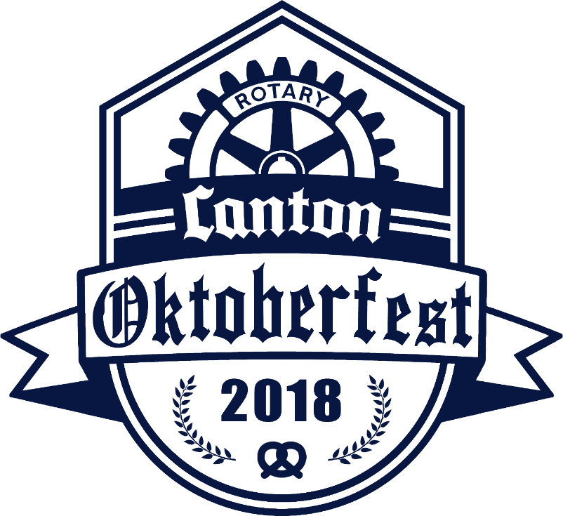

Canton Rotary OktoberFest sponsorship opportunities
____ $10, 000 Event Sponsor
____ $5,000 level Sponsor
____ $2,500 level Sponsor
____ $500 level Sponsor

Name _____________________________________________________

Name to use on sponsorship ___________________________________________

Date___________________________

Signature______________________________________________

Please fax (330-452-8614), email (info@cantonrotary.org), or call the Rotary office (330-452-2882) to confirm your sponsorship. Thank You!
The Rotary Club of Canton is a registered 501(C3) # 23-7353867

