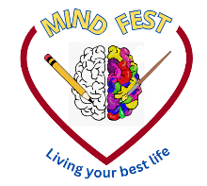

MindFest Activities List
Our Lady of the Pines Catholic Church

Please join us for interactive, hands-on activities. Fun for all ages!

Yoga will take place in Room 1 at 12:50pm with Carrie Lehtonen; otherwise, all other activities are ongoing throughout the day.

Activities include:

- Gratitude Wall

- Mood Jars

- Puzzles

- Rock Painting

- Scavenger Hunts

- Self-Esteem Bingo

- Selfie Station

- Slime station

- Tarot Card Reading

- Therapy Dough

- Yoga (12:50-1:50pm ~ Room 1)

- Zen Garden

