What is Rotary?
Rotary Club
of
Springfield South

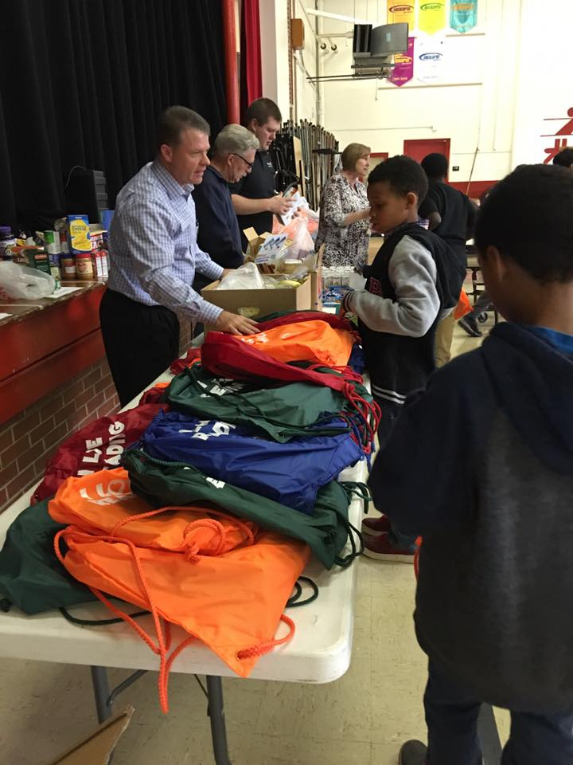

Rotary is a global humanitarian network of 1.2 million neighbors, friends, leaders, and problem-solvers who see a world where people unite and take action to create lasting change – across the globe, in our communities, and in ourselves.
Solving real problems takes real commitment and vision. For more than 110 years, Rotary's people of action have used their passion, energy, and intelligence to take action on sustainable projects. From literacy and peace to water and health, we are always working to better our world, and we stay committed to the end.
Rotary’s dedication to this ideal is best expressed in its principal motto: Service Above Self

The History of Rotary
The Rotary Club of Chicago, Illinois, USA, was the world's first service club and was formed in 1905 by attorney Paul P. Harris. The name of the new organization was derived from the fact that the original members met in rotation at their various places of business.

Today, in more than 160 countries worldwide, approximately 1.2 million Rotarians belong to more than 35,000 Rotary clubs.

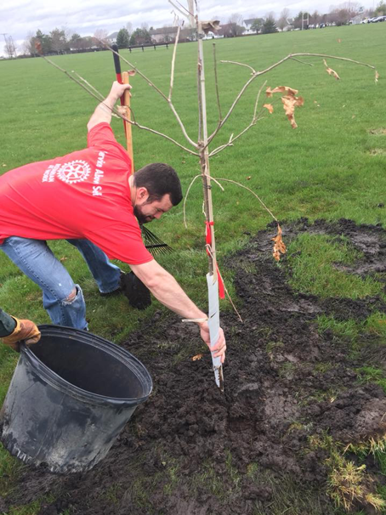

Our club planted a grove of trees at Rotary Park, which will be added to throughout the years
The Four-Way Test

This code of ethics was adopted by Rotary in 1943 and has been translated into more than a hundred languages, published in thousands of ways, and is just as applicable today as it was in 1943. It asks the following four questions:
Rotary Club
of
Springfield South

Invites you to join!

Where

“Service Above Self”

is the motto!

Of the things we think, say or do:
- Is it the TRUTH?
- Is it FAIR to all concerned?
- Will it build GOODWILL and BETTER FRIENDSHIPS?
- Will it be BENEFICIAL to all concerned?

Rotary’s International Service Achievements

An endowment fund set up by Rotarians in 1917 "for doing good in the world," became a not-for-profit corporation known as The Rotary Foundation in 1928. Today, contributions to The Rotary Foundation total more than $80 million annually.

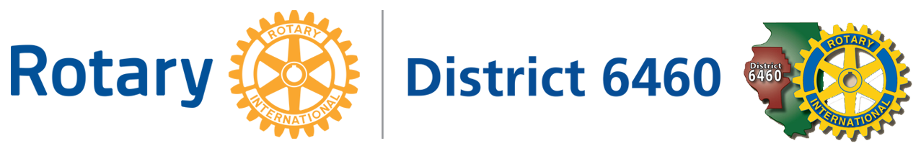
In 1985, Rotary made a historic commitment to immunize all of the world's children against polio. Working through its PolioPlus program in partnership with non-governmental organizations, national governments, and the Bill and Melinda Gates Foundation, Rotary is the largest private-sector contributor to the global polio eradication campaign. Rotarians have mobilized hundreds of thousands of PolioPlus volunteers and have immunized more than one billion children worldwide.

As a global organization that operates in nearly every country in the world, Rotary takes stewardship of its funds seriously. The Rotary International Foundation has received the highest ratings from Charity Watch (four stars) and Charity Navigator (A+).

What We DO
- Award club grants to numerous charitable organizations. Funds are raised through citrus sales, Wreaths Across America program, and trivia nights. Since the late 1980’s, our club has distributed more than $500,000 to charity!
- Prepare meals for Ronald McDonald House
- Ring bells for Salvation Army
- Deliver “Daily Bread” meals weekly through Senior Services of Central Illinois
- Provide sweatshirts to students at Douglas Alternative School
- Distribute books for Reading is Fundamental
- Participate in Rotary International Youth Exchange Program
- Collect items for St. John’s Breadline, Kumler Ministries, and Sojourn Shelter
- Sponsor Pawnee High School Interact Club
- Visit interesting places through our “Rotary on the Road” program
- Enjoy holiday get-together’s and after-hours socials
- Endow the Karen and Kelly Grant Scholarship, which is awarded annually to a student at Lincoln Land Community College

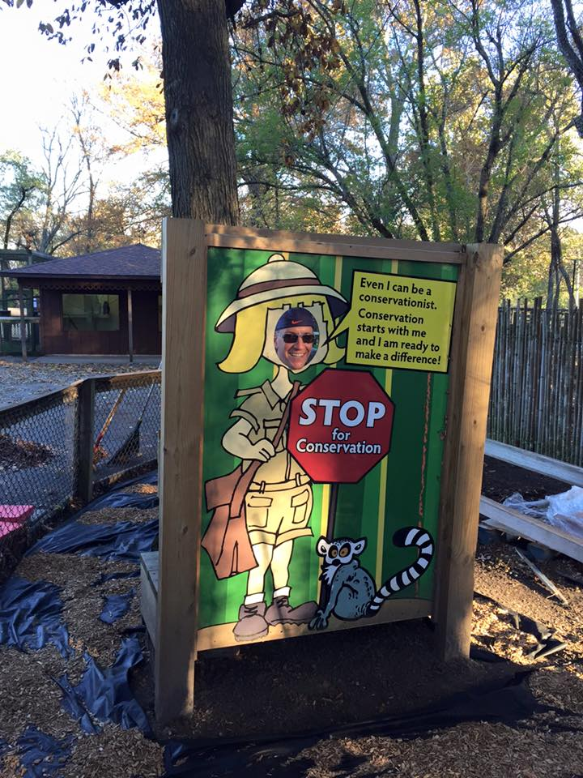
Rotary South renovated the
Conservation area at Henson Robinson Zoo.
We are always open to working on new projects that benefit our community.

Rotary South Meetings
Rotary is a great way to network, make connections, and meet new people!

You’ll find business and social connections as well as stimulating conversations at our lunch meetings. We have a diverse club membership including people involved in a variety of businesses and non-profit organizations, young professionals and retirees.

If you are looking for a place to be plugged into what's going on in Springfield, have friendly conversation, hear stimulating speakers on interesting topics of the day, and to have an opportunity to make a difference both in your community and globally, Rotary South is the place for you!

Please visit Rotary South as our guest. Meetings are held at noon each Thursday, and we encourage you to come and join us at a meeting.

Our club is very sensitive to the time commitments of our members and wants you to know that attendance at Rotary meetings and service projects is intended to keep us focused on the Rotary ideals and to foster a strong and active club. Your participation is important.

Communications
- A weekly e-bulletin prepared by the Club President is sent to each member.
- The Rotarian Magazine is mailed monthly from Rotary International

Visit the Rotary South website at http://www.rotarysouth-spi.org

Rotary Club of Springfield South (Illinois)

8-2018

5

Rotary Membership Benefits
Rotary provides you the opportunity to:
- Become connected to your community and work with others in addressing local needs.
- Make new friends and connections through our social events.
- Develop leadership skills through experience on a variety of committees and by serving on the Board of Directors.
- Participate in Rotary International’s humanitarian service efforts.
- Establish contacts with an international global network.
- Involve your family & friends in service projects.
- And have fun while you’re at it!

Springfield South Rotary

at a Glance:

Meetings are Thursdays from 11:45 to 1 PM
MCL Cafeteria
2151 Wabash Avenue
Springfield, IL 62704

Dues $50 per quarter
Weekly meals: Paid to MCL

For more information, contact our
Membership Chairman Adam Reiss
at rizzokimball@yahoo.com
or (217)390-0530

To find out more about Rotary International visit
Rotary.org

