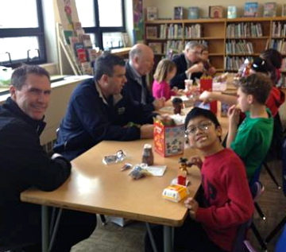
Please help recognize an
outstanding child’s achievement
at Lunch Bunch!

Lunch Bunch is scheduled for these Fridays in the 2015-16 school year:
- Sept. 18  - Oct. 16  - Nov. 20  - Dec. 11  - Jan. 22 | - Feb. 19  - Mar. 25  - April 15  - May 20

Lunch Bunch takes place at Avondale West Elementary School (on S.W. Burlingame Road, between 32nd and 33rd St.) Volunteers should be there about 11:20 a.m. with a Happy Meal from McDonald’s (either for a boy or girl). Lunch is over at noon.
Rotary volunteers share lunch with a K-5th grade child and read a brief memo from the child’s class explaining why he or she was selected as the outstanding student for the month. You then give the memo to the child to take home and share with their family. The child also receives an age-appropriate book as a gift from TSR.
According to the principal of Avondale West, “The students really look forward to Lunch Bunch! (They) are excited to continue the partnership (with TSR)!”

Give it a try! Volunteer next month or contact me for more information.

Doug Barrington, Lunch Bunch Coordinator
608-3248 or doug.barrington@washburn.edu

