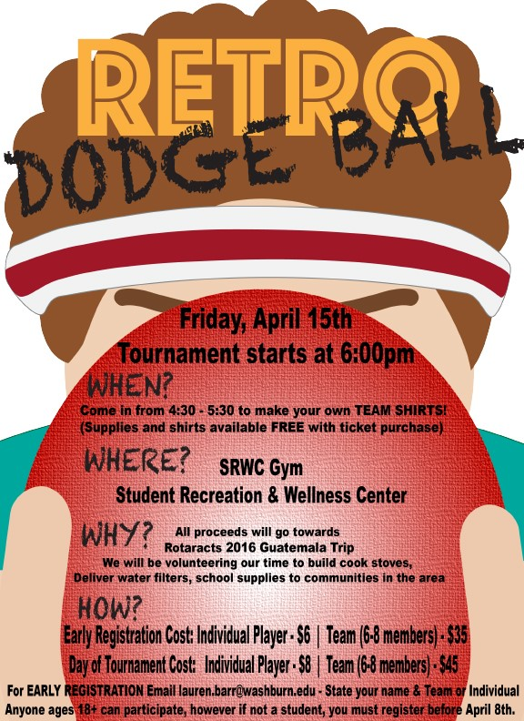
Sponsorships available:
$150 for logo on club shirts & $50 for logo on pamphlets at event
Email: lauren.barr@washburn.edu
Please send picture of the logo you want used and whether you would like it on a shirt or pamphlet.

