Daniel K. Long, Sr.
I am a 4th generation Plano Texan and to this day call Plano my home.
I am married to a wonderful woman that puts up with my Rotary club, district and service work. I have 5 kids, she has 2 kids & 4 step-children, and together we have/had a total of 11 kids, 20 grand-kids & 5 great-grand-kids.
I worked as the Plant Facility Engineer for a large company that built eighteen wheelers, and military ground support equipment. I was their military liaison to the Pentagon as the Transportation Officer, and was a member of the Air Force for over seven years.
I started working for a Bio Medical Equipment Company in New Jersey as their Sr. Field Service Engineer and worked in forty states and in many other counties like Mexico, Germany, Taiwan, India, England, Chile, Argentina, Colombia and Australia. I was honored to meet Dr. Jonas Salk at the Salk Institute of Biological Studies in 1994, I taught fermentation technology in two of his classes.
I joined the Global Network for Blood Donations (RAG group GNBD). In Rotary year 2015-2016 I was inducted into the “Fresenius Kabi Donation Hall of Fame” as Mr. February 2016 and their quote was; “Daniel works hard to share the message of the need for blood donors. In doing so, exemplifies the Rotary International motto of “Service Above Self”
I am now a member of North Texas Pioneers Rotary Club, were I am the President & a board member on our 501©c Foundation. I am very happy to have a certificate of Graduation from the Rotary International Leadership Institute (RILI) class #21. And the class #2 of Rotary University.
With my Rotary work my wife and I have had the opportunity to attending four (4) Rotary International Conventions.
Some of my past years of work & training. Facility Engineer, Industrial Master Electrician, Industrial Safety Management Trained, Emergency Management Resources Trained, C.E.R.T. Safety training, Citizens Police Academy, Red Cross First Aid trained, Rotary Grant training 3 years, Boy Scouts of America, Texas CPS & Texas Family Services.
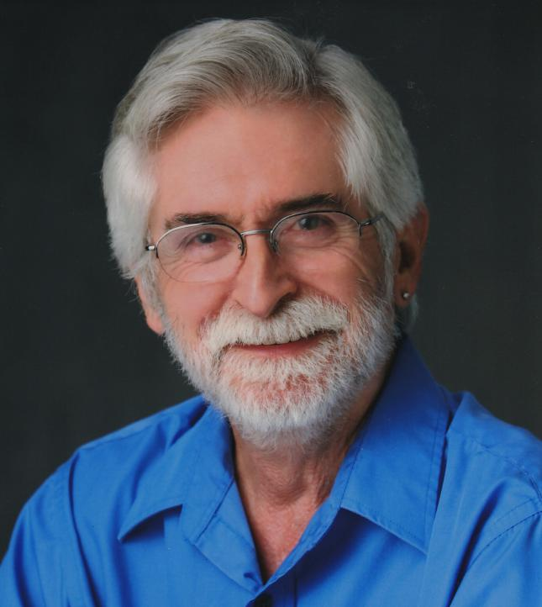
Daniel K. Long, Sr. - Rotary5810YPO@gmail.com - 214-607-7597

