JULY
July 12 – 50th Anniversary!! Party in the Park! Everyone Welcome
July 15 – Board Meeting – 0845, Ute Room – Zoom All Welcome
July 16 – Happy Hour - Timberline Craft Kitchen Patio 4:00 to 7:00 – Note extended hours to accommodate folks who work! Join us for fellowship and fun!
July 20 – Rotary night at the theatre, happy hour with Chris and Tina before – MORE TO FOLLOW
July 22 – Donor Money discussion – Ute Room and Zoom
July 29 – Membership Meeting following Rotary – 8:45 – 10:00 Hobby Room & Zoom All welcome!
July 31 – Resource Palooza – Senior Center, 4pm – 6pm
AUGUST
August 02 – Copper Triangle – 10 Course Marshalls start at 0630! See WENDY OR CATHERYN CARLSON
August 06 9:00 – 1:00 FDRD – field Project Barbed Wire Fence Removal Blue River State Wildlife Area INTEREST?????
SEPTEMBER
September 20 – Car Raffle Drawing
September 20 – Rotary 50th Anniversary Gala – Senior Center – More to follow

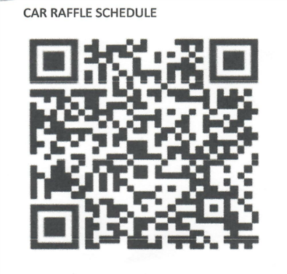
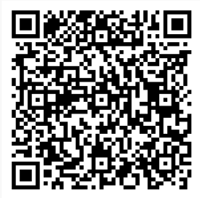
FDRD Sign up Car Raffle Sign Up

