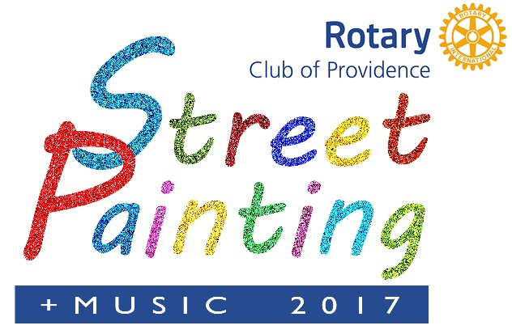
A High Profile, Fun Event that Advances and Supports A Great Cause Saturday, October 14, 2017 ALEX AND ANI City Center Downtown Providence

SPONSORSHIP FORM “Making A Difference” is the theme of this year’s festival. The Providence Rotary Street Painting Festival is an opportunity for leading corporate citizens to gain recognition for making significant contributions to the community. SPONSORSHIP OPPORTUNITIES: Sponsor Level benefits are shown on the reverse side. The DEADLINE for inclusion in ALL PRINT & MARKETING opportunities for levels $1,500 and above is September 5, 2017 and October 1, 2017 for a Sponsors name to appear in festival material on the day of the event. All logos need to be high resolution in quality. *Sponsors wishing to sponsor an artist MUST provide the following information: Name of Artist of Organization: ___________________________ Contact: _____________________ Email: ___________________________________ Phone Number: _________________________________
Proceeds from the festival benefit the Providence Rotary Charities Foundation, a non-profit 501(c)(3) organization. The Foundation provides grants each year to organizations that enrich the lives of underprivileged children in and around Providence. Consequently, there will be no refunds should the event not occur due to any Act of God or complications due to rain and other acts of nature. All donations are tax deductible to the fullest extent of the law.
