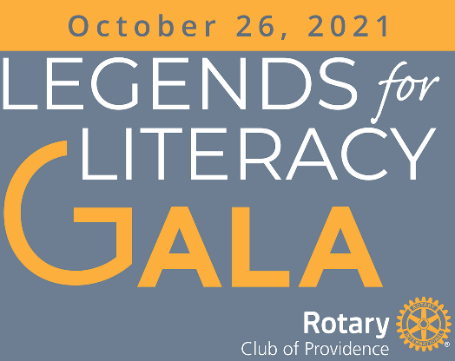
SPONSOR REGISTRATION
(Fill in on computer, save, print and mail)

Organization Click or tap here to enter text.
Contact Click or tap here to enter text.
Address Click or tap here to enter text.
City Click or tap here to enter text. State Click or tap here to enter text. ZIP Click or tap here to enter text.
Phone Click or tap here to enter text. Email Click or tap here to enter text.

Check one to select your Sponsor Level
☐ Super Bowl $5,000 ☐ Conference $2,500
☐ Division $1,500 ☐ Game $500

Payment Information:
Check for $Click or tap here to enter text. enclosed, payable to Providence Rotary Charities Foundation.

Mail to Providence Rotary Charities Foundation, P. O. Box 90, Barrington, RI 02806

