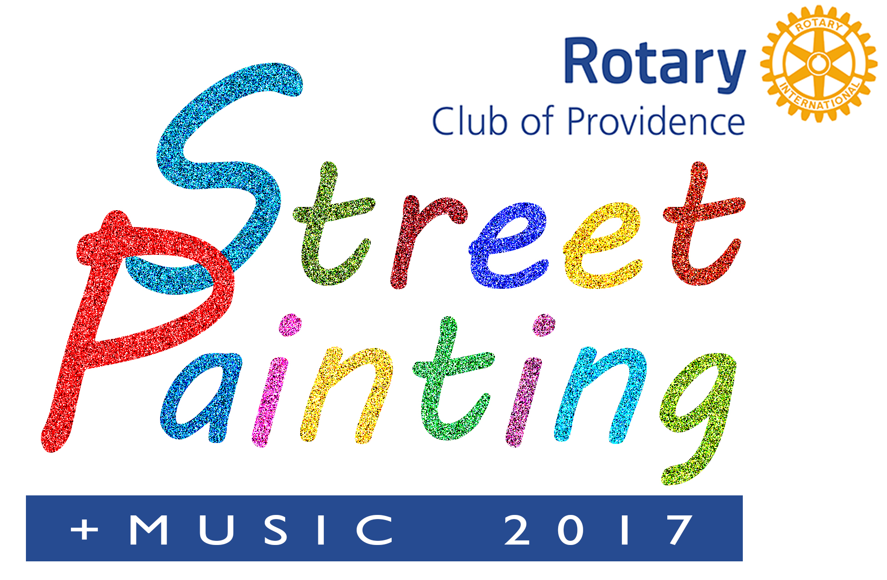

BACKGROUND AND HISTORY
Welcome to the Providence Rotary Street Painting Festival 2017.
The Rotary Club of Providence began organizing the event in the early 2000’s. Members of the Rotary Club of Providence volunteer all year to prepare for the annual Street Painting Festival. The festival has come to attract visitors each year from the New England Area. This is a Family Friendly event with a young artist area for children, music, and food.

Who benefits from the Festival?
Over the past 18 years this signature event has raised close to $300,000. All proceeds from the Street Painting Festival benefit the Providence Rotary Charities Foundation, which makes grants each year to organizations that enrich the lives of underserved children in and around Providence.
We the volunteers work to put on the Festival, but there would be no festival without you. You the artists are the stars of this show.
The people come to see you, and that is what this event is all about. It’s about the creative process. It’s about the artistic merit and value of creating a painting. And it’s about the spectators becoming a part of your creative process. In truth, it’s all about you.
You make it happen.

Who can become an Artist?
Artists starting from age 12 are welcomed. Sign up to be an artist in one of the age groups on the Artists Registration form.
The fee to register as an individual or a group is $25.00. Organizations and Corporations sponsoring the event may name a group or artist as part of their sponsorship. Scholarships are available for schools who would like to have a team of artists participate in the event.

When is the Event? The Providence Rotary Street Painting Festival is Saturday, October 14, 2017 at the ALEX AND ANI City Center in downtown Providence. Artist should arrive no later than 10:15 AM. All works should be completed by 4 PM to be judged for a festival prize.

Contact Information:
.
For More Information on how to become an artist contact email Mary Cullen at provrotaryartists@gmail.com
Learn more about the Providence Rotary Club at www.providencerotary.org The Rotary Club’s Charities Foundation is a 501 c) (3) organization.

