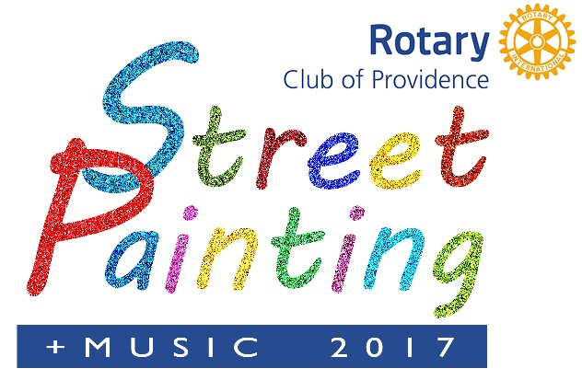
A High Profile, Fun Event that Advances and Supports A Great Cause Saturday, October 14, 2017 ALEX AND ANI City Center Downtown Providence

ARTIST REGISTRATION FORM “Making A Difference” is the theme of this year’s festival. The Providence Rotary Street Reserve Early • Spaces are Limited • Artist Registration Fee $25 is Non Refundable Applications Close Saturday, October 1, 2017
PLEASE PRINT CLEARLY! Accurate Information is essential when we award prizes! The team’s age category is the age of the oldest member. Complete ONE application per SQUARE.
Name: __________________________________________
Street: ____________________________________________
Address: _________________________________________ City: ____________________ State: _____Zip:_________ Phone Number ________________ *required in case of event cancellation Email:_________________________________________________
*Name of School (If you are part of a school team)_______________________
*Sponsor Name if you are being sponsored by an event sponsor________________ *Name of other artists if part of a group (use back of form) _________
Category (check one) ____13-15 ____ 16-18 ____ 19-25 ____Over 25 Preferred square size: 1st Choice (check one): 4x4 ___ 8x8 ____ 2nd Choice (check one): 4x4 ___ 8x8 ___
The undersigned acknowledges that all art must conform to Festival Standards. The Rotary Club of Providence and Providence Rotary Street Painting Festival reserve the right to all images for use in promotion and marketing. If under 18 Parents or Guardian Signature.
Signature: _______________________ Date:___________________________ Mail completed form with your $25 fee (checks made payable to the Providence Rotary Charities Foundation) to: Artists, Providence Rotary Street Painting Festival, 27 Dryden Lane, Providence, RI 02904. Proceeds from the festival benefit the Providence Rotary Charities Foundation, a non-profit 501(c)(3) organization. NO REFUNDS should the event not occur due to any Act of God or complications due to rain and other acts of nature. All donations are tax deductible to the fullest extent of the law.

