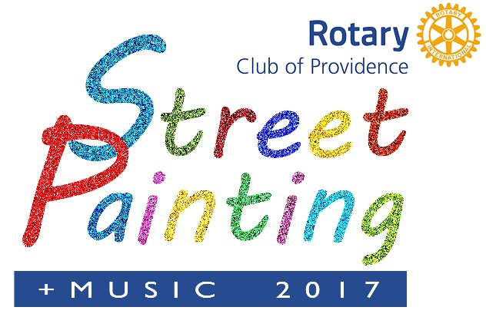
A High Profile, Fun Event that Advances and Supports A Great Cause Saturday, October 14, 2017 ALEX AND ANI City Center Downtown Providence

SPONSORSHIP FORM “Making A Difference” is the theme of this year’s festival. The Providence Rotary Street Painting Festival is an opportunity for leading corporate citizens to gain recognition for making significant contributions to the community. Sponsors wishing to sponsor an artist MUST provide the following information:
Name of Artist of Organization: ___________________________ Contact: _____________________
Email: ___________________________________ Phone Number: ___________________________
Proceeds from the festival benefit the Providence Rotary Charities Foundation, a non-profit 501(c)(3) organization. The Foundation provides grants each year to organizations that enrich the lives of underprivileged children in and around Providence. Consequently, there will be no refunds should the event not occur due to any Act of God or complications due to rain and other acts of nature. All donations are tax deductible to the fullest extent of the law.
__ Yes, we are thrilled to support the 2017 Providence Rotary Street Painting Festival.
__ No, we are not able to participate, but have enclosed a donation
Company/Organization Name __________________________________________________
Contact Name ________________________________ Title __________________________
Address ____________________________________________________________________
City _________________________________ State _____ ZIP ________________________
Phone _____________________ Email __________________________________________
Sponsorship Level:
__Michelangelo $3,000 __Rembrandt $1,500 __Picasso $1,000 __Van Gogh $500 __Renoir $250
Please make your check payable to Providence Rotary Charities Foundation and mail to
Providence Rotary Street Painting Festival, 27 Dryden Lane, Providence, RI 02904
Or charge by credit card online at www.ProvidenceRotary.org
Please submit this form by email to kd7950@gmail.com

