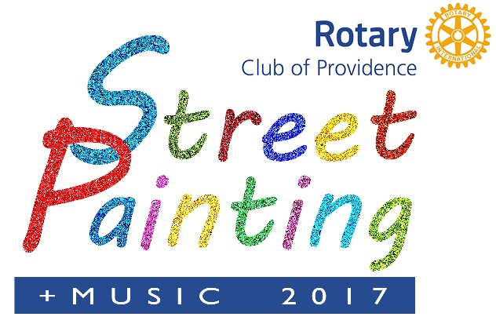 Sponsorship Opportunities
Organizations that sponsor the Providence Rotary Street Painting Festival get their names prominently associated with a premiere event that entertains families and supports the arts. Their sponsorship donations benefit the Providence Rotary Charities Foundation, supporting dozens of local nonprofits serving children in the Providence area.
Sponsorship Level
Sponsor Benefit | Michelangelo  $3,000 | Rembrandt  $1,500 | Picasso  $1,000 | Van Gogh  $500 | Renoir  $250
Designation as Presenting Sponsor. Most prominent logo on all event materials; link to your web site | 
Company mentioned as Presenting Sponsor at Award Ceremony | 
Recognition as Presenting Sponsor on festival banner | 
10x10 booth space at the Festival |  | 
VIP passes to Providence Rotary Paint-off 12/7/17* | 4 | 2
Logo on all event materials; link to your web site |  |  | 
Space to display your company banner at festival |  |  | 
Online ‘thank you’ |  |  |  | 
Recognition on sponsor banner at the festival |  |  |  | 
Provide your own artist (entry fee waived) |  |  |  |  | 

*The Providence Rotary Paint-off presents noted local artists creating new works as attendees watch, followed by a live auction where you can “Buy before the paint is dry!”

