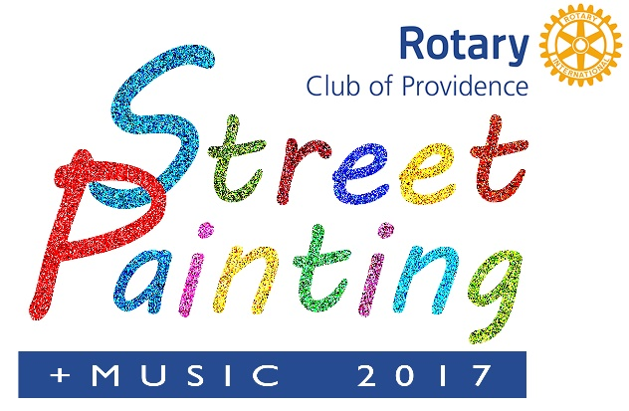
What is the Providence Rotary Street Painting Festival?
Welcome to the Providence Street Painting Festival 2017. Members of the Rotary Club of Providence began organizing this annual festival in the early 2000’s. The festival has come to attract visitors each year from across the New England Area, Canada and other parts of the United States.
It’s a full day of fun, artistic expression and art appreciation as hundreds of artists of all ages create imaginative chalk ‘paintings’ on the skating rink floor in Downtown Providence. Each artist is assigned a space as his or her ‘canvas’ and supplied with artist grade pastel chalk. Visitors watch in amazement as the blank surfaces come to life with a huge variety of beautifully detailed images. Family and friends of the artists as well as everyone attending the festival can vote for “People’s Choice” awards by purchasing $1 tokens from Rotary volunteers and placing them in containers next to the paintings they like best. In addition, cash prizes are awarded to the best ‘paintings’ as determined by a panel of judges.
The Providence Rotary Street Painting Festival is an opportunity for amateur and professional artists to display and gain recognition for their talents and for thousands of Providence area residents to view and enjoy their work on a beautiful autumn day.
In addition to Street Painting, this year’s family fun festival plans include live music by local schools and a children’s area for young artists to learn how to create their own street art.
What do festival sponsors get? Organizations that sponsor the Providence Rotary Street Painting Festival get their names prominently associated with a premiere event that attracts families, supports the arts, and benefits one of the city’s most worthwhile charities. As an annual event that’s growing in popularity, it’s also an opportunity for leading corporate citizens to make and be recognized for making significant contributions to the community. Sponsoring companies also get a great selection of promotional opportunities listed under Sponsor Benefits.
Who benefits from the festival?
Proceeds from the festival benefit the Providence Rotary Charities Foundation, a 501(c)(3) organization. The Foundation makes grants each year to organizations that enrich the lives of underprivileged children in and around Providence. Thousands of inner city kids benefit from programs supported by the Foundation. (see http://providencerotary.org/SitePage/foundation/2017-grant-recipients). The Foundation is the philanthropic arm of the Rotary Club of Providence, one of the area’s oldest and largest service organizations.

PROVIDENCE ROTARY CLUB STREET PAINTING FESTIVAL 2017
SPONSOR BENEFITS AT A GLANCE

Michelangelo ($3,000):
*Designation as a Premiere Sponsor.
*Most prominent logo on all event materials, including signage, social media posts, festival material, print advertising & festival website with a link to your company website.
*Company mentioned as premiere sponsor at award ceremony.
*Name Recognition as a premier sponsor on prominently displayed festival banner.
*10’x10’ booth space the day of the Festival to promote your company.
*Opportunity to display your company banner the day of the festival.
*Ability to provide your own artist.
*4 VIP passes to the Providence Rotary Paint Off on December 7, 2017 at the Dryden Gallery, Providence, RI.
*Online Thank You

Rembrandt ($1,500)
*Logo on all event materials, including signage media posts & festival website with a link to your company website.
*10’x10’ booth space the day of the Festival to promote your company.
*Opportunity to display your company banner the day of the festival.
*Name recognition on sponsor material at the festival.
*Ability to provide your own artist.
*2 VIP passes to the Providence Rotary Paint Off on December 7, 2017 at the Dryden Gallery, Providence, RI.
*Online Thank You.

Picasso ($1,000)
*Logo on all event materials, & festival website with a link to your company website.
*Opportunity to display your company banner the day of the festival.
*Name recognition on sponsor material at the festival
*Ability to provide your own artist.
*Online Thank.

Van Gogh ($500)
*Name recognition on sponsor material at the festival.
*Ability to provide your own artist.
*Online Thank you on social media posts.

Renoir ($250)
*Ability to provide your own artist

Deadlines for acknowledgement in media and printed advertising material is September 5, 2017 for sponsorships of $1,500 and up. All logos must be print ready and received by the deadline.
Deadline for Sponsor name to appear in the festival material is October 1, 2017. Location of company banners to be displayed on the day of the festival will be determined by the festival organizers. Company banners should be given to the organizers the week before the event.

The Providence Rotary Street Painting Festival is not responsible for complications due to rain and other acts of nature that could occur to cancel the event. There are No Refunds. The Providence Rotary Charities Foundation is a 501(c)(3) organization. All donations are tax deductible to the fullest extent of the law.

Contact Information:
Email: secretary@ProvidenceRotary.org
Mail: 27 Dryden Lane, Providence, RI 02904
Web site: www. providencerotary.org
Social Media: Follow us on Facebook and Instegram

