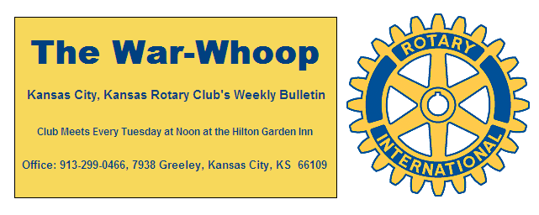
Websites: Club: www.rotarydowntownkck.org, District: www.rotary5710.org, International: www.rotary.org

Volume 76 June 19, 2015 No. 49
PROPOSE A NEW MEMBER IN 2014-15

LAST WEEK AT ROTARY- Bob Berkebile, lead architect for the KCI Airport gave a most interesting presentation on the project. He gave a history on the concept of the original airport and some of the reasons for a new airport. When he asked the members if they supported a new airport, there was a divided opinion. A quick glance of members holding up their hands it would seem that members still favored the old airport. He told members that pilots were having difficulty in landing at the airport. The old airport was built with and open concept, but after 9/11 security became a high priority for the safety of passengers. He went on to say that there were fifty proposals for a new airport. He also touched on the problem of transportation to and from the airport and again emphasized the security of the building. He took time for one or two questions.

President Ken opened the meeting and Hank Chamberlain gave the invocation. Merle Parks led the singing and Bill Strumillo introduced the visitors.

NEW MEMBER INTRODUCED- President Ken introduced Kelsy Allison for the third time and presented with the booklet “ABC’s of Rotary. Kelsy’s classification will be Law-Worker’s Compensation. Please welcome Kelsy when you meet her next week.

HEALTH REPORT- Our report is that Art Collins is doing well at home after having recent stent replacement.

PROGRAM NEXT WEEK-The program next week will be the annual Installation Dinner for Hank Chamberlain. The event and dinner will be held in the McCarthy Gallery at Jack Reardon Center. The menu for the evening will consist of Petit Bacon wrapped Fillet or Broiled Salmon w/lemon wedge and medley of fresh seasonal veggies and Baked Potato w/ sour cream, butter and chives. Dessert will consist of carrot or chocolate cake. The social hour will begin at 5:30pm followed by dinner at 6:30pm. There will be a cash bar. Cost for the evening will be $49.00 per couple. The cost for the dinner will be $18.00 per person. Reservations for the dinner should be made by Friday, June 19th at noon. Please call secretary Jim Knight at 913.299.0466 by noon on Friday with your reservation and choice of entrée. Don’t miss out on this fun event
Members are encouraged to bring door prizes for our drawings that evening.

PAUL HARRIS DRAWING- Secretary Jim won the right to draw the joker last Tuesday. Jim did not draw the joker and the amount will go to $67.00 for next week. Greg Shondell was presented his check for $41.00 for winning the drawing several weeks ago.

T-BONES BASEBALL GAME- Chairman Dan Duncan passed around a signup sheet for the T-Bones baseball game on Tuesday, July 7th. Tailgating starts at 6:00 and game begins at 7:00pm. The cost for the event cost $10.00 per ticket and includes the Tailgating Party prior to the game and the game. The night is a family event so sign up now as we have only 50 tickets.

PROGRAM CHAIRPERSONS NEEDED- Program chairman Fred Zimmerman is in need for chairpersons for August, November, January and February. Please contact Fred.

PAUL HARRIS AWARD- President Ken presented Phil Gibbs with his Paul Harris Award. The Paul Harris Award is given to members for their contribution of $1,000 to the Rotary Foundation
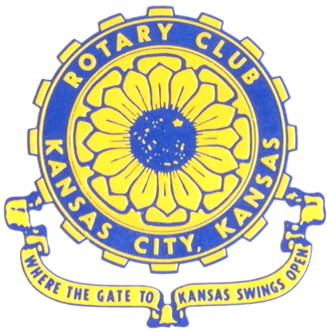
Where the Gate to Kansas Swings Open
The Kansas City, Kansas Rotary Club was organized on November 2, 1915 and received its charter as Club No. 195 in January 1916. Its members take pride in more than 90 years of Rotary service to the community and to international fellowship. From this Club have come five District Governors and two Directors of Rotary International. The Club’s history is as rich as that of the community it represents.

Following the Lewis and Clark expedition which camped at the confluence of the Kansas and Missouri rivers on June 26, 1804, in present day Kansas City, Kansas, this area became an important center for fur trappers. In the following years, many Indian tribes were relocated here from the East. In 1842 the Wyandot Indians acquired land here and founded a town. During this period, and for the next five decades, this area became the main gateway to the inviting majesty of the sprawling Kansas Prairie and the American West. This was where the frontier began. Pioneers found river transportation, outfitters and the beginning of the Santa Fe and Oregon Trails. After the covered wagons came major trunk railroads and barge lines.

In 1886, Kansas City, Kansas received its charter as an incorporated city, combining the towns of Wyandot, Argentine and Armourdale. (Rosedale was added in 1922.) Kansas City, Kansas is the site of the first industrial park in the United States, home of the prestigious University of Kansas Medical Center, and the location of the National Agricultural Hall of Fame and the nationally recognized Kansas Speedway.

Near the geographical and population centers of the contiguous United States, it is in the temperate latitudes at an elevation of 726 feet above sea level. The average rainfall is 35 inches. The average mean temperature ranges from 30°F in January to 80°F in July. The lowest recorded temperature was -23°F on December 23, 1989, and the highest was 113°F on August 14, 1936. Our city’s population of 145,000 and 155 square miles rank it 158th among cities in the United States.

Welcome to Kansas City, Kansas Rotary, and the vibrant community it represents.

Service Above Self

Rotary Websites:
KCK Club: www.rotarydowntownkck.org, District: www.rotary5710.org, International: www.rotary.org



WHERE NEARBY TO MAKE UP ATTENDANCE
MONDAY
Bonner Springs (11:45am) --------------------------------- Twister Bar & Grill, 13100 Kansas Ave.
Overland Park (11:30am) ----------------------------------- Doubletree Hotel, 10100 College Blvd.
TUESDAY
Gladstone (7:00am) -------------------------------------- Fairview Christian Church, 1800 N.E. 65th
Johnson County-Sunset (5:15pm) ----------Hilton Garden Inn(Olathe) 12080 S Strang Lin Rd
WEDNESDAY
Overland Park South (7:15am) ------------------------ Deer Creek Country Club, 7000 W. 133rd
Leavenworth (Noon) --------------------------- Riverfront Community Center, 123 S. Esplanade
KCI, Missouri (Noon) -------------------------------- KCI Expo Center, 11730 N. Ambassador Dr.
Shawnee Mission (Noon) ----------------------------- Sylvester Powell Center, Martway & Lamar
Olathe (Noon) ------------------------------ Mahaffie/Heritage Center, 1200 E. Kansas City Road
Kansas City South, Missouri (Noon) ----------------------------- EBT, 1310 Carondolet, 2nd Floor
THURSDAY
South Platte, Missouri (7:00am) ----------------------- Trezo Mare, 4105 Mulberry Drive, KCMO
Johnson County (7:15am) --------------------------- Crowne Plaza Hotel, 12601 W. 95th, Lenexa
Leawood (7:15am) ---------------------------------------- Hereford House, Town Center Dr. & Nall
Village West (7:15am) -------------------------- Dave & Buster’s, 1843 Village West Pkwy., KCK
Gardner (7:30am) ---------------------------------------------------- Senior Citizen Bldg., 128 E. Park
Olathe Santa Fe Trail (7:30am) --- Mid-Am Nazarene U, 2030 E. College Way, Campus Ctr.
Kansas City, Missouri (Noon) -------------------------------- The Gallery, 61 E. 14th Street, KCMO
FRIDAY
Desoto (7:00am) ------------------------ Desoto United Methodist Church, 8760 Kill Creek Road
Shawnee (7:15am) --------------------------------------------------- Town Hall, 11600 Johnson Drive
Plaza, Missouri (7:15am) -------------------------------- Intercontinental Hotel, 401 Ward Parkway
North Kansas City, Missouri (Noon) ------------------------------ Finnigan’s Hall, 505 E. 18th Ave.
Parkville, Missouri (Noon) ------------------------ Park University Underground, Woodard Center
Lenexa (Noon) ------------------------------- Lakeview Village, Northpointe Bldg., 91st & Park St.

Meeting make ups can be made 14 days before or after the missed meeting.
Please see the Secretary for the world directory of all Rotary Club’s meeting times, days and places.
2014-2015 Board of Directors
Officers Directors
Ken Davis Ashley Adorante
President Rick Behrens
Hank Chamberlain Karole Bradford
Vice President Phil Gibbs
Greg Shondell Terri Porter
Treasurer Bruce Schlosser
Jim Knight Donna Severance
Secretary Mark Wiebe
Rosemary Podrebarac Fred Zimmerman
Sergeant at Arms
George Moody
Past President

