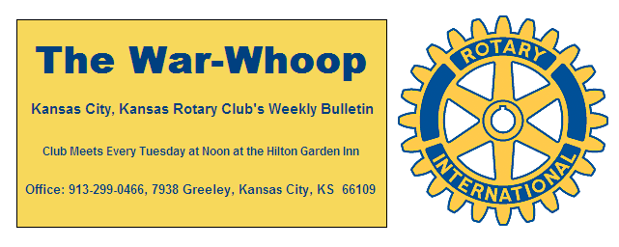
Websites: Club: www.rotarydowntownkck.org, District: www.rotary5710.org, International: www.rotary.org

Volume 77 July 3, 2015 No. 01

NO MEETING REPORT THIS WEEK- Secretary Jim was out of town with his family this week visiting their granddaughter in Wisconsin. It was 78 degrees in the day time and 60 at night.

This is the first bulletin for the new year and would like to ask members to make some resolutions for the new year. They are:
++Introduce ONE new member this coming year. The only way Rotary can grow is by YOU.
++Try to bring your attendance up to 85% this year. Our average attendance In 2014-15 was 69%.
++ Become involved in Rotary committees and activities.
++Make up when you miss a meeting. It is a great way to meet new people and make contacts that could help you in business. The Rotary meetings and places and days are printed on the back of your weekly bulletins.

INTERNATIONAL MOTTO FOR 2015-16- “ Be a Gift to the World”.

MONTHLY PROGRAM CHAIRS NEEDED- Program chairman Fred Zimmerman is still in need for chairpersons for August, November, January and February. He reminded members that they could team up and divide a month between them. Programs are important and he needs the help of ALL members. If you have an idea for a program, please contact Fred.

5th TUESDAY EVENING- Members attending the 5th Tuesday social hour this week had a great time according to reports from those in attendance.

PROGRAM NEXT WEEK – Our annual evening at the T-BONES
baseball game will be held next Tuesday evening. This is always a fun event for all members and families. This is also a great time to bring a prospective member and introduce them to our Rotary Club. Tailgating starts at 5.45 and game begins at 7:00pm. The cost for the event cost $10.00 per ticket and includes the Tailgating Party prior to the game and the game. The Rotary Tail Gating is usually held in the Northwest section of the parking lot. The night is a family event so sign up now as we have only 50 tickets.
This is also the day that the Village West has their annual event, so it will be a Rotary Night at the ball park

VACATIONING ROTARIANS- We are a little late in reporting, but several Rotarians have been on vacation both at home and abroad. Bill Mullarky and Beverly Mullarky had been in California visiting their son.
Ireland, Scotland, Whales and England were places where members visited over the last several weeks. We understand that John Bukaty, Bruce Schlosser, Greg Shondell, Karole Bradford and their spouses were in those immediate areas at the same time. They could have held a Rotary meeting if they had caught up with each other.

“THANKS” Your secretary would like to thank the following members for all their help in making 2014-15 in making a big success:
Bill Strumillo- For his help in setting up our meetings each week.
Donna Severance, Frank Simonich for their help in picking up after our meetings each week. To all others that bring the song books and attendance cards to the back desk.
Greg Shondell for his help and patience in guiding your secretary again this year in keeping the financial records straight with continuous teaching.
Terry Robinson for his help in work and patience in correcting computer errors made by the secretary and keeping the computer up to date.
Rosemary Podrebarac- For covering for the secretary when he is gone and all the behind the scenes work she does for the Club.

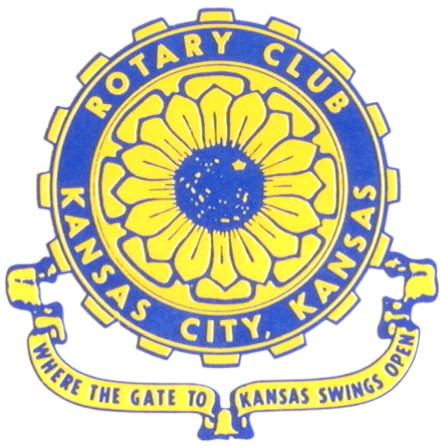
Where the Gate to Kansas Swings Open

The Kansas City, Kansas Rotary Club was organized on November 2, 1915 and received its charter as Club No. 195 in January 1916. Its members take pride in more than 90 years of Rotary service to the community and to international fellowship. From this Club have come five District Governors and two Directors of Rotary International. The Club’s history is as rich as that of the community it represents.

Following the Lewis and Clark expedition which camped at the confluence of the Kansas and Missouri rivers on June 26, 1804, in present day Kansas City, Kansas, this area became an important center for fur trappers. In the following years, many Indian tribes were relocated here from the East. In 1842 the Wyandot Indians acquired land here and founded a town. During this period, and for the next five decades, this area became the main gateway to the inviting majesty of the sprawling Kansas Prairie and the American West. This was where the frontier began. Pioneers found river transportation, outfitters and the beginning of the Santa Fe and Oregon Trails. After the covered wagons came major trunk railroads and barge lines.

In 1886, Kansas City, Kansas received its charter as an incorporated city, combining the towns of Wyandot, Argentine and Armourdale. (Rosedale was added in 1922.) Kansas City, Kansas is the site of the first industrial park in the United States, home of the prestigious University of Kansas Medical Center, and the location of the National Agricultural Hall of Fame and the nationally recognized Kansas Speedway.

Near the geographical and population centers of the contiguous United States, it is in the temperate latitudes at an elevation of 726 feet above sea level. The average rainfall is 35 inches. The average mean temperature ranges from 30°F in January to 80°F in July. The lowest recorded temperature was -23°F on December 23, 1989, and the highest was 113°F on August 14, 1936. Our city’s population of 145,000 and 155 square miles rank it 158th among cities in the United States.

Welcome to Kansas City, Kansas Rotary, and the vibrant community it represents.

Service Above Self

Rotary Websites:
KCK Club: www.rotarydowntownkck.org, District: www.rotary5710.org, International: www.rotary.org



WHERE NEARBY TO MAKE UP ATTENDANCE
MONDAY
Bonner Springs (11:45am) --------------------------------- Twister Bar & Grill, 13100 Kansas Ave.
Overland Park (11:30am) ----------------------------------- Doubletree Hotel, 10100 College Blvd.
TUESDAY
Gladstone (7:00am) -------------------------------------- Fairview Christian Church, 1800 N.E. 65th
Johnson County-Sunset (5:15pm) ------------------------------- Wil Jenny’s, 6700 W. 135th Street
WEDNESDAY
Overland Park South (7:15am) ------------------------ Deer Creek Country Club, 7000 W. 133rd
Leavenworth (Noon) --------------------------- Riverfront Community Center, 123 S. Esplanade
KCI, Missouri (Noon) -------------------------------- KCI Expo Center, 11730 N. Ambassador Dr.
Shawnee Mission (Noon) ----------------------------- Sylvester Powell Center, Martway & Lamar
Olathe (Noon) ------------------------------ Mahaffie/Heritage Center, 1200 E. Kansas City Road
Kansas City South, Missouri (Noon) ----------------------------- EBT, 1310 Carondolet, 2nd Floor
THURSDAY
South Platte, Missouri (7:00am) ----------------------- Trezo Mare, 4105 Mulberry Drive, KCMO
Johnson County (7:15am) --------------------------- Crowne Plaza Hotel, 12601 W. 95th, Lenexa
Leawood (7:15am) ---------------------------------------- Hereford House, Town Center Dr. & Nall
Village West (7:15am) -------------------------- Dave & Buster’s, 1843 Village West Pkwy., KCK
Gardner (7:30am) ---------------------------------------------------- Senior Citizen Bldg., 128 E. Park
Olathe Santa Fe Trail (7:30am) --- Mid-Am Nazarene U, 2030 E. College Way, Campus Ctr.
Kansas City, Missouri (Noon) -------------------------------- The Gallery, 61 E. 14th Street, KCMO
FRIDAY
Desoto (7:00am) ------------------------ Desoto United Methodist Church, 8760 Kill Creek Road
Shawnee (7:15am) --------------------------------------------------- Town Hall, 11600 Johnson Drive
Plaza, Missouri (7:15am) -------------------------------- Intercontinental Hotel, 401 Ward Parkway
North Kansas City, Missouri (Noon) ------------------------------ Finnigan’s Hall, 505 E. 18th Ave.
Parkville, Missouri (Noon) ------------------------ Park University Underground, Woodard Center
Lenexa (Noon) ------------------------------- Lakeview Village, Northpointe Bldg., 91st & Park St.

Meeting make ups can be made 14 days before or after the missed meeting.
Please see the Secretary for the world directory of all Rotary Club’s meeting times, days and places.

2015-2016 Board of Directors
Officers Directors
Hank Chamberlain Rick Behrens
President Karole Bradford
Ashley Adorante John Freshnock
Vice President Phil Gibbs
Greg Shondell Priscilla McInnes
Treasurer Bruce Schlosser
Jim Knight Donna Severance
Secretary Mark Wiebe
Rosemary Podrebarac Fred Zimmerman
Sergeant at Arms
Ken Davis
Past President

