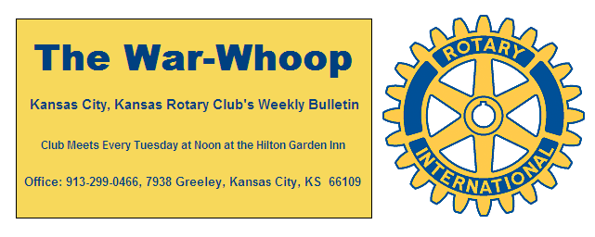
Websites: Club: www.rotarydowntownkck.org, District: www.rotary5710.org, International: www.rotary.org

Volume 77 July 24, 2015 No. 04

LAST WEEK AT ROTARY - Kathy Moore gave a dim report on this year’s legislature accomplishments. The tax plan of the Governor passed in 2012 has not been successful and has placed the state in a very difficult financial position. The legislature has passed the largest tax increases in the history of the state. She talked about the fairness of taxation. Sales taxes have been raised to 6.50% this year also. Our taxes, with local taxes, become the second highest sales tax in the nation. Her report was a good program and Rotarians had many questions for her.

President Hank opened the meeting and Merle Parks gave the invocation. Frank Simonich and Morgan Strumillo led the singing and John Freshnock introduced the visitors. Morgan is the granddaughter of Bill Strumillo and will be a senior at Louisburgh High School this fall. Lee Ann Duncan was the guest of Dan and Ashley Adorante had two of her interns, Emily and Ashley with her.

NEW MEMBER FORUM AND FOUNDATION, MEMBERSHIP, AND LEADERSHIP FORUM- Past president Ken Davis asked for a volunteer from any of the members that have been a member of our Club for one or two years to participate in a new membership forum on August 8th as a part of the Leadership Forum. Participants on the panel do not have to prepare, just sit on the panel and answer the questions that might be asked by panel director. The new member forum will be moderated by KHSB TV News Director, Elizabeth Alex. Questions will be asked of the panel in general and not on an individual basis. The date is Saturday, August 8th at Washburn University. Please contact Ken if one of the new members might be able to attend.

NEXT WEEK AT ROTARY- John Donovan, District Governor will be making the annual District Governor’s visit to our Club. All members are asked to make a special effort to be attendance at this special meeting. Governor John is a member of the Desoto Rotary Club.

Fred Zimmerman will be the program chairman for the day and for the month

PAUL HARRIS DRAWING- John Bukaty won the right to draw for the joker last Tuesday for the second week in a row.. John did not draw the joker for the second week in a row and the amount now goes to $91.00 for next week’s drawing

VOLUNTEERS STILL NEEDED- President Hank is asking for help from members for the Kaw Point Canoe Race scheduled on July 27th and 28th. This race is for several hundred boaters that will travel 340 miles to St Charles, Missouri from Kaw Point. This project will need 5 to 6 volunteers to help with the registration in the Reardon Center on Monday, July 27th from about 12:00 (noon) through 7:00pm. We will also need an additional 5 or 6 members at Kaw Point from 8:00pm to 9:30pm to control parking that evening. We need to have at least 12 or more volunteers at Kaw Point before 5:00am on Tuesday morning, July 28th for parking control and general organizational assistance. Members are asked to stay around until 8:30am following the 8:00am race start to facilitate traffic flow out of the parking lot.
The race event should provide an opportunity for Rotarians to participate in a community event. There will be coffee, soda, water and donuts for all volunteers.

OUR ROAMING ROTARIAN
Bonner Springs-----------------------------------------------Merle Parks
Shawnee Mission--------------------------------------------Bill Mullarky
Merle was the program for the Bonner Springs Club

NEW MEMBER FORUM AND FOUNDATION FORUM- The new Member and Leadership Forum is open to all members on Saturday, August 8th. There are no costs involved as luncheon is provided by the district. A great way to meet other Rotarians.

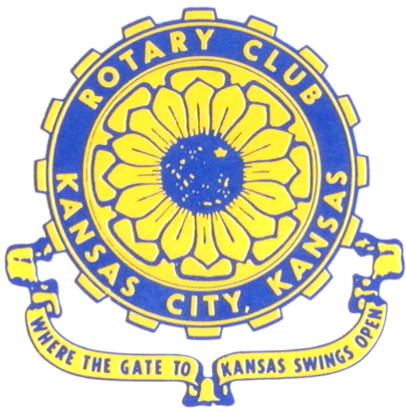
Where the Gate to Kansas Swings Open

The Kansas City, Kansas Rotary Club was organized on November 2, 1915 and received its charter as Club No. 195 in January 1916. Its members take pride in more than 90 years of Rotary service to the community and to international fellowship. From this Club have come five District Governors and two Directors of Rotary International. The Club’s history is as rich as that of the community it represents.

Following the Lewis and Clark expedition which camped at the confluence of the Kansas and Missouri rivers on June 26, 1804, in present day Kansas City, Kansas, this area became an important center for fur trappers. In the following years, many Indian tribes were relocated here from the East. In 1842 the Wyandot Indians acquired land here and founded a town. During this period, and for the next five decades, this area became the main gateway to the inviting majesty of the sprawling Kansas Prairie and the American West. This was where the frontier began. Pioneers found river transportation, outfitters and the beginning of the Santa Fe and Oregon Trails. After the covered wagons came major trunk railroads and barge lines.

In 1886, Kansas City, Kansas received its charter as an incorporated city, combining the towns of Wyandot, Argentine and Armourdale. (Rosedale was added in 1922.) Kansas City, Kansas is the site of the first industrial park in the United States, home of the prestigious University of Kansas Medical Center, and the location of the National Agricultural Hall of Fame and the nationally recognized Kansas Speedway.

Near the geographical and population centers of the contiguous United States, it is in the temperate latitudes at an elevation of 726 feet above sea level. The average rainfall is 35 inches. The average mean temperature ranges from 30°F in January to 80°F in July. The lowest recorded temperature was -23°F on December 23, 1989, and the highest was 113°F on August 14, 1936. Our city’s population of 145,000 and 155 square miles rank it 158th among cities in the United States.

Welcome to Kansas City, Kansas Rotary, and the vibrant community it represents.

Service Above Self

Rotary Websites:
KCK Club: www.rotarydowntownkck.org, District: www.rotary5710.org, International: www.rotary.org



WHERE NEARBY TO MAKE UP ATTENDANCE
MONDAY
Bonner Springs (11:45am) --------------------------------- Twister Bar & Grill, 13100 Kansas Ave.
Overland Park (11:30am) ----------------------------------- Doubletree Hotel, 10100 College Blvd.
TUESDAY
Gladstone (7:00am) -------------------------------------- Fairview Christian Church, 1800 N.E. 65th
Johnson County-Sunset (5:15pm) --------------------------------Hilton Garden Inn, 119th and I-35
WEDNESDAY
Overland Park South (7:15am) ------------------------ Deer Creek Country Club, 7000 W. 133rd
Leavenworth (Noon) --------------------------- Riverfront Community Center, 123 S. Esplanade
KCI, Missouri (Noon) -------------------------------- KCI Expo Center, 11730 N. Ambassador Dr.
Shawnee Mission (Noon) ----------------------------- Sylvester Powell Center, Martway & Lamar
Olathe (Noon) ------------------------------ Mahaffie/Heritage Center, 1200 E. Kansas City Road
Kansas City South, Missouri (Noon) ----------------------------- EBT, 1310 Carondolet, 2nd Floor
THURSDAY
South Platte, Missouri (7:00am) ----------------------- Trezo Mare, 4105 Mulberry Drive, KCMO
Johnson County (7:15am) --------------------------- Crowne Plaza Hotel, 12601 W. 95th, Lenexa
Leawood (7:15am) ---------------------------------------- Hereford House, Town Center Dr. & Nall
Village West (7:15am) -------------------------- Dave & Buster’s, 1843 Village West Pkwy., KCK
Gardner (7:30am) ---------------------------------------------------- Senior Citizen Bldg., 128 E. Park
Olathe Santa Fe Trail (7:30am) --- Mid-Am Nazarene U, 2030 E. College Way, Campus Ctr.
Kansas City, Missouri (Noon) -------------------------------- The Gallery, 61 E. 14th Street, KCMO
FRIDAY
Desoto (7:00am) ------------------------ Desoto United Methodist Church, 8760 Kill Creek Road
Shawnee (7:15am) --------------------------------------------------- Town Hall, 11600 Johnson Drive
Plaza, Missouri (7:15am) -------------------------------- Intercontinental Hotel, 401 Ward Parkway
North Kansas City, Missouri (Noon) ------------------------------ Finnigan’s Hall, 505 E. 18th Ave.
Parkville, Missouri (Noon) ------------------------ Park University Underground, Woodard Center
Lenexa (Noon) ------------------------------- Lakeview Village, Northpointe Bldg., 91st & Park St.

Meeting make ups can be made 14 days before or after the missed meeting.
Please see the Secretary for the world directory of all Rotary Club’s meeting times, days and places.

2015-2016 Board of Directors
Officers Directors
Hank Chamberlain Rick Behrens
President Karole Bradford
Ashley Adorante John Freshnock
Vice President Phil Gibbs
Greg Shondell Priscilla McInnes
Treasurer Bruce Schlosser
Jim Knight Donna Severance
Secretary Mark Wiebe
Rosemary Podrebarac Fred Zimmerman
Sergeant at Arms
Ken Davis
Past President

