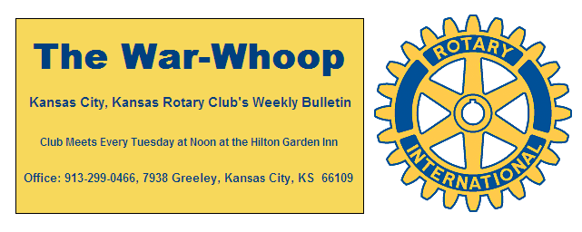
Websites: Club: www.rotarydowntownkck.org, District: www.rotary5710.org, International: www.rotary.org

Volume 77 August 28, 2015 No. 09

LAST WEEK AT ROTARY Sharon Reed and Brandy Wells, Managers for Procurement and Contract Compliance Department for the United Government talked about the purchasing policies of our local government. Purchases over $1,999.00 need the approval of department of the County Administrator. Any purchases over $50,000 are submitted for bids from companies. Any bid over $250,000 is submitted to a committee that is made up of a nine person committee. Companies submitting bids must also show that they meet the certifications of the local government. The requirement consist of local ownership, women in local businesses and minorities. Both ladies answered many questions regarding the purchasing policies for the United Government.
.
President Hank opened the meeting and Rick Behrens gave the invocation. Scott Kaufmann led the singing and John Bukaty introduced the visiting Rotarians and guests.

FIFTH TUESDAY PROGRAM-Chairman Scott Kaufmann reported that plans for the next FIFTH Tuesday event is still open. He also proposed that the Club revise the food and beverage allowance for this event and permit the purchase of beer and wine with Club funds. The consensus was that the Club consider this proposal at the next regular meeting.

PROGRAM NEXT WEEK- Member Sarah Antrobus will present on “ What’s happening at UMB?”- including building renovations and exciting new developments at UMB.

Karole Bradford will be the program chair for the day and for the month.

UNITED WAY GOLF TOURNAMENT- The Wyandotte County United Way will hold a Campaign Kick-Off, Tee-Off on Thursday, September 10th at the Painted Hills Golf Course. Wendell Maddox would like to welcome all Rotary golfers to the tournament. Visit www.UNITEDWAY-WYCO.ORG or call 913-371-1507 to register.

ROTARY HISTORY 50 YEARS AGO- Rotarian Harry West was installed as the 50th president of the Kansas City, Kansas Rotary Club at the Town House. The date was July 6, 1965. President West presented a 5-point program he intends to carry out during his year. A special, surprise memento of the day, a special edition of the Kansan, which contains the history of the club, lists of charter members, presidents and secretaries, was passed out to all members. Officers and directors were also installed at the luncheon meeting. One of the directors was F. Robert Kimball.
The War Whoop will be printed on goldenrod paper for the year in celebration of the 50th year.
The club will host District Governor Henry Turrell at
an evening CLUB ASSEMBLY at the Town House, Junior Ball Room. Forty five members received a special invitation to the event.
The Rotary Club won the YMCA Service Club Olympics held in May.

PAUL HARRIS DRAWING- A number was called last Tuesday, but no one had the number. Many members had left as soon as President Hank called the number, so another number was not called. The amount for next week’s drawing goes to $171.00.

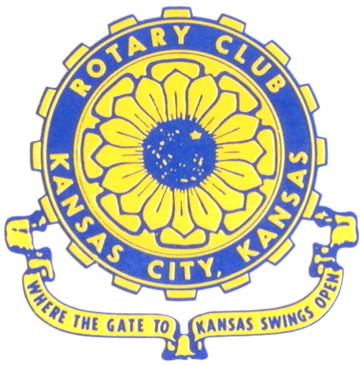
Where the Gate to Kansas Swings Open

The Kansas City, Kansas Rotary Club was organized on November 2, 1915 and received its charter as Club No. 195 in January 1916. Its members take pride in more than 90 years of Rotary service to the community and to international fellowship. From this Club have come five District Governors and two Directors of Rotary International. The Club’s history is as rich as that of the community it represents.

Following the Lewis and Clark expedition which camped at the confluence of the Kansas and Missouri rivers on June 26, 1804, in present day Kansas City, Kansas, this area became an important center for fur trappers. In the following years, many Indian tribes were relocated here from the East. In 1842 the Wyandot Indians acquired land here and founded a town. During this period, and for the next five decades, this area became the main gateway to the inviting majesty of the sprawling Kansas Prairie and the American West. This was where the frontier began. Pioneers found river transportation, outfitters and the beginning of the Santa Fe and Oregon Trails. After the covered wagons came major trunk railroads and barge lines.

In 1886, Kansas City, Kansas received its charter as an incorporated city, combining the towns of Wyandot, Argentine and Armourdale. (Rosedale was added in 1922.) Kansas City, Kansas is the site of the first industrial park in the United States, home of the prestigious University of Kansas Medical Center, and the location of the National Agricultural Hall of Fame and the nationally recognized Kansas Speedway.

Near the geographical and population centers of the contiguous United States, it is in the temperate latitudes at an elevation of 726 feet above sea level. The average rainfall is 35 inches. The average mean temperature ranges from 30°F in January to 80°F in July. The lowest recorded temperature was -23°F on December 23, 1989, and the highest was 113°F on August 14, 1936. Our city’s population of 145,000 and 155 square miles rank it 158th among cities in the United States.

Welcome to Kansas City, Kansas Rotary, and the vibrant community it represents.

Service Above Self

Rotary Websites:
KCK Club: www.rotarydowntownkck.org, District: www.rotary5710.org, International: www.rotary.org



WHERE NEARBY TO MAKE UP ATTENDANCE
MONDAY
Bonner Springs (11:45am) --------------------------------- Twister Bar & Grill, 13100 Kansas Ave.
Overland Park (11:30am) ----------------------------------- Doubletree Hotel, 10100 College Blvd.
TUESDAY
Gladstone (7:00am) -------------------------------------- Fairview Christian Church, 1800 N.E. 65th
Johnson County-Sunset (5:15pm) --------------------------------Hilton Garden Inn, 119th and I-35
WEDNESDAY
Overland Park South (7:15am) ------------------------ Deer Creek Country Club, 7000 W. 133rd
Leavenworth (Noon) --------------------------- Riverfront Community Center, 123 S. Esplanade
KCI, Missouri (Noon) -------------------------------- KCI Expo Center, 11730 N. Ambassador Dr.
Shawnee Mission (Noon) ----------------------------- Sylvester Powell Center, Martway & Lamar
Olathe (Noon) ------------------------------ Mahaffie/Heritage Center, 1200 E. Kansas City Road
Kansas City South, Missouri (Noon) ----------------------------- EBT, 1310 Carondolet, 2nd Floor
THURSDAY
South Platte, Missouri (7:00am) ----------------------- Trezo Mare, 4105 Mulberry Drive, KCMO
Johnson County (7:15am) --------------------------- Crowne Plaza Hotel, 12601 W. 95th, Lenexa
Leawood (7:15am) ---------------------------------------- Hereford House, Town Center Dr. & Nall
Village West (7:15am) -------------------------- Dave & Buster’s, 1843 Village West Pkwy., KCK
Gardner (7:30am) ---------------------------------------------------- Senior Citizen Bldg., 128 E. Park
Olathe Santa Fe Trail (7:30am) --- Mid-Am Nazarene U, 2030 E. College Way, Campus Ctr.
Kansas City, Missouri (Noon) -------------------------------- The Gallery, 61 E. 14th Street, KCMO
FRIDAY
Desoto (7:00am) ------------------------ Desoto United Methodist Church, 8760 Kill Creek Road
Shawnee (7:15am) --------------------------------------------------- Town Hall, 11600 Johnson Drive
Plaza, Missouri (7:15am) -------------------------------- Intercontinental Hotel, 401 Ward Parkway
North Kansas City, Missouri (Noon) ------------------------------ Finnigan’s Hall, 505 E. 18th Ave.
Parkville, Missouri (Noon) ------------------------ Park University Underground, Woodard Center
Lenexa (Noon) ------------------------------- Lakeview Village, Northpointe Bldg., 91st & Park St.

Meeting make ups can be made 14 days before or after the missed meeting.
Please see the Secretary for the world directory of all Rotary Club’s meeting times, days and places.

2015-2016 Board of Directors
Officers Directors
Hank Chamberlain Rick Behrens
President Karole Bradford
Ashley Adorante John Freshnock
Vice President Phil Gibbs
Greg Shondell Priscilla McInnes
Treasurer Bruce Schlosser
Jim Knight Donna Severance
Secretary Mark Wiebe
Rosemary Podrebarac Fred Zimmerman
Sergeant at Arms
Ken Davis
Past President

