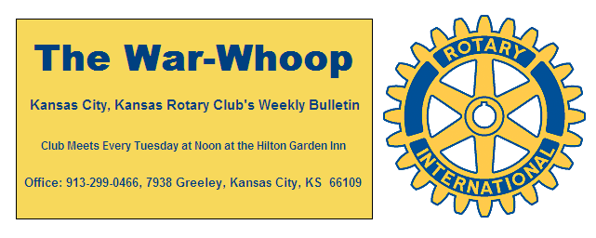
Websites: Club: www.rotarydowntownkck.org, District: www.rotary5710.org, International: www.rotary.org

Volume 77 September 4, 2015 No. 10

LAST WEEK AT ROTARY- Member Sara Antrobus talked about the history of the UMB Bank building at 601 Minnesota Ave. The building was established as a National Bank in 1897 and then was renamed as The Commercial Natl Bank in 1990. In 1994 the bank was acquired by UMB Bank, Kansas and then the bank became a branch of the UMB Bank, Kansas in 1994 and then a branch in 1997. Sara is the branch manager of the facility. In September of last year, an investor group led by Ted Ehney purchased the building from the bank. Mr. Ehney told Rotary members that they are remodeling the building and it should take two years to complete. During questions about the building, Mr. Ehney found out information about the building that he did not know at this time. The group plans on putting 20 apartments on the top floors. They have also made some investments in other buildings in Kansas City, Kansas.

Vice President Ashley Adorante opened the meeting and Chris McCord gave the invocation. Scott Kaufmann led the singing and Dave Tyler introduced the visiting Rotarians and guests. Guests this week included Sara Parks from Fall Oaks, California. She exchanged banners with Ashley. Other guests included Chuck Schlitter and Joy Bell, intern with Ashley Adorante. Rotarian Cindy Cash, member of the Village West was in attendance.

PROGRAM NEXT WEEK- Angie Jones, member of the FBI Cyber Crimes Task Force, will present a program on “Keeping our Kids Safe”.

Karole Bradford will be the program chair for the day and for the month.

PAUL HARRIS DRAWING- Fred Zimmerman won the right to draw the joker last week. Fred did not draw the joker and the amount will go $189.00 for next week’s drawing.

HAPPY BIRTHDAY- Scott led members in singing “Happy Birthday” to Bill Epperheimer, Bruce Schlosser and guest, Sara Parks.

HEALTH REPORT-Bob Kimball reported that he talked with Art Collins this past week. Art is doing better and is walking and doing physical therapy.

PAUL HARRIS AWARD- Ashley presented Merle Parks with his Paul Harris Plus One Award. This award is given to Rotarians who have contributed $1,000 to Rotary Foundation in addition to the original $1,000.

HISTORY- We are trying to bring pictures of presidents over the years. If any member would have pictures of the following members, bring them to Secretary Jim so that he can make copies and then they will be returned. They are: Robert Kaufman, Walter McGregor, John Thompson, and Jim Boddie. Several of these members go back to 1977-78. We have several other presidents, without pictures, from the early years. Your help will be appreciated.

QUARTERLY DUES- Just a reminder that present quarterly dues are now past due. The secretary will be sending out an email to remind members.

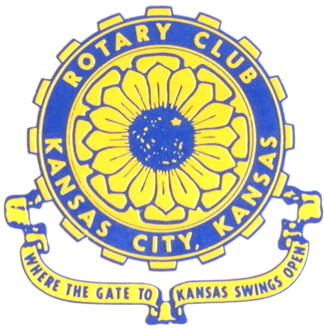
Where the Gate to Kansas Swings Open

The Kansas City, Kansas Rotary Club was organized on November 2, 1915 and received its charter as Club No. 195 in January 1916. Its members take pride in more than 90 years of Rotary service to the community and to international fellowship. From this Club have come five District Governors and two Directors of Rotary International. The Club’s history is as rich as that of the community it represents.

Following the Lewis and Clark expedition which camped at the confluence of the Kansas and Missouri rivers on June 26, 1804, in present day Kansas City, Kansas, this area became an important center for fur trappers. In the following years, many Indian tribes were relocated here from the East. In 1842 the Wyandot Indians acquired land here and founded a town. During this period, and for the next five decades, this area became the main gateway to the inviting majesty of the sprawling Kansas Prairie and the American West. This was where the frontier began. Pioneers found river transportation, outfitters and the beginning of the Santa Fe and Oregon Trails. After the covered wagons came major trunk railroads and barge lines.

In 1886, Kansas City, Kansas received its charter as an incorporated city, combining the towns of Wyandot, Argentine and Armourdale. (Rosedale was added in 1922.) Kansas City, Kansas is the site of the first industrial park in the United States, home of the prestigious University of Kansas Medical Center, and the location of the National Agricultural Hall of Fame and the nationally recognized Kansas Speedway.

Near the geographical and population centers of the contiguous United States, it is in the temperate latitudes at an elevation of 726 feet above sea level. The average rainfall is 35 inches. The average mean temperature ranges from 30°F in January to 80°F in July. The lowest recorded temperature was -23°F on December 23, 1989, and the highest was 113°F on August 14, 1936. Our city’s population of 145,000 and 155 square miles rank it 158th among cities in the United States.

Welcome to Kansas City, Kansas Rotary, and the vibrant community it represents.

Service Above Self

Rotary Websites:
KCK Club: www.rotarydowntownkck.org, District: www.rotary5710.org, International: www.rotary.org



WHERE NEARBY TO MAKE UP ATTENDANCE
MONDAY
Bonner Springs (11:45am) --------------------------------- Twister Bar & Grill, 13100 Kansas Ave.
Overland Park (11:30am) ----------------------------------- Doubletree Hotel, 10100 College Blvd.
TUESDAY
Gladstone (7:00am) -------------------------------------- Fairview Christian Church, 1800 N.E. 65th
Johnson County-Sunset (5:15pm) --------------------------------Hilton Garden Inn, 119th and I-35
WEDNESDAY
Overland Park South (7:15am) ------------------------ Deer Creek Country Club, 7000 W. 133rd
Leavenworth (Noon) --------------------------- Riverfront Community Center, 123 S. Esplanade
KCI, Missouri (Noon) -------------------------------- KCI Expo Center, 11730 N. Ambassador Dr.
Shawnee Mission (Noon) ----------------------------- Sylvester Powell Center, Martway & Lamar
Olathe (Noon) ------------------------------ Mahaffie/Heritage Center, 1200 E. Kansas City Road
Kansas City South, Missouri (Noon) ----------------------------- EBT, 1310 Carondolet, 2nd Floor
THURSDAY
South Platte, Missouri (7:00am) ----------------------- Trezo Mare, 4105 Mulberry Drive, KCMO
Johnson County (7:15am) --------------------------- Crowne Plaza Hotel, 12601 W. 95th, Lenexa
Leawood (7:15am) ---------------------------------------- Hereford House, Town Center Dr. & Nall
Village West (7:15am) -------------------------- Dave & Buster’s, 1843 Village West Pkwy., KCK
Gardner (7:30am) ---------------------------------------------------- Senior Citizen Bldg., 128 E. Park
Olathe Santa Fe Trail (7:30am) --- Mid-Am Nazarene U, 2030 E. College Way, Campus Ctr.
Kansas City, Missouri (Noon) -------------------------------- The Gallery, 61 E. 14th Street, KCMO
FRIDAY
Desoto (7:00am) ------------------------ Desoto United Methodist Church, 8760 Kill Creek Road
Shawnee (7:15am) --------------------------------------------------- Town Hall, 11600 Johnson Drive
Plaza, Missouri (7:15am) -------------------------------- Intercontinental Hotel, 401 Ward Parkway
North Kansas City, Missouri (Noon) ------------------------------ Finnigan’s Hall, 505 E. 18th Ave.
Parkville, Missouri (Noon) ------------------------ Park University Underground, Woodard Center
Lenexa (Noon) ------------------------------- Lakeview Village, Northpointe Bldg., 91st & Park St.

Meeting make ups can be made 14 days before or after the missed meeting.
Please see the Secretary for the world directory of all Rotary Club’s meeting times, days and places.

2015-2016 Board of Directors
Officers Directors
Hank Chamberlain Rick Behrens
President Karole Bradford
Ashley Adorante John Freshnock
Vice President Phil Gibbs
Greg Shondell Priscilla McInnes
Treasurer Bruce Schlosser
Jim Knight Donna Severance
Secretary Mark Wiebe
Rosemary Podrebarac Fred Zimmerman
Sergeant at Arms
Ken Davis
Past President

