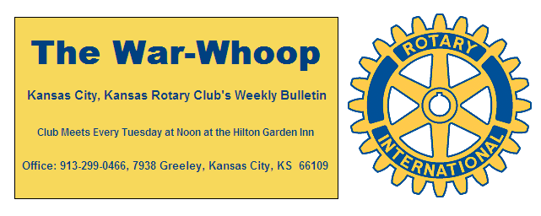
Websites: Club: www.rotarydowntownkck.org, District: www.rotary5710.org, International: www.rotary.org

Volume 77 September 18, 2015 No. 12

LAST WEEK AT ROTARY- -Mary Hindle, Community Rela-tions Manager at Mosaic talked and showed a power point presentation on their program. Their mission is to “be partners with people with intellectual disabilities and to create a mean-ful life in a caring community, giving a voice to their needs”’ Mosaic is an International organization and came to Kansas City in 1994.
She introduced a mother of a student that talked about experience with her child and after placing him in an institution for several years was able to bring him back home with help from the organization.
One of their students was also in attendance and sang the song, “Impossible Dream” and did a great job. She also spoke of a young man that works as a mail courier and has that job for 15 years. They have volunteers that support the program by forming a buddy program for these clients or actually living in homes outside the program. Mosaic receives 90% of their funding from Medicare.

President Hank opened the meeting and Scott Kaufmann gave the invocation. Scott Kaufmann led the singing and Dave Tyler introduced the visitors.

PAUL HARRIS DRAWING- Ken Davis, just back from a New York vacation won the right to draw the joker last week. Ken did not draw the joker and the amount will go $204.00 for next week’s drawing. .

PROGRAM NEXT WEEK- Jenn Jewett, KCK Fire Depart-ment will present the fire department’s focus on women in leadership.

Karole Bradford will be the program chair for the day and for the month.

MEMBERSHIP PIN- President Hank presented Phil Gibbs with his membership International pin for bringing a new member into Rotary.

HISTORY- The Paul Harris drawing idea was started in September twenty three years ago this month.
There are four sets of Father and sons that have been presidents in our Club. They are:
Ferris and Bob Kimball Harold and Bruce Schlosser
Jim and Bill Porter Jim and Greg Shondell
However there is one father in Rotary that had two sons in Rotary plus a son in law that were presidents of Rotary. That father was the Miller Family. The father Harry Miller Sr. was the father of two presidents, Harry Jr. 1954-55 and Conrad 1960-61. Roy Holiday, President 1963-64 was the son in law in the family.
There have been many father and son members in Rotary over the years. At the present time our Rotary Club does not have a combination of father and son or daughter membership.
The three oldest members, in length of service to Rotary, are Bob Kimball, 1961, Jim Knight 1964 and Bill Strumillo 1969. Bill Mullarky has the longest length of service in Rotary as he joined our Club coming from Oklahoma City in 1977.

THOUGHT FOR THE DAY- “One way to get the most out of life is to look upon it as an adventure”.

INTRODUCE SOMEONE TO ROTARY

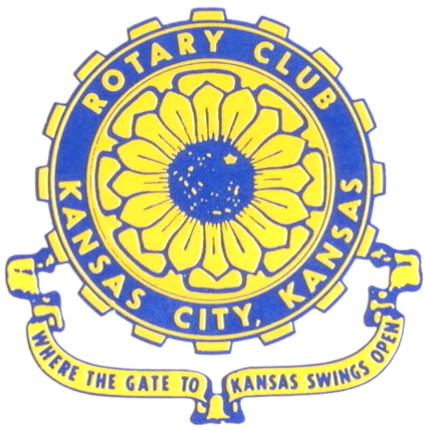
Where the Gate to Kansas Swings Open

The Kansas City, Kansas Rotary Club was organized on November 2, 1915 and received its charter as Club No. 195 in January 1916. Its members take pride in more than 90 years of Rotary service to the community and to international fellowship. From this Club have come five District Governors and two Directors of Rotary International. The Club’s history is as rich as that of the community it represents.

Following the Lewis and Clark expedition which camped at the confluence of the Kansas and Missouri rivers on June 26, 1804, in present day Kansas City, Kansas, this area became an important center for fur trappers. In the following years, many Indian tribes were relocated here from the East. In 1842 the Wyandot Indians acquired land here and founded a town. During this period, and for the next five decades, this area became the main gateway to the inviting majesty of the sprawling Kansas Prairie and the American West. This was where the frontier began. Pioneers found river transportation, outfitters and the beginning of the Santa Fe and Oregon Trails. After the covered wagons came major trunk railroads and barge lines.

In 1886, Kansas City, Kansas received its charter as an incorporated city, combining the towns of Wyandot, Argentine and Armourdale. (Rosedale was added in 1922.) Kansas City, Kansas is the site of the first industrial park in the United States, home of the prestigious University of Kansas Medical Center, and the location of the National Agricultural Hall of Fame and the nationally recognized Kansas Speedway.

Near the geographical and population centers of the contiguous United States, it is in the temperate latitudes at an elevation of 726 feet above sea level. The average rainfall is 35 inches. The average mean temperature ranges from 30°F in January to 80°F in July. The lowest recorded temperature was -23°F on December 23, 1989, and the highest was 113°F on August 14, 1936. Our city’s population of 145,000 and 155 square miles rank it 158th among cities in the United States.

Welcome to Kansas City, Kansas Rotary, and the vibrant community it represents.

Service Above Self

Rotary Websites:
KCK Club: www.rotarydowntownkck.org, District: www.rotary5710.org, International: www.rotary.org



WHERE NEARBY TO MAKE UP ATTENDANCE
MONDAY
Bonner Springs (11:45am) --------------------------------- Twister Bar & Grill, 13100 Kansas Ave.
Overland Park (11:30am) ----------------------------------- Doubletree Hotel, 10100 College Blvd.
TUESDAY
Gladstone (7:00am) -------------------------------------- Fairview Christian Church, 1800 N.E. 65th
Johnson County-Sunset (5:15pm) --------------------------------Hilton Garden Inn, 119th and I-35
WEDNESDAY
Overland Park South (7:15am) ------------------------ Deer Creek Country Club, 7000 W. 133rd
Leavenworth (Noon) --------------------------- Riverfront Community Center, 123 S. Esplanade
KCI, Missouri (Noon) -------------------------------- KCI Expo Center, 11730 N. Ambassador Dr.
Shawnee Mission (Noon) ----------------------------- Sylvester Powell Center, Martway & Lamar
Olathe (Noon) ------------------------------ Mahaffie/Heritage Center, 1200 E. Kansas City Road
Kansas City South, Missouri (Noon) ----------------------------- EBT, 1310 Carondolet, 2nd Floor
THURSDAY
South Platte, Missouri (7:00am) ----------------------- Trezo Mare, 4105 Mulberry Drive, KCMO
Johnson County (7:15am) --------------------------- Crowne Plaza Hotel, 12601 W. 95th, Lenexa
Leawood (7:15am) ---------------------------------------- Hereford House, Town Center Dr. & Nall
Village West (7:15am) -------------------------- Dave & Buster’s, 1843 Village West Pkwy., KCK
Gardner (7:30am) ---------------------------------------------------- Senior Citizen Bldg., 128 E. Park
Olathe Santa Fe Trail (7:30am) --- Mid-Am Nazarene U, 2030 E. College Way, Campus Ctr.
Kansas City, Missouri (Noon) -------------------------------- The Gallery, 61 E. 14th Street, KCMO
FRIDAY
Desoto (7:00am) ------------------------ Desoto United Methodist Church, 8760 Kill Creek Road
Shawnee (7:15am) --------------------------------------------------- Town Hall, 11600 Johnson Drive
Plaza, Missouri (7:15am) -------------------------------- Intercontinental Hotel, 401 Ward Parkway
North Kansas City, Missouri (Noon) ------------------------------ Finnigan’s Hall, 505 E. 18th Ave.
Parkville, Missouri (Noon) ------------------------ Park University Underground, Woodard Center
Lenexa (Noon) ------------------------------- Lakeview Village, Northpointe Bldg., 91st & Park St.

Meeting make ups can be made 14 days before or after the missed meeting.
Please see the Secretary for the world directory of all Rotary Club’s meeting times, days and places.

2015-2016 Board of Directors
Officers Directors
Hank Chamberlain Rick Behrens
President Karole Bradford
Ashley Adorante John Freshnock
Vice President Phil Gibbs
Greg Shondell Priscilla McInnes
Treasurer Bruce Schlosser
Jim Knight Donna Severance
Secretary Mark Wiebe
Rosemary Podrebarac Fred Zimmerman
Sergeant at Arms
Ken Davis
Past President

