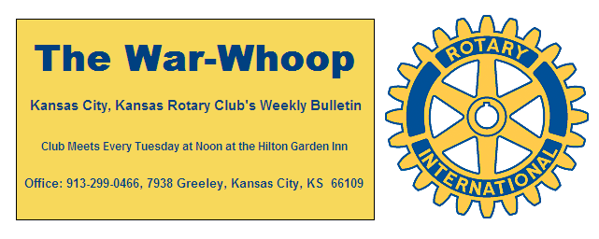
Websites: Club: www.rotarydowntownkck.org, District: www.rotary5710.org, International: www.rotary.org

Volume 76 February 6, 2015 No. 29
PROPOSE A NEW MEMBER IN 2014-15

LAST WEEK AT ROTARY - Mr. Bruce Chlandy, County Extension Director for Wyandotte County was our speaker last Tuesday. He talked about the history of the Extension pro-in Wyandotte County. There are Extension offices in most counties in Kansas. He went on to say that some extension offices serve more than one county. They are funded by state and the local governments. They also receive government grants. He answered many questions during his presentation. The local Extension Office is located at 79th and State Ave.

President Ken opened the meeting and Karole Bradford gave the invocation. Scott Kaufmann led the singing and Dave Tyler introduced the visitors.

PAUL HARRIS DRAWING- Bob Kimball won the right to draw for the joker last Tuesday. Bob did not draw the joker and the amount goes to $75.00 for next week’s drawing.

WEBSITE UPDATE- All members should check our website on a weekly basis. Greg Shondell has brought it up to date with pictures and activities. The weekly bulletin is now a part of the website. Take some time and check the website out by going to rotarydowntownkck.org.

NEXT WEEK AT ROTARY- Chuck Arney, Chief Operating Officer of Hillcrest Transitional Housing of Kansas, will be our speaker next week. Hillcrest Transitional Housing offers homeless families, singles and youth a disciplined education-program within a caring supportive environment. Their primary objective is to move clients from homelessness to self-sufficiency within ninety days by addressing the total life situation.

Chris McCord is the program chairman for the day and for the month.

WHAT ARE MEMBERS DOING OR GOING? Your secretary would like to keep members up to date on what other members are doing during the week or month. Give your info to the secretary so that he might let other members up to date.
It was good to see John Bukaty back after a short vacation in Florida. Bruce Schlosser is on his way back from Florida this week.

MAYOR’S LUNCHEON- The cost of GUEST tickets for the luncheon this year will be $24.00. There will be no increase in the cost for members. The luncheon will be treated as a regular luncheon and members will be billed as usual. Rotary members are asked to make reservations for their guests through the secretary.

ACCELRATE ROTARY MEETING- Hank Chamberlain and Greg Shondell attended the District meeting this past week-end in Lawrence.

SOMEONE SAID-“There is no limit to the amount of good that people can accomplish, if they don’t care who get the credit.”

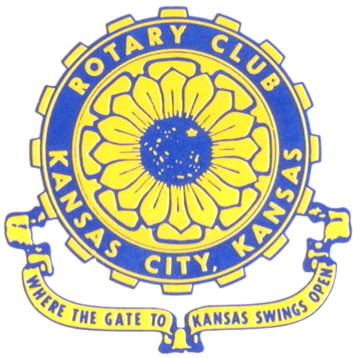
Where the Gate to Kansas Swings Open
The Kansas City, Kansas Rotary Club was organized on November 2, 1915 and received its charter as Club No. 195 in January 1916. Its members take pride in more than 90 years of Rotary service to the community and to international fellowship. From this Club have come five District Governors and two Directors of Rotary International. The Club’s history is as rich as that of the community it represents.

Following the Lewis and Clark expedition which camped at the confluence of the Kansas and Missouri rivers on June 26, 1804, in present day Kansas City, Kansas, this area became an important center for fur trappers. In the following years, many Indian tribes were relocated here from the East. In 1842 the Wyandot Indians acquired land here and founded a town. During this period, and for the next five decades, this area became the main gateway to the inviting majesty of the sprawling Kansas Prairie and the American West. This was where the frontier began. Pioneers found river transportation, outfitters and the beginning of the Santa Fe and Oregon Trails. After the covered wagons came major trunk railroads and barge lines.

In 1886, Kansas City, Kansas received its charter as an incorporated city, combining the towns of Wyandot, Argentine and Armourdale. (Rosedale was added in 1922.) Kansas City, Kansas is the site of the first industrial park in the United States, home of the prestigious University of Kansas Medical Center, and the location of the National Agricultural Hall of Fame and the nationally recognized Kansas Speedway.

Near the geographical and population centers of the contiguous United States, it is in the temperate latitudes at an elevation of 726 feet above sea level. The average rainfall is 35 inches. The average mean temperature ranges from 30°F in January to 80°F in July. The lowest recorded temperature was -23°F on December 23, 1989, and the highest was 113°F on August 14, 1936. Our city’s population of 145,000 and 155 square miles rank it 158th among cities in the United States.

Welcome to Kansas City, Kansas Rotary, and the vibrant community it represents.

Service Above Self

Rotary Websites:
KCK Club: www.rotarydowntownkck.org, District: www.rotary5710.org, International: www.rotary.org



WHERE NEARBY TO MAKE UP ATTENDANCE
MONDAY
Bonner Springs (11:45am) --------------------------------- Twister Bar & Grill, 13100 Kansas Ave.
Overland Park (11:30am) ----------------------------------- Doubletree Hotel, 10100 College Blvd.
TUESDAY
Gladstone (7:00am) -------------------------------------- Fairview Christian Church, 1800 N.E. 65th
Johnson County-Sunset (5:15pm) ----------Hilton Garden Inn(Olathe) 12080 S Strang Lin Rd
WEDNESDAY
Overland Park South (7:15am) ------------------------ Deer Creek Country Club, 7000 W. 133rd
Leavenworth (Noon) --------------------------- Riverfront Community Center, 123 S. Esplanade
KCI, Missouri (Noon) -------------------------------- KCI Expo Center, 11730 N. Ambassador Dr.
Shawnee Mission (Noon) ----------------------------- Sylvester Powell Center, Martway & Lamar
Olathe (Noon) ------------------------------ Mahaffie/Heritage Center, 1200 E. Kansas City Road
Kansas City South, Missouri (Noon) ----------------------------- EBT, 1310 Carondolet, 2nd Floor
THURSDAY
South Platte, Missouri (7:00am) ----------------------- Trezo Mare, 4105 Mulberry Drive, KCMO
Johnson County (7:15am) --------------------------- Crowne Plaza Hotel, 12601 W. 95th, Lenexa
Leawood (7:15am) ---------------------------------------- Hereford House, Town Center Dr. & Nall
Village West (7:15am) -------------------------- Dave & Buster’s, 1843 Village West Pkwy., KCK
Gardner (7:30am) ---------------------------------------------------- Senior Citizen Bldg., 128 E. Park
Olathe Santa Fe Trail (7:30am) --- Mid-Am Nazarene U, 2030 E. College Way, Campus Ctr.
Kansas City, Missouri (Noon) -------------------------------- The Gallery, 61 E. 14th Street, KCMO
FRIDAY
Desoto (7:00am) ------------------------ Desoto United Methodist Church, 8760 Kill Creek Road
Shawnee (7:15am) --------------------------------------------------- Town Hall, 11600 Johnson Drive
Plaza, Missouri (7:15am) -------------------------------- Intercontinental Hotel, 401 Ward Parkway
North Kansas City, Missouri (Noon) ------------------------------ Finnigan’s Hall, 505 E. 18th Ave.
Parkville, Missouri (Noon) ------------------------ Park University Underground, Woodard Center
Lenexa (Noon) ------------------------------- Lakeview Village, Northpointe Bldg., 91st & Park St.

Meeting make ups can be made 14 days before or after the missed meeting.
Please see the Secretary for the world directory of all Rotary Club’s meeting times, days and places.
2014-2015 Board of Directors
Officers Directors
Ken Davis Ashley Adorante
President Rick Behrens
Hank Chamberlain Karole Bradford
Vice President Phil Gibbs
Greg Shondell Terri Porter
Treasurer Bruce Schlosser
Jim Knight Donna Severance
Secretary Mark Wiebe
Rosemary Podrebarac Fred Zimmerman
Sergeant at Arms
George Moody
Past President

