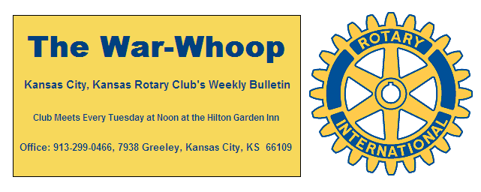
Websites: Club: www.rotarydowntownkck.org, District: www.rotary5710.org, International: www.rotary.org

Volume 77 January 8,2016 No. 26

LAST WEEK AT ROTARY- Kevin Flattery talked about the early history of the Kansas University Medical Center. He actually talked about the history of hospitals and how they began. He went back to the 18th and 19th centuries to talk about their early beginnings. The hospitals were started in the large cities for the poorer citizens. Many of these medical facilities were voluntary and sponsored by faith based organizations. Early hospitals started in Europe and actually began in the United States during the Civil War.
In 1904 Simon Bell donated land in Rosedale to start a hospital emulating John Hopkins Med Center in Baltimore, Maryland. Nurses were a critical part of the growth of the hospital systems. The move of the hospital from the Rosedale area to the present location happened in 1924. Mr. Flattery presentation went up to 1924 and several members ask if he could come back and bring us up to date. Mr. Flattery answered several questions after his presentation.

President Hank opened the meeting and Merle Parks gave the invocation. Scott Kaufmann led the singing and Rick Behrens introduced the visiting Rotarians. Rotarian Mike Roorbach from Marion, Indiana was in attendance.

PAUL HARRIS DRAWING- George Moody won the right to draw for the joker last week. George did not draw the joker and the amount goes to $149.00 for next week’s drawing.

NEXT WEEK AT ROTARY- David Rau, Director of Projects and Planning Facilities Management, will talk about the “Twenty Year Plan for the Kansas University Medical Center.”

Ken Davis is the program chair for the month and for the day.

HAPPY BIRTHDAY- Scott led the members in singing “Happy Birthday” to Frank Simonich and Bill Strumillo.

100th YEAR ANNIVERSAY CELEBRATION- Our date for our 100th Anniversary has been changed to April 5th. The event will be held at the Lake Quivira Country Club. Members are working hard to make the event a great evening. Please mark this date on your calendar NOW.

STATEMENTS- Dues statements were passed out this week to all members in attendance. If you have any questions, please contact the secretary.

RESOLUTION- As you finish up with your resolution make several regarding Rotary.
- Introduce ONE new member before July 1st.
- If you are not a 100% in attendance, increase your attendance in the coming weeks.

ROTARIAN MAGAZINE- Any member not receiving the monthly magazine should contact the secretary.

HELP- If YOU have been a collector of copies of the War Whoop over the years, please contact Greg Shondell of Jim Knight. We are looking for copies of the War Whoop between the years 1980-1981, 1982-1983, 1983-1985, 1986-1987, 1988-1989 and the last six months of 2006. We have been unable to find these years in the archives of the Club.

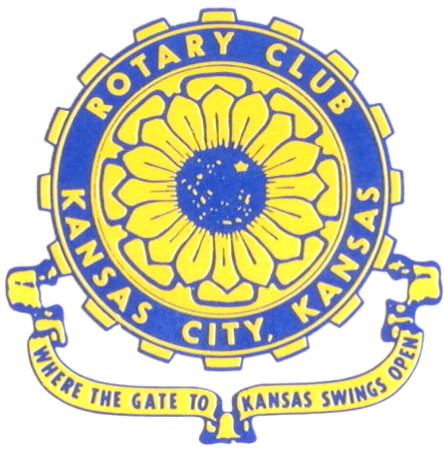
Where the Gate to Kansas Swings Open

The Kansas City, Kansas Rotary Club was organized on November 2, 1915 and received its charter as Club No. 195 in January 1916. Its members take pride in more than 90 years of Rotary service to the community and to international fellowship. From this Club have come five District Governors and two Directors of Rotary International. The Club’s history is as rich as that of the community it represents.

Following the Lewis and Clark expedition which camped at the confluence of the Kansas and Missouri rivers on June 26, 1804, in present day Kansas City, Kansas, this area became an important center for fur trappers. In the following years, many Indian tribes were relocated here from the East. In 1842 the Wyandot Indians acquired land here and founded a town. During this period, and for the next five decades, this area became the main gateway to the inviting majesty of the sprawling Kansas Prairie and the American West. This was where the frontier began. Pioneers found river transportation, outfitters and the beginning of the Santa Fe and Oregon Trails. After the covered wagons came major trunk railroads and barge lines.

In 1886, Kansas City, Kansas received its charter as an incorporated city, combining the towns of Wyandot, Argentine and Armourdale. (Rosedale was added in 1922.) Kansas City, Kansas is the site of the first industrial park in the United States, home of the prestigious University of Kansas Medical Center, and the location of the National Agricultural Hall of Fame and the nationally recognized Kansas Speedway.

Near the geographical and population centers of the contiguous United States, it is in the temperate latitudes at an elevation of 726 feet above sea level. The average rainfall is 35 inches. The average mean temperature ranges from 30°F in January to 80°F in July. The lowest recorded temperature was -23°F on December 23, 1989, and the highest was 113°F on August 14, 1936. Our city’s population of 145,000 and 155 square miles rank it 158th among cities in the United States.

Welcome to Kansas City, Kansas Rotary, and the vibrant community it represents.

Service Above Self

Rotary Websites:
KCK Club: www.rotarydowntownkck.org, District: www.rotary5710.org, International: www.rotary.org



WHERE NEARBY TO MAKE UP ATTENDANCE
MONDAY
Bonner Springs (11:45am) --------------------------------- Twister Bar & Grill, 13100 Kansas Ave.
Overland Park (11:30am) ----------------------------------- Doubletree Hotel, 10100 College Blvd.
TUESDAY
Gladstone (7:00am) -------------------------------------- Fairview Christian Church, 1800 N.E. 65th
Johnson County-Sunset (5:15pm) --------------(Grand Street Café) 8815 Renner Rd, Lenexa
WEDNESDAY
Overland Park South (7:15am) ------------------------ Deer Creek Country Club, 7000 W. 133rd
Leavenworth (Noon) --------------------------- Riverfront Community Center, 123 S. Esplanade
KCI, Missouri (Noon) -------------------------------- KCI Expo Center, 11730 N. Ambassador Dr.
Shawnee Mission (Noon) ----------------------------- Sylvester Powell Center, Martway & Lamar
Olathe (Noon) ------------------------------ Mahaffie/Heritage Center, 1200 E. Kansas City Road
Kansas City South, Missouri (Noon) ----------------------------- EBT, 1310 Carondolet, 2nd Floor
THURSDAY
South Platte, Missouri (7:00am) ----------------------- Trezo Mare, 4105 Mulberry Drive, KCMO
Johnson County (7:15am) --------------------------- Crowne Plaza Hotel, 12601 W. 95th, Lenexa
Leawood (7:15am) ---------------------------------------- Hereford House, Town Center Dr. & Nall
Village West (7:15am) -------------------------- Dave & Buster’s, 1843 Village West Pkwy., KCK
Gardner (7:30am) ---------------------------------------------------- Senior Citizen Bldg., 128 E. Park
Olathe Santa Fe Trail (7:30am) --- Mid-Am Nazarene U, 2030 E. College Way, Campus Ctr.
Kansas City, Missouri (Noon) -------------------------------- The Gallery, 61 E. 14th Street, KCMO
FRIDAY
Desoto (7:00am) ------------------------ Desoto United Methodist Church, 8760 Kill Creek Road
Shawnee (7:15am) --------------------------------------------------- Town Hall, 11600 Johnson Drive
Plaza, Missouri (7:15am) -------------------------------- Intercontinental Hotel, 401 Ward Parkway
North Kansas City, Missouri (Noon) ------------------------------ Finnigan’s Hall, 505 E. 18th Ave.
Parkville, Missouri (Noon) ------------------------ Park University Underground, Woodard Center
Lenexa (Noon) ------------------------------- Lakeview Village, Northpointe Bldg., 91st & Park St.

Meeting make ups can be made 14 days before or after the missed meeting.
Please see the Secretary for the world directory of all Rotary Club’s meeting times, days and places.

2015-2016 Board of Directors
Officers Directors
Hank Chamberlain Rick Behrens
President Karole Bradford
Ashley Adorante John Freshnock
Vice President Phil Gibbs
Greg Shondell Melissa Mundt
Treasurer Bruce Schlosser
Jim Knight Donna Severance
Secretary Mark Wiebe
Rosemary Podrebarac Fred Zimmerman
Sergeant at Arms
Ken Davis
Past President

