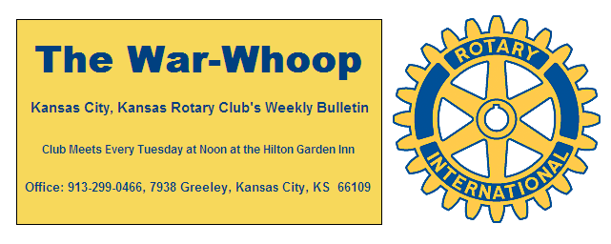
Websites: Club: www.rotarydowntownkck.org, District: www.rotary5710.org, International: www.rotary.org

Volume 77 January 29, 2016 No. 29

LAST WEEK AT ROTARY- Terry Brecheisen, Director of Public Health for Wyandotte County, talked about the history in public health over the past hundred years. He told members that in 1916 the life span for a person was 47nyear of age and now it is 79 years of age. The extra thirty two years has created some extra public health issues. Tuberculous was the number one disease in 1916 followed by the influenza and gastro-intestinal issues. In 2016 the number one disease is heart disease followed by cancer, chronic respiratory problems and accidents, strokes and diabetes.
While measles were wide spread in early 1900’s they are rare at this time. He went on to add that vaccinations have limited the number of diseases. Lead poison is a big health risk to children due to lead based paint.
The local health department provides services for healthy mothers and babies, vaccinations, motor vehicle safety, safer and heathy food programs, safer work environ-ments, center for diseases, family planning and prevention of diseases. He also made some interesting predictions about the future. He answered many questions after his presentation.

President Hank opened the meeting and Karen Hostetler gave the invocation. Scott Kaufmann led the singing and introduced the visiting Rotarians. Dave Tyler introduced the visitors. Erica Estes from Fayetteville, Arkansas was the long distance Rotarian. She exchange banners with President Hank.

NEXT WEEK AT ROTARY- Don Crimm, Master Gardner for the K-State Extension Services, will be our speaker. He specializes in turf matters. He will be speaking on spring lawn maintenance abd getting our yards ready for the growing season.

Chris McCord is the program chair for the month and for the day.

PAUL HARRIS DRAWING- Bob Kimball won the right to draw for the joker last week. Bob did not draw the joker and the amount goes to $186.00 for next week’s drawing.

NEW MEMBER -President Hank introduced Bill Heatherman and presented him with his Rotary pin as our newest member in Rotary. Bill is the County Engineer of the Public Works Department for Wyandotte County. His classification in Rotary will be Engineer/ Public Works. Please welcome Bill to Rotary when you meet him next week

OUR ROAMING ROTARIAN
Catedral al Sur, Buenos Aires, Argentina --- Dave Skidgel
Shawnee Mission----------------------------------Ken David
Scott Martens
EClub Southeast USA & Caribbean------------Terry Robinson

MAYOR’S LUNCHEON- Another reminder that the Mayor’s Luncheon will be held on Tuesday, February 23th. This is another important Rotary date to mark on your calendars.

DISTRICT NEWS- The district newsletter came out this week. Take some time and see what is going on in the district. There are many activities planned in the coming months. All members should receive the newsletter, so if you did not receive a letter, please notify the secretary.

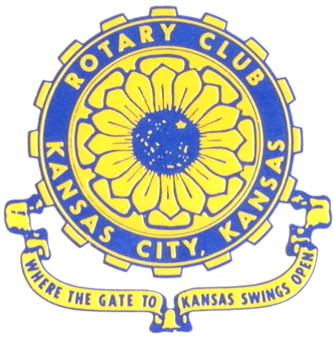
Where the Gate to Kansas Swings Open

The Kansas City, Kansas Rotary Club was organized on November 2, 1915 and received its charter as Club No. 195 in January 1916. Its members take pride in more than 90 years of Rotary service to the community and to international fellowship. From this Club have come five District Governors and two Directors of Rotary International. The Club’s history is as rich as that of the community it represents.

Following the Lewis and Clark expedition which camped at the confluence of the Kansas and Missouri rivers on June 26, 1804, in present day Kansas City, Kansas, this area became an important center for fur trappers. In the following years, many Indian tribes were relocated here from the East. In 1842 the Wyandot Indians acquired land here and founded a town. During this period, and for the next five decades, this area became the main gateway to the inviting majesty of the sprawling Kansas Prairie and the American West. This was where the frontier began. Pioneers found river transportation, outfitters and the beginning of the Santa Fe and Oregon Trails. After the covered wagons came major trunk railroads and barge lines.

In 1886, Kansas City, Kansas received its charter as an incorporated city, combining the towns of Wyandot, Argentine and Armourdale. (Rosedale was added in 1922.) Kansas City, Kansas is the site of the first industrial park in the United States, home of the prestigious University of Kansas Medical Center, and the location of the National Agricultural Hall of Fame and the nationally recognized Kansas Speedway.

Near the geographical and population centers of the contiguous United States, it is in the temperate latitudes at an elevation of 726 feet above sea level. The average rainfall is 35 inches. The average mean temperature ranges from 30°F in January to 80°F in July. The lowest recorded temperature was -23°F on December 23, 1989, and the highest was 113°F on August 14, 1936. Our city’s population of 145,000 and 155 square miles rank it 158th among cities in the United States.

Welcome to Kansas City, Kansas Rotary, and the vibrant community it represents.

Service Above Self

Rotary Websites:
KCK Club: www.rotarydowntownkck.org, District: www.rotary5710.org, International: www.rotary.org



WHERE NEARBY TO MAKE UP ATTENDANCE
MONDAY
Bonner Springs (11:45am) --------------------------------- Twister Bar & Grill, 13100 Kansas Ave.
Overland Park (11:30am) ----------------------------------- Doubletree Hotel, 10100 College Blvd.
TUESDAY
Gladstone (7:00am) -------------------------------------- Fairview Christian Church, 1800 N.E. 65th
Johnson County-Sunset (5:15pm) --------------(Grand Street Café) 8815 Renner Rd, Lenexa
WEDNESDAY
Overland Park South (7:15am) ------------------------ Deer Creek Country Club, 7000 W. 133rd
Leavenworth (Noon) --------------------------- Riverfront Community Center, 123 S. Esplanade
KCI, Missouri (Noon) -------------------------------- KCI Expo Center, 11730 N. Ambassador Dr.
Shawnee Mission (Noon) ----------------------------- Sylvester Powell Center, Martway & Lamar
Olathe (Noon) ------------------------------ Mahaffie/Heritage Center, 1200 E. Kansas City Road
Kansas City South, Missouri (Noon) ----------------------------- EBT, 1310 Carondolet, 2nd Floor
THURSDAY
South Platte, Missouri (7:00am) ----------------------- Trezo Mare, 4105 Mulberry Drive, KCMO
Johnson County (7:15am) --------------------------- Crowne Plaza Hotel, 12601 W. 95th, Lenexa
Leawood (7:15am) ---------------------------------------- Hereford House, Town Center Dr. & Nall
Village West (7:15am) -------------------------- Dave & Buster’s, 1843 Village West Pkwy., KCK
Gardner (7:30am) ---------------------------------------------------- Senior Citizen Bldg., 128 E. Park
Olathe Santa Fe Trail (7:30am) --- Mid-Am Nazarene U, 2030 E. College Way, Campus Ctr.
Kansas City, Missouri (Noon) -------------------------------- The Gallery, 61 E. 14th Street, KCMO
FRIDAY
Desoto (7:00am) ------------------------ Desoto United Methodist Church, 8760 Kill Creek Road
Shawnee (7:15am) --------------------------------------------------- Town Hall, 11600 Johnson Drive
Plaza, Missouri (7:15am) -------------------------------- Intercontinental Hotel, 401 Ward Parkway
North Kansas City, Missouri (Noon) ------------------------------ Finnigan’s Hall, 505 E. 18th Ave.
Parkville, Missouri (Noon) ------------------------ Park University Underground, Woodard Center
Lenexa (Noon) ------------------------------- Lakeview Village, Northpointe Bldg., 91st & Park St.

Meeting make ups can be made 14 days before or after the missed meeting.
Please see the Secretary for the world directory of all Rotary Club’s meeting times, days and places.

2015-2016 Board of Directors
Officers Directors
Hank Chamberlain Rick Behrens
President Karole Bradford
Ashley Adorante John Freshnock
Vice President Phil Gibbs
Greg Shondell Melissa Mundt
Treasurer Bruce Schlosser
Jim Knight Donna Severance
Secretary Mark Wiebe
Rosemary Podrebarac Fred Zimmerman
Sergeant at Arms
Ken Davis
Past President

