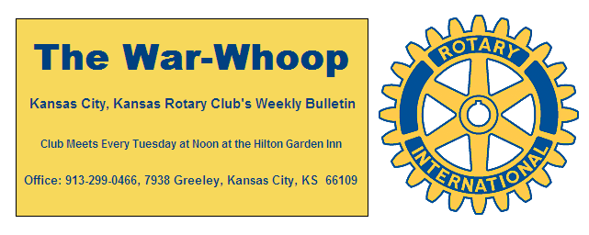
Websites: Club: www.rotarydowntownkck.org, District: www.rotary5710.org, International: www.rotary.org

Volume 77 February 11, 2016 No. 29

LAST WEEK AT ROTARY - Mark Naster, the Director of Corporate and Foundation Relations for the Heartland Habitat for Humanity talked about the program in the metro area. The program was started in 1976. There are 1500 affiliates throughout the United States and three here in Kansas City. Seventy percent of the work is done by volunteers. The group has built 250 homes since 1987. They not only build new homes, but they also help residents to update their homes and bring them up to city codes. When asked how these people qualify, he told members, the applicants MUST HAVE A NEED, SHOW THE ABILITY TO PAY FOR THE HOME AFTER IT IS BUILT, MUST DO THE PAPER WORK FOR A CONVENTIAL LOAN, AND PROVIDE SOME SWEAT EQUITY IN THE VENRURE. The family must receive 50 hours of education and 50 hours of sweat equity to qualify for the home. While he did not ask for money he did request that members volunteer to help in building homes. They will provide five hours of education to the community if asked. He answered several question after his presentation

President Hank opened the meeting and Mary Viveros gave the invocation. Scott Kaufmann led the singing and Ashley Adorante introduced the visiting Rotarians.

PAUL HARRIS DRAWING- Kyle Fulbright won the right to draw for the joker last week. Kyle drew the joker and will split $16.00 with the Foundation. President Hank presented Scott Kaufman with a $199.50 check for drawing the joker last week.

DUES STATEMENT REMINDER- Dues for the present quarter are now past due. Anyone who needs another statement should contact the secretary.

NEXT WEEK AT ROTARY- The speaker next week will be Carol D’Attoma, President and Executive Director of SACRED, which stands for Sexually Abused Children’s Relief Endeavor. She has a story to tell about her six year old granddaughter and will be talking about her organization.

Chris McCord is the program chair for the month and for the day.

All Club Members and their guests are invited to the Centennial Gala, a celebration of 100 years of service, on Tuesday, April 5, 2016 at the Lake Quivira Country Club 100 Crescent Blvd, Lake Quivira, Ks 66217.Cocktail reception at 5:30 p.m. with live jazz by the KCKCC ensemble. Dinner at 6:30, Program to follow. $50per person. Please RSVP to Jim Knight for this splendid evening of fellowship and celebration

MAYOR’S LUNCHEON- The Mayor’s Luncheon will be held on Tuesday, February 23th. All members are asked to make a RESERVATIONS FOR THIS LUNCHEON. ALL VOLUNTEERS SHOULD TRY AND BE AT THE HOTEL BY 11:15am. Reservations are needed by FEBRUARY 16th.

NEW MEMBER- President Hank introduced Bill Heatherman for the third time and presented him with his book on Rotary. Bill is the County Engineer of the Public Works Department for Wyandotte County. His classification in Rotary will be Engineer/ Public Works. Please welcome Bill to Rotary when you meet him next week

VILLAGE WEST SEAFOOD FEST- The Village West Club has changed their location for their SEAFOOD FEST to the Savior Pastoral Center at 12601 Parallel Parkway. Please see attachment about the Seafood fest.

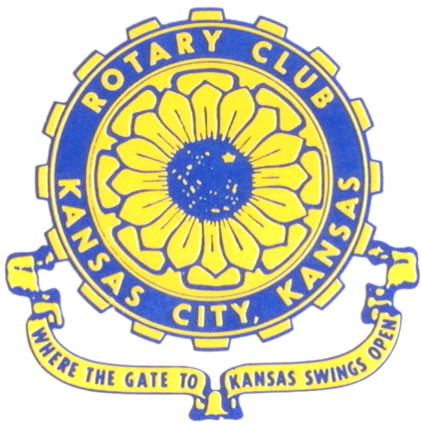
Where the Gate to Kansas Swings Open

The Kansas City, Kansas Rotary Club was organized on November 2, 1915 and received its charter as Club No. 195 in January 1916. Its members take pride in more than 90 years of Rotary service to the community and to international fellowship. From this Club have come five District Governors and two Directors of Rotary International. The Club’s history is as rich as that of the community it represents.

Following the Lewis and Clark expedition which camped at the confluence of the Kansas and Missouri rivers on June 26, 1804, in present day Kansas City, Kansas, this area became an important center for fur trappers. In the following years, many Indian tribes were relocated here from the East. In 1842 the Wyandot Indians acquired land here and founded a town. During this period, and for the next five decades, this area became the main gateway to the inviting majesty of the sprawling Kansas Prairie and the American West. This was where the frontier began. Pioneers found river transportation, outfitters and the beginning of the Santa Fe and Oregon Trails. After the covered wagons came major trunk railroads and barge lines.

In 1886, Kansas City, Kansas received its charter as an incorporated city, combining the towns of Wyandot, Argentine and Armourdale. (Rosedale was added in 1922.) Kansas City, Kansas is the site of the first industrial park in the United States, home of the prestigious University of Kansas Medical Center, and the location of the National Agricultural Hall of Fame and the nationally recognized Kansas Speedway.

Near the geographical and population centers of the contiguous United States, it is in the temperate latitudes at an elevation of 726 feet above sea level. The average rainfall is 35 inches. The average mean temperature ranges from 30°F in January to 80°F in July. The lowest recorded temperature was -23°F on December 23, 1989, and the highest was 113°F on August 14, 1936. Our city’s population of 145,000 and 155 square miles rank it 158th among cities in the United States.

Welcome to Kansas City, Kansas Rotary, and the vibrant community it represents.

Service Above Self

Rotary Websites:
KCK Club: www.rotarydowntownkck.org, District: www.rotary5710.org, International: www.rotary.org



WHERE NEARBY TO MAKE UP ATTENDANCE
MONDAY
Bonner Springs (11:45am) --------------------------------- Twister Bar & Grill, 13100 Kansas Ave.
Overland Park (11:30am) ----------------------------------- Doubletree Hotel, 10100 College Blvd.
TUESDAY
Gladstone (7:00am) -------------------------------------- Fairview Christian Church, 1800 N.E. 65th
Johnson County-Sunset (5:15pm) --------------(Grand Street Café) 8815 Renner Rd, Lenexa
WEDNESDAY
Overland Park South (7:15am) ------------------------ Deer Creek Country Club, 7000 W. 133rd
Leavenworth (Noon) --------------------------- Riverfront Community Center, 123 S. Esplanade
KCI, Missouri (Noon) -------------------------------- KCI Expo Center, 11730 N. Ambassador Dr.
Shawnee Mission (Noon) ----------------------------- Sylvester Powell Center, Martway & Lamar
Olathe (Noon) ------------------------------ Mahaffie/Heritage Center, 1200 E. Kansas City Road
Kansas City South, Missouri (Noon) ----------------------------- EBT, 1310 Carondolet, 2nd Floor
THURSDAY
South Platte, Missouri (7:00am) ----------------------- Trezo Mare, 4105 Mulberry Drive, KCMO
Johnson County (7:15am) --------------------------- Crowne Plaza Hotel, 12601 W. 95th, Lenexa
Leawood (7:15am) ---------------------------------------- Hereford House, Town Center Dr. & Nall
Village West (7:15am) -------------------------- Dave & Buster’s, 1843 Village West Pkwy., KCK
Gardner (7:30am) ---------------------------------------------------- Senior Citizen Bldg., 128 E. Park
Olathe Santa Fe Trail (7:30am) --- Mid-Am Nazarene U, 2030 E. College Way, Campus Ctr.
Kansas City, Missouri (Noon) -------------------------------- The Gallery, 61 E. 14th Street, KCMO
FRIDAY
Desoto (7:00am) ------------------------ Desoto United Methodist Church, 8760 Kill Creek Road
Shawnee (7:15am) --------------------------------------------------- Town Hall, 11600 Johnson Drive
Plaza, Missouri (7:15am) -------------------------------- Intercontinental Hotel, 401 Ward Parkway
North Kansas City, Missouri (Noon) ------------------------------ Finnigan’s Hall, 505 E. 18th Ave.
Parkville, Missouri (Noon) ------------------------ Park University Underground, Woodard Center
Lenexa (Noon) ------------------------------- Lakeview Village, Northpointe Bldg., 91st & Park St.

Meeting make ups can be made 14 days before or after the missed meeting.
Please see the Secretary for the world directory of all Rotary Club’s meeting times, days and places.

2015-2016 Board of Directors
Officers Directors
Hank Chamberlain Rick Behrens
President Karole Bradford
Ashley Adorante John Freshnock
Vice President Phil Gibbs
Greg Shondell Melissa Mundt
Treasurer Bruce Schlosser
Jim Knight Donna Severance
Secretary Mark Wiebe
Rosemary Podrebarac Fred Zimmerman
Sergeant at Arms
Ken Davis
Past President

