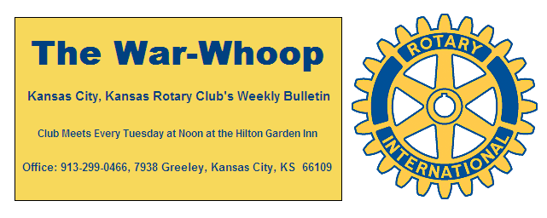
Websites: Club: www.rotarydowntownkck.org, District: www.rotary5710.org, International: www.rotary.org

Volume 77 February 25, 2016 No. 33

LAST WEEK AT ROTARY- Congratulations to Mayor Mark Holland for a great report last Tuesday. A very large crowd attended the Mayor’s Annual Report to the Community. Although the firm number has not been sent to us at this time, it was reported that there were between 420-450 people in attendance at the event. The guarantee to the hotel started out at 350, upped to 400 and then we had to add more seats that morning.
The event was also steam lined and the Mayor’s office reported that there were another 450 people watching the luncheon over the internet. This was the first time that the mayor’s luncheon was shown on the internet.
Hank Chamberlain open the meeting and welcome the people to the event. Rick Behrens gave the invocation. Pat Crilly introduced the mayor to the community.
A big thanks goes to Rosemary Podrebarac and Lindsay Behgan (Mayor’s assistant) for all the work they did in organizing another successful report to the community.
Thanks to all the Rotarians who helped out in directing people to their seats.

ROTARIAN LEAVING- Bill Henderson, a new member for a short time, is moving to St. Joseph, Missouri. Bill will become the Public Safety Director for the city. We would like to wish Bill the very best in the future, he will be missed.

.

NEXT WEEK AT ROTARY- Michelle Rivera of Spay and Neuter KC will be talking about the new clinic in KCKs at the Tower Plaza and the work of the clinic in general.

John Freshnock will be the program chairman for the day and for the month.

All Club Members and their guests are invited to the Centennial Gala, a celebration of 100 years of service, on Tuesday, April 5, 2016 at the Lake Quivira Country Club 100 Crescent Blvd, Lake Quivira, Ks 66217.Cocktail reception at 5:30 p.m. with live jazz by the KCKCC ensemble. Dinner at 6:30, Program to follow. $50 per person. Please RSVP to Jim Knight for this splendid evening of fellowship and celebration.

KANSAS CITY DAY- Don’t forget to add Kansas City Day on your busy schedules. We will again be selling papers on Monday, April 4th. Chairman Dan Duncan will be keeping you up to date.

PAST PRESIDENT NEWS- Past President Ivan Bartolome 2002-2003 called on Tuesday to ask about the Centennial Gala on April 5th. Ivan and his family now reside in Dallas, Texas.

BITS AND PIECES- The weekly Paul Harris drawing was started in September 1993.
The new format of the War Whoop was printed 1n 1971. Bob Kimball was president at the time.
Our Rotary Club was the host for the Big Eight Luncheon during the holidays in 1971. We hosted the luncheon for three years and then was moved across the river.

. 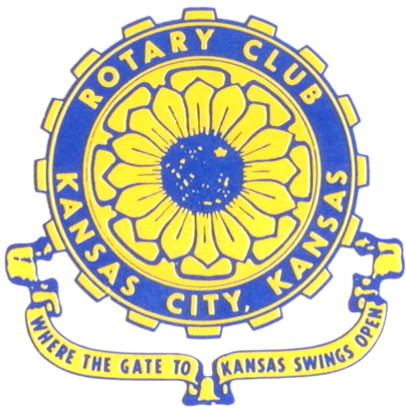
Where the Gate to Kansas Swings Open

The Kansas City, Kansas Rotary Club was organized on November 2, 1915 and received its charter as Club No. 195 in January 1916. Its members take pride in more than 90 years of Rotary service to the community and to international fellowship. From this Club have come five District Governors and two Directors of Rotary International. The Club’s history is as rich as that of the community it represents.

Following the Lewis and Clark expedition which camped at the confluence of the Kansas and Missouri rivers on June 26, 1804, in present day Kansas City, Kansas, this area became an important center for fur trappers. In the following years, many Indian tribes were relocated here from the East. In 1842 the Wyandot Indians acquired land here and founded a town. During this period, and for the next five decades, this area became the main gateway to the inviting majesty of the sprawling Kansas Prairie and the American West. This was where the frontier began. Pioneers found river transportation, outfitters and the beginning of the Santa Fe and Oregon Trails. After the covered wagons came major trunk railroads and barge lines.

In 1886, Kansas City, Kansas received its charter as an incorporated city, combining the towns of Wyandot, Argentine and Armourdale. (Rosedale was added in 1922.) Kansas City, Kansas is the site of the first industrial park in the United States, home of the prestigious University of Kansas Medical Center, and the location of the National Agricultural Hall of Fame and the nationally recognized Kansas Speedway.

Near the geographical and population centers of the contiguous United States, it is in the temperate latitudes at an elevation of 726 feet above sea level. The average rainfall is 35 inches. The average mean temperature ranges from 30°F in January to 80°F in July. The lowest recorded temperature was -23°F on December 23, 1989, and the highest was 113°F on August 14, 1936. Our city’s population of 145,000 and 155 square miles rank it 158th among cities in the United States.

Welcome to Kansas City, Kansas Rotary, and the vibrant community it represents.

Service Above Self

Rotary Websites:
KCK Club: www.rotarydowntownkck.org, District: www.rotary5710.org, International: www.rotary.org



WHERE NEARBY TO MAKE UP ATTENDANCE
MONDAY
Bonner Springs (11:45am) --------------------------------- Twister Bar & Grill, 13100 Kansas Ave.
Overland Park (11:30am) ----------------------------------- Doubletree Hotel, 10100 College Blvd.
TUESDAY
Gladstone (7:00am) -------------------------------------- Fairview Christian Church, 1800 N.E. 65th
Johnson County-Sunset (5:15pm) --------------(Grand Street Café) 8815 Renner Rd, Lenexa
WEDNESDAY
Overland Park South (7:15am) ------------------------ Deer Creek Country Club, 7000 W. 133rd
Leavenworth (Noon) --------------------------- Riverfront Community Center, 123 S. Esplanade
KCI, Missouri (Noon) -------------------------------- KCI Expo Center, 11730 N. Ambassador Dr.
Shawnee Mission (Noon) ----------------------------- Sylvester Powell Center, Martway & Lamar
Olathe (Noon) ------------------------------ Mahaffie/Heritage Center, 1200 E. Kansas City Road
Kansas City South, Missouri (Noon) ----------------------------- EBT, 1310 Carondolet, 2nd Floor
THURSDAY
South Platte, Missouri (7:00am) ----------------------- Trezo Mare, 4105 Mulberry Drive, KCMO
Johnson County (7:15am) --------------------------- Crowne Plaza Hotel, 12601 W. 95th, Lenexa
Leawood (7:15am) ---------------------------------------- Hereford House, Town Center Dr. & Nall
Village West (7:15am) -------------------------- Dave & Buster’s, 1843 Village West Pkwy., KCK
Gardner (7:30am) ---------------------------------------------------- Senior Citizen Bldg., 128 E. Park
Olathe Santa Fe Trail (7:30am) --- Mid-Am Nazarene U, 2030 E. College Way, Campus Ctr.
Kansas City, Missouri (Noon) -------------------------------- The Gallery, 61 E. 14th Street, KCMO
FRIDAY
Desoto (7:00am) ------------------------ Desoto United Methodist Church, 8760 Kill Creek Road
Shawnee (7:15am) --------------------------------------------------- Town Hall, 11600 Johnson Drive
Plaza, Missouri (7:15am) -------------------------------- Intercontinental Hotel, 401 Ward Parkway
North Kansas City, Missouri (Noon) ------------------------------ Finnigan’s Hall, 505 E. 18th Ave.
Parkville, Missouri (Noon) ------------------------ Park University Underground, Woodard Center
Lenexa (Noon) ------------------------------- Lakeview Village, Northpointe Bldg., 91st & Park St.

Meeting make ups can be made 14 days before or after the missed meeting.
Please see the Secretary for the world directory of all Rotary Club’s meeting times, days and places.

2015-2016 Board of Directors
Officers Directors
Hank Chamberlain Rick Behrens
President Karole Bradford
Ashley Adorante John Freshnock
Vice President Phil Gibbs
Greg Shondell Melissa Mundt
Treasurer Bruce Schlosser
Jim Knight Donna Severance
Secretary Mark Wiebe
Rosemary Podrebarac Fred Zimmerman
Sergeant at Arms
Ken Davis
Past President

