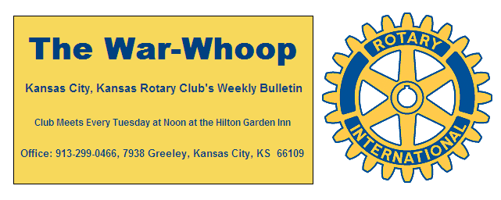
Websites: Club: www.rotarydowntownkck.org, District: www.rotary5710.org, International: www.rotary.org

Volume 77 March 25, 2016 No. 38

LAST WEEK AT ROTARY- Randy Gorton and Lideana Lahoy presented the program last Tuesday. Lideana, City Traffic Engineer for the Unified Government, and Randy, an engineer for the BHC Firm talked and showed a power point presentation on the problems with the pedestrian and auto traffic on Central Avenue. There is a big need for parking on the avenue. The major project will begin in the spring of 2017. They will use a part of the maintenance budget of the city, Some of the things that need to be done in 2016 are pavement overlay, sidewalk ramps, and traffic light improvements. Bike lanes will be added and the street markings will be standardized, diagonal parking added and miles per hour will be increased to 30 MPH on Central Avenue. The street sidewalks will be brought up to ADA requirements. Both speakers answered questions after their presentations.

President Hank opened the meeting and Scott Kaufmann gave the invocation. Scott Kaufmann led the singing and Scott Anglemyer introduced the visitors. Cathia Hahner was a guest of Wendell Maddox. A moment of silent prayer was held for those killed in Belgium Tuesday morning

PAUL HARRIS DRAWING- Scott Anglemyer won the right to draw for the joker last week. Scott did not draw the joker and the amount will go to $45.00 for the next week’s drawing.

KANSAS CITY DAY- Dan Duncan reminded members that Kansas City Day is on Friday, April 1^{st.}. Dan told members last week that if anyone needed a corner to work on, please give him a call at 913-573-2911.

NEXT WEEK AT ROTARY- Rotary will meet at the DOTTE SPOT next week for our 5th week event. The social hour will begin at 4:00pm and will go to ??. Scott Kaufmann and Dan Duncan have a fun evening planned for all members. The Dotte Spot is located on the south side of Parallel in the 8100 block
.
All Club Members and their guests are invited to the Centennial Gala, a celebration of 100 years of service, on Tuesday, April 5, 2016 at the Lake Quivira Country Club 100 Crescent Blvd, Lake Quivira, Ks 66217.Cocktail reception at 5:30 p.m. with live jazz by the KCKCC ensemble. Dinner at 6:30, Program to follow. $50 per person. Please RSVP to Jim Knight for this splendid evening of fellowship and celebration.

LAST CHANCE TO SIGN UP FOR THIS MAJOR EVENT OF THE KANSAS CITY, KANSAS ROTARY CLUB.
****Rotarians will receive credit for their luncheons that day. Members will be billed on their quarterly statement for the dinner.
There are 98 reservations made for the dinner at this time. Past presidents that have made reservations are Dick Bond, Owen Kross, Ivan Bartolome, DuMont Reed. These names bring back some great memories. Don’t miss out on this SPECIAL NIGHT.

WELCOME BACK- Mark Wiebe was back last Tuesday. Mark has had to resigned from Rotary due to cut backs at Wyandotte Inc.

DAFFIDOLS- Ken Davis has taken pictures of the daffodils in bloom at several schools and we will try to reproduce them for members as an attachment. Please note the file is too large to send with the bulletin, so will try to send it by separate email.

BOARD MEETING- The board meeting for April has been rescheduled for Wednesday, April 13th at the hotel

. 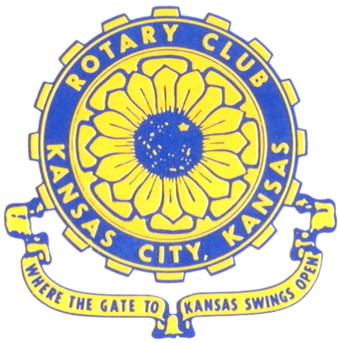
Where the Gate to Kansas Swings Open

The Kansas City, Kansas Rotary Club was organized on November 2, 1915 and received its charter as Club No. 195 in January 1916. Its members take pride in more than 90 years of Rotary service to the community and to international fellowship. From this Club have come five District Governors and two Directors of Rotary International. The Club’s history is as rich as that of the community it represents.

Following the Lewis and Clark expedition which camped at the confluence of the Kansas and Missouri rivers on June 26, 1804, in present day Kansas City, Kansas, this area became an important center for fur trappers. In the following years, many Indian tribes were relocated here from the East. In 1842 the Wyandot Indians acquired land here and founded a town. During this period, and for the next five decades, this area became the main gateway to the inviting majesty of the sprawling Kansas Prairie and the American West. This was where the frontier began. Pioneers found river transportation, outfitters and the beginning of the Santa Fe and Oregon Trails. After the covered wagons came major trunk railroads and barge lines.

In 1886, Kansas City, Kansas received its charter as an incorporated city, combining the towns of Wyandot, Argentine and Armourdale. (Rosedale was added in 1922.) Kansas City, Kansas is the site of the first industrial park in the United States, home of the prestigious University of Kansas Medical Center, and the location of the National Agricultural Hall of Fame and the nationally recognized Kansas Speedway.

Near the geographical and population centers of the contiguous United States, it is in the temperate latitudes at an elevation of 726 feet above sea level. The average rainfall is 35 inches. The average mean temperature ranges from 30°F in January to 80°F in July. The lowest recorded temperature was -23°F on December 23, 1989, and the highest was 113°F on August 14, 1936. Our city’s population of 145,000 and 155 square miles rank it 158th among cities in the United States.

Welcome to Kansas City, Kansas Rotary, and the vibrant community it represents.

Service Above Self

Rotary Websites:
KCK Club: www.rotarydowntownkck.org, District: www.rotary5710.org, International: www.rotary.org



WHERE NEARBY TO MAKE UP ATTENDANCE
MONDAY
Bonner Springs (11:45am) --------------------------------- Twister Bar & Grill, 13100 Kansas Ave.
Overland Park (11:30am) ----------------------------------- Doubletree Hotel, 10100 College Blvd.
TUESDAY
Gladstone (7:00am) -------------------------------------- Fairview Christian Church, 1800 N.E. 65th
Johnson County-Sunset (5:15pm) --------------(Grand Street Café) 8815 Renner Rd, Lenexa
WEDNESDAY
Overland Park South (7:15am) ------------------------ Deer Creek Country Club, 7000 W. 133rd
Leavenworth (Noon) --------------------------- Riverfront Community Center, 123 S. Esplanade
KCI, Missouri (Noon) -------------------------------- KCI Expo Center, 11730 N. Ambassador Dr.
Shawnee Mission (Noon) ----------------------------- Sylvester Powell Center, Martway & Lamar
Olathe (Noon) ------------------------------ Mahaffie/Heritage Center, 1200 E. Kansas City Road
Kansas City South, Missouri (Noon) ----------------------------- EBT, 1310 Carondolet, 2nd Floor
THURSDAY
South Platte, Missouri (7:00am) ----------------------- Trezo Mare, 4105 Mulberry Drive, KCMO
Johnson County (7:15am) --------------------------- Crowne Plaza Hotel, 12601 W. 95th, Lenexa
Leawood (7:15am) ---------------------------------------- Hereford House, Town Center Dr. & Nall
Village West (7:15am) -------------------------- Dave & Buster’s, 1843 Village West Pkwy., KCK
Gardner (7:30am) ---------------------------------------------------- Senior Citizen Bldg., 128 E. Park
Olathe Santa Fe Trail (7:30am) --- Mid-Am Nazarene U, 2030 E. College Way, Campus Ctr.
Kansas City, Missouri (Noon) -------------------------------- The Gallery, 61 E. 14th Street, KCMO
FRIDAY
Desoto (7:00am) ------------------------ Desoto United Methodist Church, 8760 Kill Creek Road
Shawnee (7:15am) --------------------------------------------------- Town Hall, 11600 Johnson Drive
Plaza, Missouri (7:15am) -------------------------------- Intercontinental Hotel, 401 Ward Parkway
North Kansas City, Missouri (Noon) ------------------------------ Finnigan’s Hall, 505 E. 18th Ave.
Parkville, Missouri (Noon) ------------------------ Park University Underground, Woodard Center
Lenexa (Noon) ------------------------------- Lakeview Village, Northpointe Bldg., 91st & Park St.

Meeting make ups can be made 14 days before or after the missed meeting.
Please see the Secretary for the world directory of all Rotary Club’s meeting times, days and places.

2015-2016 Board of Directors
Officers Directors
Hank Chamberlain Rick Behrens
President Karole Bradford
Ashley Adorante John Freshnock
Vice President Phil Gibbs
Greg Shondell Melissa Mundt
Treasurer Bruce Schlosser
Jim Knight Donna Severance
Secretary Mark Wiebe
Rosemary Podrebarac Fred Zimmerman
Sergeant at Arms
Ken Davis
Past President

