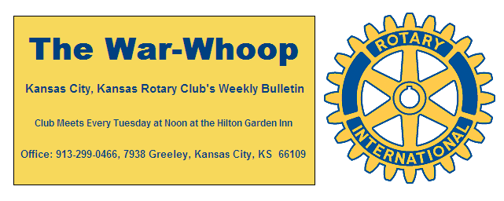
Websites: Club: www.rotarydowntownkck.org, District: www.rotary5710.org, International: www.rotary.org

Volume 77 April 15, 2016 No. 41

LAST WEEK AT ROTARY- Male students from seven local high schools talked about their lives and what they hope to accomplish in the future. The young men did a great job in representing their schools. Terry Robinson acted as the master of ceremonies for the event.

President Hank opened the meeting and Dan Duncan gave the invocation. Scott Kaufmann led the singing and Dave Tyler introduced the visiting Rotarians and guests. Jim Grassi, Rotarian from Shawnee Mission, made up. There were many guests visiting last Tuesday supporting the students.

SERVERS LEAVING- Our faithful servers over the years served us for the last time last Tuesday. The hotel and the Reardon Center changed ownership on April13th. The ladies have been very good to our club over the years and will be missed. They did so many little things that we took for granted.
Members gave them a standing ovation when the announce-ment was made by President Hank.

SORRY- We missed Bill Epperheimer when we printed the names of members that have been in Rotary over twenty-five years. Bill has been a member of Rotary since 1986.

PAUL HARRIS DRAWING- Wendell Maddox won the right to draw for the joker last week. Wendell did not draw the joke and the amount will go to $60.00 for next week’s drawing.

NEXT WEEK AT ROTARY- The female students from local high schools will be speaking next week trying to earn a one thousand dollar scholarship from our Rotary Club. We are scheduled to l be in the Wyandot Room for the program next week.

Terry Robinson is the program chairman for the day and for the month of April.

100 YEAR PRESENTATION- President Hank presented Bob Kimball with his Hard Copy of the 100th year history of our Club.

KANSAS CITY DAY- Chairman Dan Duncan reported that our Club raised a total of $2,502.52 from selling newspapers on April 1st. Half of the money raised willt go to youth charities in our town. The board met on Wednesday and will give half of the proceeds to the Boy Scouts and the other half to Turner House. The other half of the money that was raised goes to the Kansas City, Missouri Rotary Youth Camp.

DISTRICT GOLF TOURNAMENT- The district golf tour-nament will be held on Friday, April 22nd at the Leavenworth Country Club. Pat Crilly and Merle Parks have signed up, but need two more members to make a foursome. Cost of the day is $75.00 per person. Any member that would be interested in joining Pat and Merle should contact Pat at (913)-371-3355.

HOTEL CHANGE- There will be two groups handling the change of the hotel and the Reardon Center. The hotel will remain under the same name with the change, but Reardon Center will be run by the Unified Government and Rotary will have a private caterer serving the club’s luncheons.

STATEMENTS- Statements will be given to members in attendance next week. Statements will include all activities up to and including April 5th.

. 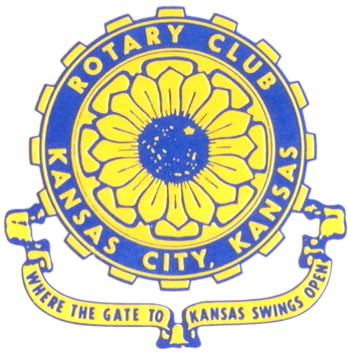
Where the Gate to Kansas Swings Open

The Kansas City, Kansas Rotary Club was organized on November 2, 1915 and received its charter as Club No. 195 in January 1916. Its members take pride in more than 90 years of Rotary service to the community and to international fellowship. From this Club have come five District Governors and two Directors of Rotary International. The Club’s history is as rich as that of the community it represents.

Following the Lewis and Clark expedition which camped at the confluence of the Kansas and Missouri rivers on June 26, 1804, in present day Kansas City, Kansas, this area became an important center for fur trappers. In the following years, many Indian tribes were relocated here from the East. In 1842 the Wyandot Indians acquired land here and founded a town. During this period, and for the next five decades, this area became the main gateway to the inviting majesty of the sprawling Kansas Prairie and the American West. This was where the frontier began. Pioneers found river transportation, outfitters and the beginning of the Santa Fe and Oregon Trails. After the covered wagons came major trunk railroads and barge lines.

In 1886, Kansas City, Kansas received its charter as an incorporated city, combining the towns of Wyandot, Argentine and Armourdale. (Rosedale was added in 1922.) Kansas City, Kansas is the site of the first industrial park in the United States, home of the prestigious University of Kansas Medical Center, and the location of the National Agricultural Hall of Fame and the nationally recognized Kansas Speedway.

Near the geographical and population centers of the contiguous United States, it is in the temperate latitudes at an elevation of 726 feet above sea level. The average rainfall is 35 inches. The average mean temperature ranges from 30°F in January to 80°F in July. The lowest recorded temperature was -23°F on December 23, 1989, and the highest was 113°F on August 14, 1936. Our city’s population of 145,000 and 155 square miles rank it 158th among cities in the United States.

Welcome to Kansas City, Kansas Rotary, and the vibrant community it represents.

Service Above Self

Rotary Websites:
KCK Club: www.rotarydowntownkck.org, District: www.rotary5710.org, International: www.rotary.org



WHERE NEARBY TO MAKE UP ATTENDANCE
MONDAY
Bonner Springs (11:45am) --------------------------------- Twister Bar & Grill, 13100 Kansas Ave.
Overland Park (11:30am) ----------------------------------- Doubletree Hotel, 10100 College Blvd.
TUESDAY
Gladstone (7:00am) -------------------------------------- Fairview Christian Church, 1800 N.E. 65th
Johnson County-Sunset (5:15pm) --------------(Grand Street Café) 8815 Renner Rd, Lenexa
WEDNESDAY
Overland Park South (7:15am) ------------------------ Deer Creek Country Club, 7000 W. 133rd
Leavenworth (Noon) --------------------------- Riverfront Community Center, 123 S. Esplanade
KCI, Missouri (Noon) -------------------------------- KCI Expo Center, 11730 N. Ambassador Dr.
Shawnee Mission (Noon) ----------------------------- Sylvester Powell Center, Martway & Lamar
Olathe (Noon) ------------------------------ Mahaffie/Heritage Center, 1200 E. Kansas City Road
Kansas City South, Missouri (Noon) ----------------------------- EBT, 1310 Carondolet, 2nd Floor
THURSDAY
South Platte, Missouri (7:00am) ----------------------- Trezo Mare, 4105 Mulberry Drive, KCMO
Johnson County (7:15am) --------------------------- Crowne Plaza Hotel, 12601 W. 95th, Lenexa
Leawood (7:15am) ---------------------------------------- Hereford House, Town Center Dr. & Nall
Village West (7:15am) -------------------------- Dave & Buster’s, 1843 Village West Pkwy., KCK
Gardner (7:30am) ---------------------------------------------------- Senior Citizen Bldg., 128 E. Park
Olathe Santa Fe Trail (7:30am) --- Mid-Am Nazarene U, 2030 E. College Way, Campus Ctr.
Kansas City, Missouri (Noon) -------------------------------- The Gallery, 61 E. 14th Street, KCMO
FRIDAY
Desoto (7:00am) ------------------------ Desoto United Methodist Church, 8760 Kill Creek Road
Shawnee (7:15am) --------------------------------------------------- Town Hall, 11600 Johnson Drive
Plaza, Missouri (7:15am) -------------------------------- Intercontinental Hotel, 401 Ward Parkway
North Kansas City, Missouri (Noon) ------------------------------ Finnigan’s Hall, 505 E. 18th Ave.
Parkville, Missouri (Noon) ------------------------ Park University Underground, Woodard Center
Lenexa (Noon) ------------------------------- Lakeview Village, Northpointe Bldg., 91st & Park St.

Meeting make ups can be made 14 days before or after the missed meeting.
Please see the Secretary for the world directory of all Rotary Club’s meeting times, days and places.

2015-2016 Board of Directors
Officers Directors
Hank Chamberlain Rick Behrens
President Karole Bradford
Ashley Adorante John Freshnock
Vice President Phil Gibbs
Greg Shondell Melissa Mundt
Treasurer Bruce Schlosser
Jim Knight Donna Severance
Secretary Mark Wiebe
Rosemary Podrebarac Fred Zimmerman
Sergeant at Arms
Ken Davis
Past President

