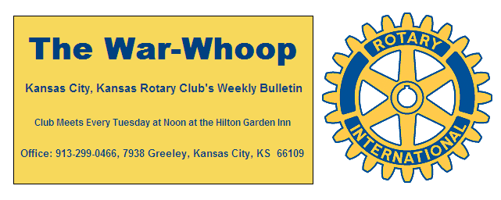
Websites: Club: www.rotarydowntownkck.org, District: www.rotary5710.org, International: www.rotary.org

Volume 77 June 2, 2016 No. 48

LAST WEEK AT ROTARY- there will not be a report on the 5th Tuesday evening last week. The secretary is out of town this week making his annual trek to Bennett Springs trying to catch a few trout.

NEW MEMBERS- There are three new members that have joined Rotary over the past month. Introduce yourself to them and make them feel welcome. Sponsors should make a special effort to introduce new members. The idea of having the new member sit at the head table is to introduce that member to the club.

HOW DOES A MEMBER PROPOSE A NEW MEMBER?
- A member picks up a proposal card from the secretary.
- The proposed member then fills out the proposal card and gives it back to the secretary. The proposer should explain the costs and the attendance requirements at the very beginning.
- The secretary then presents the name of the individual to the board for their approval.
- The name of the proposer and the name of the new person in printed in the weekly bulletin for membership approval.
- Once the individual’s name has been presented to both the board and the membership, the person sits at the head table for three (3) weeks to be introduced to the membership.

PROGRAM NEXT WEEK- Peter Wetzel, Director for the Rainbow Freedom School will be our speaker next week. Mr. Wetzel will be talking about the reading program that will be held at the Rainbow Mennonite Church again this summer and he will bring us up to date on what is happening.

Karen Hostetler will be the program chair for the day. Pat Crilly is the program chairman for the month.

*********************************************************************
Propose a new member (con’t)
6.The proposer should prepare a bio on the new member for introduction and then introduces the new member the first time from the head table.

ATTENDANCE- Attendance is important for all members for fellowship in Rotary. Members may make up at another Club meeting within two weeks before or two weeks after a meeting. The member will receive financial and attendance credit for the make up on the next quarterly billing date. Making up at another club affords a member an opportunity to make new business friends in the metropolitan area. Clubs and their meeting times and locations are located on the back of your War Whoops.

T BONES NIGHT- The T Bones baseball evening will be held on June 21st. This is always a fun night when Rotary will have Tail gate party prior to the game. This is always fun event for Rotarians and their families. More details later. Cost of the ticket is $10.00 per person and that includes the TAIL GATE PARTY AND THE GAME. There are 50 tickets and 48 tickets are gone for that night.

INAUGURAL DINNER- The Inaugural Dinner has been scheduled for Tuesday, July 5th. Mark this date on your calendar this week. The time and place will be announced at a later date.

. 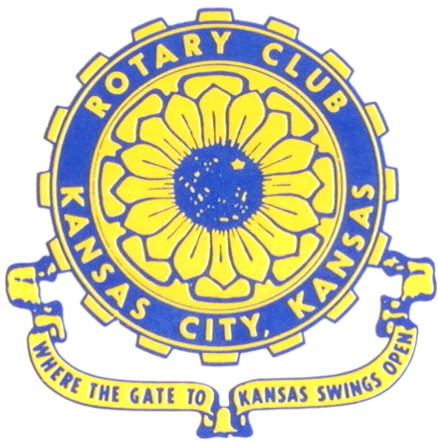
Where the Gate to Kansas Swings Open

The Kansas City, Kansas Rotary Club was organized on November 2, 1915 and received its charter as Club No. 195 in January 1916. Its members take pride in more than 90 years of Rotary service to the community and to international fellowship. From this Club have come five District Governors and two Directors of Rotary International. The Club’s history is as rich as that of the community it represents.

Following the Lewis and Clark expedition which camped at the confluence of the Kansas and Missouri rivers on June 26, 1804, in present day Kansas City, Kansas, this area became an important center for fur trappers. In the following years, many Indian tribes were relocated here from the East. In 1842 the Wyandot Indians acquired land here and founded a town. During this period, and for the next five decades, this area became the main gateway to the inviting majesty of the sprawling Kansas Prairie and the American West. This was where the frontier began. Pioneers found river transportation, outfitters and the beginning of the Santa Fe and Oregon Trails. After the covered wagons came major trunk railroads and barge lines.

In 1886, Kansas City, Kansas received its charter as an incorporated city, combining the towns of Wyandot, Argentine and Armourdale. (Rosedale was added in 1922.) Kansas City, Kansas is the site of the first industrial park in the United States, home of the prestigious University of Kansas Medical Center, and the location of the National Agricultural Hall of Fame and the nationally recognized Kansas Speedway.

Near the geographical and population centers of the contiguous United States, it is in the temperate latitudes at an elevation of 726 feet above sea level. The average rainfall is 35 inches. The average mean temperature ranges from 30°F in January to 80°F in July. The lowest recorded temperature was -23°F on December 23, 1989, and the highest was 113°F on August 14, 1936. Our city’s population of 145,000 and 155 square miles rank it 158th among cities in the United States.

Welcome to Kansas City, Kansas Rotary, and the vibrant community it represents.

Service Above Self

Rotary Websites:
KCK Club: www.rotarydowntownkck.org, District: www.rotary5710.org, International: www.rotary.org



WHERE NEARBY TO MAKE UP ATTENDANCE
MONDAY
Bonner Springs (11:45am) --------------------------------- Twister Bar & Grill, 13100 Kansas Ave.
Overland Park (11:30am) ----------------------------------- Doubletree Hotel, 10100 College Blvd.
TUESDAY
Gladstone (7:00am) -------------------------------------- Fairview Christian Church, 1800 N.E. 65th
Johnson County-Sunset (5:15pm) --------------(Grand Street Café) 8815 Renner Rd, Lenexa
WEDNESDAY
Overland Park South (7:15am) ------------------------ Deer Creek Country Club, 7000 W. 133rd
Leavenworth (Noon) --------------------------- Riverfront Community Center, 123 S. Esplanade
KCI, Missouri (Noon) -------------------------------- KCI Expo Center, 11730 N. Ambassador Dr.
Shawnee Mission (Noon) ----------------------------- Sylvester Powell Center, Martway & Lamar
Olathe (Noon) ------------------------------ Mahaffie/Heritage Center, 1200 E. Kansas City Road
Kansas City South, Missouri (Noon) ----------------------------- EBT, 1310 Carondolet, 2nd Floor
THURSDAY
South Platte, Missouri (7:00am) ----------------------- Trezo Mare, 4105 Mulberry Drive, KCMO
Johnson County (7:15am) --------------------------- Crowne Plaza Hotel, 12601 W. 95th, Lenexa
Leawood (7:15am) ---------------------------------------- Hereford House, Town Center Dr. & Nall
Village West (7:15am) -------------------------- Dave & Buster’s, 1843 Village West Pkwy., KCK
Gardner (7:30am) ---------------------------------------------------- Senior Citizen Bldg., 128 E. Park
Olathe Santa Fe Trail (7:30am) --- Mid-Am Nazarene U, 2030 E. College Way, Campus Ctr.
Kansas City, Missouri (Noon) -------------------------------- The Gallery, 61 E. 14th Street, KCMO
FRIDAY
Desoto (7:00am) ------------------------ Desoto United Methodist Church, 8760 Kill Creek Road
Shawnee (7:15am) --------------------------------------------------- Town Hall, 11600 Johnson Drive
Plaza, Missouri (7:15am) -------------------------------- Intercontinental Hotel, 401 Ward Parkway
North Kansas City, Missouri (Noon) ------------------------------ Finnigan’s Hall, 505 E. 18th Ave.
Parkville, Missouri (Noon) ------------------------ Park University Underground, Woodard Center
Lenexa (Noon) ------------------------------- Lakeview Village, Northpointe Bldg., 91st & Park St.

Meeting make ups can be made 14 days before or after the missed meeting.
Please see the Secretary for the world directory of all Rotary Club’s meeting times, days and places.

2015-2016 Board of Directors
Officers Directors
Hank Chamberlain Rick Behrens
President Karole Bradford
Ashley Adorante John Freshnock
Vice President Phil Gibbs
Greg Shondell Melissa Mundt
Treasurer Bruce Schlosser
Jim Knight Donna Severance
Secretary Mark Wiebe
Rosemary Podrebarac Fred Zimmerman
Sergeant at Arms
Ken Davis
Past President

