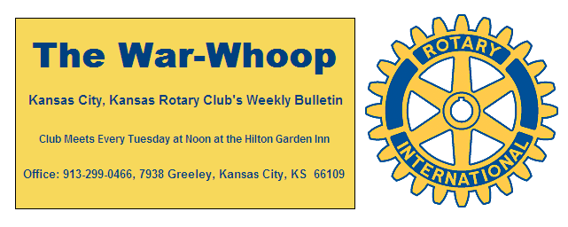
Websites: Club: www.rotarydowntownkck.org, District: www.rotary5710.org, International: www.rotary.org

Volume 77 June 9, 2016 No. 49

LAST WEEK AT ROTARY- Peter Wetzel, Director of the Rainbow Freedom School, talked about their youth literacy program for the summer. The overarching message of the program for the children is” I can make a difference in myself, family, community, country, and world with hope, education and action.”
Mr. Wetzel use a power point presentation to show some of our own Rotarians working with children. He told the group that there were thirteen Rotarians involved in the program last year. There are 100 children in the program again this year. These children are divided in to ten groups. He added that over 90% improve their reading during the summer session.
Mr. Wetzel asked for Rotarians to help again this summer. The program starts on June 20h and runs for six weeks.

President Hank opened the meeting and Pat Crilly gave the invocation. Scott Kauffman led the singing and Dave Tyler introduced the visitors. A guest of Ken Davis, Mike Caldwell turned his application for membership into the secretary for processing.

HAPPY BIRTHDAY- Scott led members in singing “Happy Birthday” to members with birthdays in June. Members with birthdays were Wendell Maddox, Merle Parks and Greg Shondell.

PROGRAM NEXT WEEK- Daniel Silca, Executive Director for our local Chamber of Commerce, will be our speaker next week

Pat Crilly will be the program chairman for the day and for the month.

***Another reminder to all program chairs for the new year that they will have to provide their own projectors for programs. We have found a screen at the center that will be able to use for further programs.

NEW MEMBER- Melissa Mundt introduced the new-est member in the person of Kathleen VonAchen. Kathleen is the new Chief Financial Officer for the Unified Government of Wyandotte County. Her class-ification in Rotary will be Government -Finance. Please welcome Kathleen when you meet her next week.

MULLARKY MINUTE- Bill gave one of his famous minute last Tuesday regarding introducing a person to Rotary.

OUR ROAMING ROTARIAN
Shawnee Mission--------------------------------Dave Tyler

T BONES NIGHT- The T Bones baseball evening will be held on June 21st. This is always a fun night when Rotary will have Tail gate party prior to the game. This is always fun event for Rotarians and their families. The tailgate party will begin at 5:00pm. Chairman Dan Duncan told members last week that we will again meet in the NORTHWEST CORNER of the parking lot. Members do not have to go to the ball game, just come out for an evening of fellowship with fellow Rotarians and their families. WE still have two tickets left for the ball game.

. 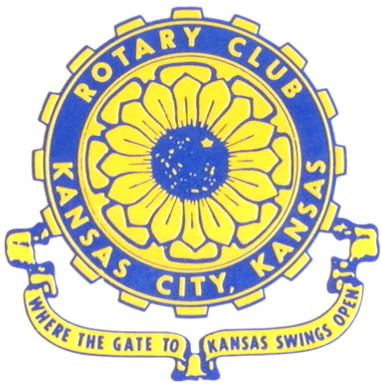
Where the Gate to Kansas Swings Open

The Kansas City, Kansas Rotary Club was organized on November 2, 1915 and received its charter as Club No. 195 in January 1916. Its members take pride in more than 90 years of Rotary service to the community and to international fellowship. From this Club have come five District Governors and two Directors of Rotary International. The Club’s history is as rich as that of the community it represents.

Following the Lewis and Clark expedition which camped at the confluence of the Kansas and Missouri rivers on June 26, 1804, in present day Kansas City, Kansas, this area became an important center for fur trappers. In the following years, many Indian tribes were relocated here from the East. In 1842 the Wyandot Indians acquired land here and founded a town. During this period, and for the next five decades, this area became the main gateway to the inviting majesty of the sprawling Kansas Prairie and the American West. This was where the frontier began. Pioneers found river transportation, outfitters and the beginning of the Santa Fe and Oregon Trails. After the covered wagons came major trunk railroads and barge lines.

In 1886, Kansas City, Kansas received its charter as an incorporated city, combining the towns of Wyandot, Argentine and Armourdale. (Rosedale was added in 1922.) Kansas City, Kansas is the site of the first industrial park in the United States, home of the prestigious University of Kansas Medical Center, and the location of the National Agricultural Hall of Fame and the nationally recognized Kansas Speedway.

Near the geographical and population centers of the contiguous United States, it is in the temperate latitudes at an elevation of 726 feet above sea level. The average rainfall is 35 inches. The average mean temperature ranges from 30°F in January to 80°F in July. The lowest recorded temperature was -23°F on December 23, 1989, and the highest was 113°F on August 14, 1936. Our city’s population of 145,000 and 155 square miles rank it 158th among cities in the United States.

Welcome to Kansas City, Kansas Rotary, and the vibrant community it represents.

Service Above Self

Rotary Websites:
KCK Club: www.rotarydowntownkck.org, District: www.rotary5710.org, International: www.rotary.org



WHERE NEARBY TO MAKE UP ATTENDANCE
MONDAY
Bonner Springs (11:45am) --------------------------------- Twister Bar & Grill, 13100 Kansas Ave.
Overland Park (11:30am) ----------------------------------- Doubletree Hotel, 10100 College Blvd.
TUESDAY
Gladstone (7:00am) -------------------------------------- Fairview Christian Church, 1800 N.E. 65th
Johnson County-Sunset (5:15pm) --------------(Grand Street Café) 8815 Renner Rd, Lenexa
WEDNESDAY
Overland Park South (7:15am) ------------------------ Deer Creek Country Club, 7000 W. 133rd
Leavenworth (Noon) --------------------------- Riverfront Community Center, 123 S. Esplanade
KCI, Missouri (Noon) -------------------------------- KCI Expo Center, 11730 N. Ambassador Dr.
Shawnee Mission (Noon) ----------------------------- Sylvester Powell Center, Martway & Lamar
Olathe (Noon) ------------------------------ Mahaffie/Heritage Center, 1200 E. Kansas City Road
Kansas City South, Missouri (Noon) ----------------------------- EBT, 1310 Carondolet, 2nd Floor
THURSDAY
South Platte, Missouri (7:00am) ----------------------- Trezo Mare, 4105 Mulberry Drive, KCMO
Johnson County (7:15am) --------------------------- Crowne Plaza Hotel, 12601 W. 95th, Lenexa
Leawood (7:15am) ---------------------------------------- Hereford House, Town Center Dr. & Nall
Village West (7:15am) -------------------------- Dave & Buster’s, 1843 Village West Pkwy., KCK
Gardner (7:30am) ---------------------------------------------------- Senior Citizen Bldg., 128 E. Park
Olathe Santa Fe Trail (7:30am) --- Mid-Am Nazarene U, 2030 E. College Way, Campus Ctr.
Kansas City, Missouri (Noon) -------------------------------- The Gallery, 61 E. 14th Street, KCMO
FRIDAY
Desoto (7:00am) ------------------------ Desoto United Methodist Church, 8760 Kill Creek Road
Shawnee (7:15am) --------------------------------------------------- Town Hall, 11600 Johnson Drive
Plaza, Missouri (7:15am) -------------------------------- Intercontinental Hotel, 401 Ward Parkway
North Kansas City, Missouri (Noon) ------------------------------ Finnigan’s Hall, 505 E. 18th Ave.
Parkville, Missouri (Noon) ------------------------ Park University Underground, Woodard Center
Lenexa (Noon) ------------------------------- Lakeview Village, Northpointe Bldg., 91st & Park St.

Meeting make ups can be made 14 days before or after the missed meeting.
Please see the Secretary for the world directory of all Rotary Club’s meeting times, days and places.

2015-2016 Board of Directors
Officers Directors
Hank Chamberlain Rick Behrens
President Karole Bradford
Ashley Adorante John Freshnock
Vice President Phil Gibbs
Greg Shondell Melissa Mundt
Treasurer Bruce Schlosser
Jim Knight Donna Severance
Secretary Mark Wiebe
Rosemary Podrebarac Fred Zimmerman
Sergeant at Arms
Ken Davis
Past President

