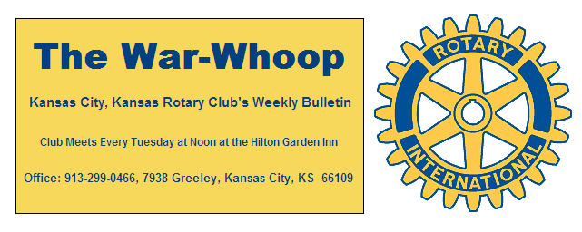
Websites: Club: www.rotarydowntownkck.org, District: www.rotary5710.org, International: www.rotary.org

Volume 78 August 5, 2016 No. 05
LAST WEEK AT ROTARY- Member Melissa Mundt, Assistant County Administrator for the Unified Government, talked about the efforts of the local government to revitalize some of the blighted areas in the city. She told Rotarians that there is blight all over the city. She has formed this task force to help with communications between the different departments in the local government. She went on to say that there are approximately 6,000 tracts that are considered as blight areas. She touched on code enforcement and the animal control. She talked about packs of dogs that are a danger to the public to a point that people are afraid to be out on the sidewalks. She added that blight is created people who don’t need help, but there are also people that create blight that need the help of the government. She answered questions during her presentation. She will continue with this presentation next week

Vice President Fred Zimmerman opened the meeting and. George Turner gave the invocation. Scott Kaufmann led the singing and Merle Parks introduced our visitors.

HAPPY BIRTHDAY- Scott led members in singing “ Happy Birthday” to Dave Tyler. If we missed someone last Tuesday, please let the secretary know.

PAUL HARRIS DRAWING- John Freshnock won the right to draw for the joker last week. John did not draw the joke and the amount goes to $143 for next week.

PROGRAM FOR NEXT WEEK – Melissa Mundt will finish up with her presentation regarding the blight program for the city.

Melissa is the program chairperson for the day and for the month of August.

CONGRATULATIONS- It was good to see Kyle Fulbright back after what he called a vacation. Kyle was recently married and just returned from his honeymoon.

JULY ATTENDANCE- The following members had 100% attendance for July:
Ashley Adorante Scott Kaufmann Bill Strumillo
Rick Behrens Rosemary Podrebarac Bud Thurston
Pat Crilly Terry Robinson Dave Tyler
Dan Duncan Greg Shondell Lacy Ward
Ken Davis Dave Skidgel Fred Zimmerman
Bill Epperheimer Frank Simonich Bill Mullarky
Just a reminder to make up at another Rotary Club when you miss a meeting. A list of Rotary Club meetings are listed on the back of this War Whoop. A makeup is a great way to make new business contacts.

PICTURES- Pages for the Roster Book for the new year are available from the back desk. Please pick up your updates from Secretary Jim next week at Rotary.

EXCHANGE STUDENT- Our Exchange student, Carlotta Hogan, left this week for Italy to study for one year. We will try and get her email address so that members can keep up with her progress.

IDEAS- From time to time we need filler for the bulletin. If any member has an idea for material, please let the secretary know.

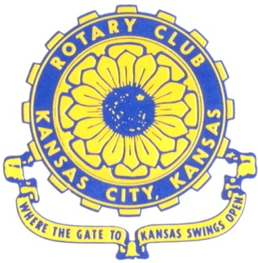
Where the Gate to Kansas Swings Open

The Kansas City, Kansas Rotary Club was organized on November 2, 1915 and received its charter as Club No. 195 in January 1916. Its members take pride in more than 100 years of Rotary service to the community and to international fellowship. From this Club have come five District Governors and two Directors of Rotary International. The Club’s history is as rich as that of the community it represents.

Following the Lewis and Clark expedition which camped at the confluence of the Kansas and Missouri rivers on June 26, 1804, in present day Kansas City, Kansas, this area became an important center for fur trappers. In the following years, many Indian tribes were relocated here from the East. In 1842 the Wyandot Indians acquired land here and founded a town. During this period, and for the next five decades, this area became the main gateway to the inviting majesty of the sprawling Kansas Prairie and the American West. This was where the frontier began. Pioneers found river transportation, outfitters and the beginning of the Santa Fe and Oregon Trails. After the covered wagons came major trunk railroads and barge lines.

In 1886, Kansas City, Kansas received its charter as an incorporated city, combining the towns of Wyandot, Argentine and Armourdale. (Rosedale was added in 1922.) Kansas City, Kansas is the site of the first industrial park in the United States, home of the prestigious University of Kansas Medical Center, and the location of the National Agricultural Hall of Fame and the nationally recognized Kansas Speedway.

Near the geographical and population centers of the contiguous United States, it is in the temperate latitudes at an elevation of 726 feet above sea level. The average rainfall is 35 inches. The average mean temperature ranges from 30°F in January to 80°F in July. The lowest recorded temperature was -23°F on December 23, 1989, and the highest was 113°F on August 14, 1936. Our city’s population of 145,000 and 155 square miles rank it 158th among cities in the United States.

Welcome to Kansas City, Kansas Rotary, and the vibrant community it represents.

Service Above Self

Rotary Websites:
KCK Club: www.rotarydowntownkck.org, District: www.rotary5710.org, International: www.rotary.org

WHERE NEARBY TO MAKE UP ATTENDANCE
MONDAY
Bonner Springs (11:45am) --------------------------------- Twister Bar & Grill, 13100 Kansas Ave.
Overland Park (11:30am) ----------------------------------- Doubletree Hotel, 10100 College Blvd.
TUESDAY
Gladstone (7:00am) -------------------------------------- Fairview Christian Church, 1800 N.E. 65th
Johnson County-Sunset (5:15pm) ------------------------------- Wil Jenny’s, 6700 W. 135th Street
WEDNESDAY
Overland Park South (7:15am) ------------------------ Deer Creek Country Club, 7000 W. 133rd
Leavenworth (Noon) --------------------------- Riverfront Community Center, 123 S. Esplanade
KCI, Missouri (Noon) -------------------------------- KCI Expo Center, 11730 N. Ambassador Dr.
Shawnee Mission (Noon) ----------------------------- Sylvester Powell Center, Martway & Lamar
Olathe (Noon) ------------------------------ Mahaffie/Heritage Center, 1200 E. Kansas City Road
Kansas City South, Missouri (Noon) ----------------------------- EBT, 1310 Carondolet, 2nd Floor
THURSDAY
South Platte, Missouri (7:00am) ----------------------- Trezo Mare, 4105 Mulberry Drive, KCMO
Johnson County (7:15am) --------------------------- Crowne Plaza Hotel, 12601 W. 95th, Lenexa
Leawood (7:15am) ---------------------------------------- Hereford House, Town Center Dr. & Nall
Village West (7:15am) -------------------------- Dave & Buster’s, 1843 Village West Pkwy., KCK
Gardner (7:30am) ---------------------------------------------------- Senior Citizen Bldg., 128 E. Park
Olathe Santa Fe Trail (7:30am) --- Mid-Am Nazarene U, 2030 E. College Way, Campus Ctr.
Kansas City, Missouri (Noon) -------------------------------- The Gallery, 61 E. 14th Street, KCMO
FRIDAY
Desoto (7:00am) ------------------------ Desoto United Methodist Church, 8760 Kill Creek Road
Shawnee (7:15am) --------------------------------------------------- Town Hall, 11600 Johnson Drive
Plaza, Missouri (7:15am) -------------------------------- Intercontinental Hotel, 401 Ward Parkway
North Kansas City, Missouri (Noon) ------------------------------ Finnigan’s Hall, 505 E. 18th Ave.
Parkville, Missouri (Noon) ------------------------ Park University Underground, Woodard Center
Lenexa (Noon) ------------------------------- Lakeview Village, Northpointe Bldg., 91st & Park St.

Meeting make ups can be made 14 days before or after the missed meeting.
Please see the Secretary for the world directory of all Rotary Club’s meeting times, days and places.

2016-2017 Board of Directors
Officers Directors
Ashley Adorante Rick Behrens
President Karole Bradford
Fred Zimmerman John Freshnock
Vice President Phil Gibbs
Greg Shondell Wendell Maddox
Treasurer Melissa Mundt
Jim Knight Bruce Schlosser
Secretary Donna Severance
Rosemary Podrebarac
Sergeant at Arms
Hank Chamberlain
Past President

