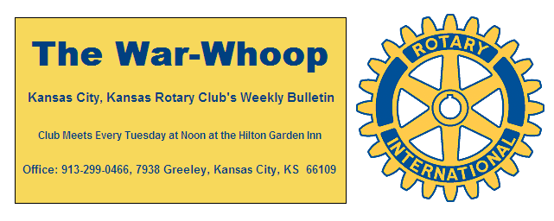
Websites: Club: www.rotarydowntownkck.org, District: www.rotary5710.org, International: www.rotary.org

Volume 78 August 12, 2016 No. 06

LAST WEEK AT ROTARY- Melissa Mundt continued talking about the efforts of the government to clean up the blight in Wyandotte County. They are using study data that has been provided by John Hopkins University. Once the plan is implemented they will turn to the local MARC organization. The process will take a long time. Communication is going to be the major factor in bringing the people together.
She told members that there are 6,000 properties that are not on the tax rolls at this time. She answered many questions about the plan to remove blight from our town.

President Ashley opened the meeting and Lacy Ward gave the invocation. Frank Simonich led the singing and Donna Severance introduced our visitors.

MEMBERSHIP MONTH- Phil Gibbs reminded members that August is designated as MEMBERSHIP MONTH by Rotary International. Phil has prepared small invitation tickets that are at the back table for members to use to invite someone to a luncheon meeting. Pick up a ticket next Tuesday. We had a young woman from a local architectural firm present a card and visited Rotary last Tuesday. She told Rotarians that she was interested in getting involve in the community. There are new people in the community, we just need to locate them.

PROGRAM FOR NEXT WEEK – Member Rick Behrens will be our speaker next week. Rick will be talking about the city’s bicycle and pedrestrain trails available to residents.

Melissa Mundt is the program chairperson for the day and for the month of August.

FIFTH TUESDAY- The Fifth Tuesday evening Happy Hour for the month (August 30th) will be held at AMIGOS located at 47rh and Shawnee Rd. The restaurant is at the north end of the small mall. The evening is set for 5:30pm. This would be a great time to bring a prospect to Rotary,

PAUL HARRIS DRAWING- Greg Shondell won the right to draw for the joker last week. Greg did not draw the joker and the amount goes to $153 for next week.

OUR ROAMING ROTARIANS

Village West---------------------------------------------Lacy Ward
Johnson County Sunset------------------------------Bill Mullarky
Point of information: If a member tries to make up at another club, and there is no meeting, the member receives credit for their effort in trying to make up. Our list on the back of the War Whoop is given to us by the District. Please notify the secretary if you find any changes in trying to make up.

UNITED WAY- Members are invited to the United Way Kick off Breakfast on Thursday, September 8th 7:30-9:00am at Children’s Mercy Park. Wendell Maddox told members that there will be a tour of the facility after the breakfast. Cost of the breakfast is $30.00 per person.

JUST A THOUGHT- “Just remember, once you are over the hill, you pick up speed.”

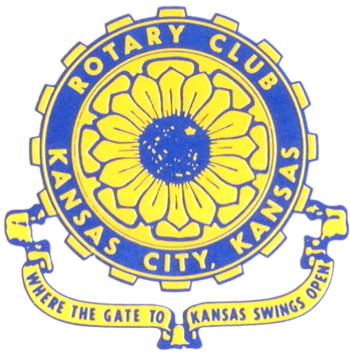
Where the Gate to Kansas Swings Open

The Kansas City, Kansas Rotary Club was organized on November 2, 1915 and received its charter as Club No. 195 in January 1916. Its members take pride in more than 100 years of Rotary service to the community and to international fellowship. From this Club have come five District Governors and two Directors of Rotary International. The Club’s history is as rich as that of the community it represents.

Following the Lewis and Clark expedition which camped at the confluence of the Kansas and Missouri rivers on June 26, 1804, in present day Kansas City, Kansas, this area became an important center for fur trappers. In the following years, many Indian tribes were relocated here from the East. In 1842 the Wyandot Indians acquired land here and founded a town. During this period, and for the next five decades, this area became the main gateway to the inviting majesty of the sprawling Kansas Prairie and the American West. This was where the frontier began. Pioneers found river transportation, outfitters and the beginning of the Santa Fe and Oregon Trails. After the covered wagons came major trunk railroads and barge lines.

In 1886, Kansas City, Kansas received its charter as an incorporated city, combining the towns of Wyandot, Argentine and Armourdale. (Rosedale was added in 1922.) Kansas City, Kansas is the site of the first industrial park in the United States, home of the prestigious University of Kansas Medical Center, and the location of the National Agricultural Hall of Fame and the nationally recognized Kansas Speedway.

Near the geographical and population centers of the contiguous United States, it is in the temperate latitudes at an elevation of 726 feet above sea level. The average rainfall is 35 inches. The average mean temperature ranges from 30°F in January to 80°F in July. The lowest recorded temperature was -23°F on December 23, 1989, and the highest was 113°F on August 14, 1936. Our city’s population of 145,000 and 155 square miles rank it 158th among cities in the United States.

Welcome to Kansas City, Kansas Rotary, and the vibrant community it represents.

Service Above Self

Rotary Websites:
KCK Club: www.rotarydowntownkck.org, District: www.rotary5710.org, International: www.rotary.org

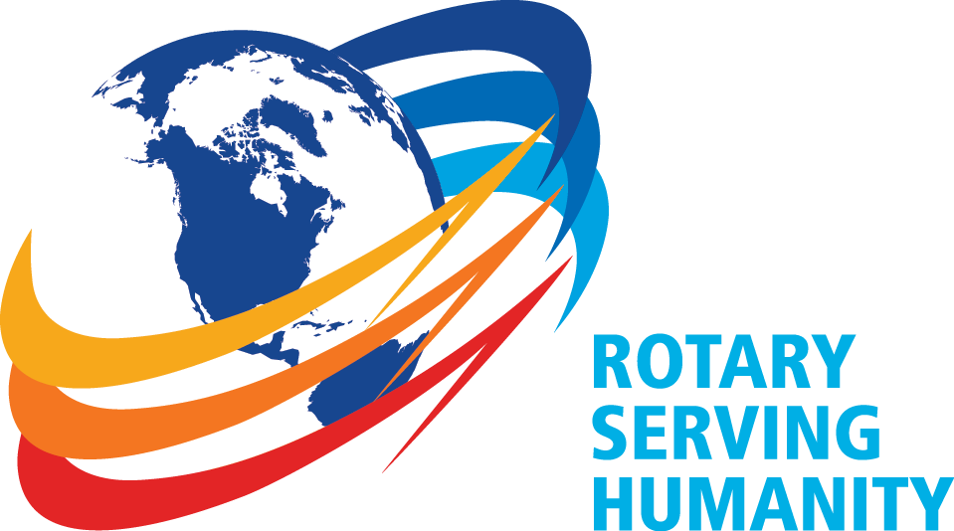

WHERE NEARBY TO MAKE UP ATTENDANCE
MONDAY
Bonner Springs (11:45am) --------------------------------- Twister Bar & Grill, 13100 Kansas Ave.
Overland Park (11:30am) ----------------------------------- Doubletree Hotel, 10100 College Blvd.
TUESDAY
Gladstone (7:00am) -------------------------------------- Fairview Christian Church, 1800 N.E. 65th
Johnson County-Sunset (5:15pm) ------------------------------- Wil Jenny’s, 6700 W. 135th Street
WEDNESDAY
Overland Park South (7:15am) ------------------------ Deer Creek Country Club, 7000 W. 133rd
Leavenworth (Noon) --------------------------- Riverfront Community Center, 123 S. Esplanade
KCI, Missouri (Noon) -------------------------------- KCI Expo Center, 11730 N. Ambassador Dr.
Shawnee Mission (Noon) ----------------------------- Sylvester Powell Center, Martway & Lamar
Olathe (Noon) ------------------------------ Mahaffie/Heritage Center, 1200 E. Kansas City Road
Kansas City South, Missouri (Noon) ----------------------------- EBT, 1310 Carondolet, 2nd Floor
THURSDAY
South Platte, Missouri (7:00am) ----------------------- Trezo Mare, 4105 Mulberry Drive, KCMO
Johnson County (7:15am) --------------------------- Crowne Plaza Hotel, 12601 W. 95th, Lenexa
Leawood (7:15am) ---------------------------------------- Hereford House, Town Center Dr. & Nall
Village West (7:15am) -------------------------- Dave & Buster’s, 1843 Village West Pkwy., KCK
Gardner (7:30am) ---------------------------------------------------- Senior Citizen Bldg., 128 E. Park
Olathe Santa Fe Trail (7:30am) --- Mid-Am Nazarene U, 2030 E. College Way, Campus Ctr.
Kansas City, Missouri (Noon) -------------------------------- The Gallery, 61 E. 14th Street, KCMO
FRIDAY
Desoto (7:00am) ------------------------ Desoto United Methodist Church, 8760 Kill Creek Road
Shawnee (7:15am) --------------------------------------------------- Town Hall, 11600 Johnson Drive
Plaza, Missouri (7:15am) -------------------------------- Intercontinental Hotel, 401 Ward Parkway
North Kansas City, Missouri (Noon) ------------------------------ Finnigan’s Hall, 505 E. 18th Ave.
Parkville, Missouri (Noon) ------------------------ Park University Underground, Woodard Center
Lenexa (Noon) ------------------------------- Lakeview Village, Northpointe Bldg., 91st & Park St.

Meeting make ups can be made 14 days before or after the missed meeting.
Please see the Secretary for the world directory of all Rotary Club’s meeting times, days and places.

2016-2017 Board of Directors
Officers Directors
Ashley Adorante Rick Behrens
President Karole Bradford
Fred Zimmerman John Freshnock
Vice President Phil Gibbs
Greg Shondell Wendell Maddox
Treasurer Melissa Mundt
Jim Knight Bruce Schlosser
Secretary Donna Severance
Rosemary Podrebarac
Sergeant at Arms
Hank Chamberlain
Past President

